# Minutes of the Ordinary Meeting of Ockbrook and Borrowash Parish Council.

# Held at the Parish Hall, Ockbrook, on Wednesday 14th December 2022 at 19:00.

## Public Speaking.

### Members of Public

* A member of public mentioned that on behalf of Ockbrook in Bloom they would like to thank the Parish Council for all of their support this year and for continuing with Wayne Peapell’s contract as he has done a fantastic job.

### Derbyshire County Council Report.

Nothing to report.

### Erewash Borough Council Report.

The core strategy has now gone to the inspectorate, waiting for their decision on if it is acceptable.

### Derbyshire Constabulary Report.

Figures obtained from the website – see appendix 1

### Ashbrook Trustees.

Councillor R Locke updated members on:

* The external lighting has been installed.
* Changing benches for the football groups have been purchased they just need to be installed.
* The food bank has relocated to the Borrowbrook Homelink office.
* The trustees agreed to cover the room hire for the Youth Group and the Mondays sessions for Borrowbrook Homelink, this takes the costs away from the Parish Council.
* The trustees were all informed on the yearly Parish Council support reducing to £5,000 for 2023/24.

### Ashbrook Youth Group.

Nothing to report.

## Present.

Councillors M White (Chairman), J Locke (Vice Chairman), J White, C Millward, G Maskalick, AM Stevenson, M Wallis, T Holbrook and R Locke.

## Also, Present.

S Kitchener (Clerk and RFO) and 6 members of public.

## 259/12/22 Accepted Apologies for Absence.

Councillors P Fisher, W Major and R Parkinson.

## 260/12/22 Noted Absence.

Councillor D Webster

## 261/12/22 Declarations of Members Interests.

None.

## 262/12/22 Dispensations.

None.

## 263/12/22 Variation of Order of Business.

Councillor M White moved section 14 halls, to be discussed before section 10 Finance and Hr as the hall discussion could impact on the budget decision.

## 264/12/22 Approve the Minutes of the Ordinary Parish Council Meeting, Held on the 2nd November 2022.

Proposed by Councillor G Maskalick, seconded by Councillor J Locke and all unanimously agreed that the minutes be approved as a true record and were signed by the Chairman at the meeting.

## 265/12/22 Items to be Taken into Private Session.

None.

## 266/12/22 Report of the Parish Clerk/RFO.

* Wrote to all the groups regarding the increase in hall hire fees, one commercial group complained, and a non-commercial group will have to find grants to pay the difference.
* All Funeral Directors and stone masons have been informed of the burial price increase.
* The external auditor has been confirmed as PKF Littlejohn again for the next 5 years.
* As per last month’s meeting, I looked into having new bins installed in the centre of Borrowash. Erewash will install and empty the bins, but the Parish Council need to buy them, at the moment they are £330-£465, this will be an agenda item in February.
* The Community Payback Team are unable to help with Belmont Drive as they require toilet facilities, running water and shelter which we are unable to provide, awaiting to hear back from one more company.
* All the memorial blossom trees have been installed and allocated, Wayne should be adding the plinths before Christmas, and I will inform all that they have been installed.
* The Grounds Maintenance contract has gone out to be signed.
* Christmas trees sold this year were 78, a bit down on last year.
* Table decorating only had 6 people over the two sessions, I recommend going back to wreath making next year.

## 267/12/22 Report of the Chairman.

* Would like to thank all the Councillors for their hard work this year.

## 268/12/22 General Purposes.

Nothing to report.

## 269/12/22 Halls.

Councillors R Locke, J Locke and J White proposed to review the new hall charges that were voted on in Novembers meeting. A discussion was held, and different options were looked at, but the new rates will be kept.

## 270/12/22 Finance and HR.

### Note the minutes from the Finance Committee meeting on the 23rd November 2022.

**RESOLVED** Councillor J Locke noted the minutes, seconded by Councillor C Millward and all unanimously agreed.

### Accept Accounts for Payment.

**RESOLVED** Proposed by Councillor M Wallis, seconded by Councillor T Holbrook and all unanimously agreed to accept the payment list, see appendix 2.

### Accept the Bank statement Reconciliations. – see appendix 3

* October 2022 Ashbrook Community Group Account.
* October 2022 HSBC Account.
* October 2022 Unity Trust Account.

**RESOLVED** Councillor C Millward signed to accept the bank statement reconciliations all unanimously agreed.

### Agree on the budget figures submitted by the finance committee – see appendix 4.

**RESOLVED** Councillor R Locke proposed to accept the budget figures, seconded by Councillor J Locke and all unanimously agreed.

### Accept Karen Howe as next year’s internal auditor, at the recommendation of Joanne Taylor.

**RESOLVED** Councillor J White proposed to accept the above, seconded by Councillor M Wallis and all unanimously agreed**.**

### Agree to allow the Clerk to make Decembers invoice payments in the month of January, to be ratified in Februarys Parish Council meeting.

**RESOLVED** Councillor M Wallis proposed to accept the above, seconded by Councillor J Locke and all unanimously agreed.

## 271/12/22 Contractors

Nothing to discuss.

## 272/12/22 Recreation.

Councillor J White wanted to thank all the Councillors who have helped with the events this year.

## 273/12/22 Burials.

Nothing to discuss.

## 274/12/22 Allotment.

Nothing to discuss.

## 275/12/22 Environment and Neighbourhood Plan.

### Note the minutes from the environment and neighbourhood plan committee meeting held on the 23rd November 2022.

**RESOLVED** Councillor G Maskalick noted the minutes, seconded by Councillor M White and all unanimously agreed.

### Update on the Neighbourhood Plan.

Councillor A-M Stevenson updated members on the committee meeting with the planner in November, a quote was received which will be discussed in Februarys meeting.

### Update on the cycling report.

Councillor G Maskalick forwarded his cycling report to all before the meeting – see appendix 5, this will be an agenda item in Februarys meeting.

## 276/12/22 Planning.

* Note any comments on the draft revised planning enforcement plan – no comments were made.
* Councillor M White updated all that the 3 Pares Way Planning application appeal failed.

## 277/12/22 Correspondence Received.

The correspondence received and listed in the agenda were available at the meeting, see appendix 6.

## 278/12/22 Date and Time of Next Meeting.

The next Parish Council meeting is scheduled to take place at the Ashbrook Centre, Borrowash on Wednesday 1st February 2023, commencing at 19:00.

## 279/12/22 Exclusion of Press and Public.

Nothing to report.

There being no further business the meeting concluded at 19:50

### **Appendix 1 – Crime Statistics**

September

Antisocial behaviour 4

Violence and sexual offences 9

Criminal damage and arson 3 -

Public order 3

### **Appendix 2– Decembers Payment List.**

|  |  |  |  |
| --- | --- | --- | --- |
| **Invoices to be paid** | - | - | minute agreed |
| Wayne Peapell Consultancy LTD | £3,000 | November works | - |
| Ashbrook Youth Group | £280.00 | Monthly donation | 11/04/22 |
| Guiding Sparks Circus | £500.00 | Xmas light switch in entertainment balance | - |
| Lisa’s | £215.00 | Nov Parish Clean | - |
| Sarah Kitchener | £19.80 | Expenses Nov – mileage | - |
| Cardinus risk mgmt. | £312.00 | Reinstatement cost of PH and AB centre | - |
| Jeans Pantry | £151.50 | Xmas light switch on | - |
| Gallagher | £279.94 | Insurance amendment due to hall re-evaluation | - |
| Computer Lifeline | £149.85 | Annual back up | - |
| B & B Audio | £240.00 | Sound system remembrance | - |
| Simply Sparkle | £30.00 | Oct and Nov windows | - |
| ARB & Grounds | £300.08 | Petrol and generator service | - |
| GTM | £960.00 | Remembrance road closure | - |
| Long Eaton Silver Prize | £150.00 | Xmas light switch on x2 | - |
| EBC | £6201.78 | Nov payroll | - |
| 2commune | £522.00 | Annual website fee | - |
| Manor Electrical | £3932.40 | Ashbrook outside lighting | - |
| NALC | £60.00 | Local council award scheme registration fee | 35/05/22 |
| Leisure Lites LTD | £840.00 | Christmas tree lights x2 | - |
| - | - | - | - |
| **Invoice already Paid** | - | - | - |
| Christiana J Fitness | £140.00 | Nov Chair based exercise | - |
| M White | £170.00 | PA System | 240/11/22 |
| PK Jackson Joinery | £769.00 | Repair PH water damage | 161/09/22 |
| **-** | - | - | - |
| **Monthly direct debits** | - | - | - |
| Lloyds Credit Card – Oct | £614.34 | Posters, stationary, plaques, postage, choc santas | 27/05/22 |
| EBC | £40.00 | Cem rates Nov and Dec | 27/05/22 |
| BT | £70.10 | a/b Nov and Dec | 27/05/22 |
| Everflow | £217.50 | Water Dec and Jan | 27/05/22 |
| British Gas | -£218.04 | June – Oct | - |
| British Gas | £49.83 | Jun- Nov | 27/05/22 |
| Engie | £290.98 | Oct Gas | 27/05/22 |
| O2 | £29.62 | Mobile Dec | 27/05/22 |
| Virgin | £64.90 | Broadband and phone | 27/05/22 |
| Lloyds Credit Card – Nov | £169.81 | Stationary, stamps, high viz jackets | 27/05/22 |

### **Appendix 3 – Bank Reconciliation**

**October 2022 Bank Reconciliation – Ashbrook Community Group**

|  |  |  |  |
| --- | --- | --- | --- |
| **Bank Balance** | - | - | - |
| Bank s/m bal as at 01/04/22 | - | 1,523.45 | - |
| + total cash book receipts | - | 0.00 | - |
| - total Cashbook payments | - | 1,523.45 | - |
| **Cashbook Closing Balance** | - | **0.00** | - |
| - | - | - | - |
| **Bank Balance at 31/10/22** | - | **0.00** | - |
| - outstanding payments | - | 0.00 | - |
| + outstanding receipts | - | 0.00 | - |
| **Net Balance** | - | **0.00** | - |
| - | - | - | - |
| **-** | - | **-** | **Difference: 0.00** |

**October 2022 Bank Reconciliation - HSBC Account**

|  |  |  |  |
| --- | --- | --- | --- |
| **Bank Balance** | - | - | - |
| Bank s/m bal as at 01/04/22 | - | 49,950.50 | - |
| + total cash book receipts | - | 45,000 | - |
| - total Cashbook payments | - | 50,038.50 | - |
| **Cashbook Closing Balance** | - | **44,912.00** | - |
| - | - | - | - |
| **Bank Balance at 04/11/22** | - | **44,912.00** | - |
| - outstanding payments | - | 0.00 | - |
| + outstanding receipts | - | 0.00 | - |
| **Net Balance** | - | **44,912.00** | - |
| - | - | - | - |
| **-** | - | **-** | **Difference: 0.00** |

**October 2022 Bank Reconciliation - Unity Trust Account**

|  |  |  |  |
| --- | --- | --- | --- |
| **Bank Balance** | - | - | - |
| Bank s/m bal as at 01/04/22 | - | 21,925.66 | - |
| Less items related to 21/22 | - | 10,875.92 | - |
| - | - | 11,049.74 | - |
| + total cash book receipts | - | 210,471.36 | - |
| - total Cashbook payments | - | 190,049.95 | - |
| **Cashbook Closing Balance** | - | **31,471.15** | - |
| - | - | - | - |
| **Bank Balance at 01/11/22** | - | **33,474.64** | - |
| - outstanding payments | - | 12,821.81 | - |
| + outstanding receipts | - | 10,818.32 | - |
| **Net Balance** | - | **31,471.15** | - |
| - | - | - | - |
| **Balance per Cashbook** | - | **31,471.15** | **Difference: 0.00** |
| - | - | - | - |
| Charity Accounts included in bank total: | - | - | - |
| Parochial Charities | 1634.53 | - | - |
| S Alcock | 0 | - | - |
| A Potter Dole | 346.56 | - | - |
| Burial Ground | 65.60 | - | - |

### **Appendix 4 – Proposed Budget 2023/2024**

|  |  |  |  |  |  |  |  |  |  |  |  |  |  |  |  |
| --- | --- | --- | --- | --- | --- | --- | --- | --- | --- | --- | --- | --- | --- | --- | --- |
| - | - | Actual | Actual | Actual | Budget | Actual | Budget | Actual | Budget | Actual | Budget | - | Proposed budget | Proposed budget | Proposed budget |
| - | - | 2016/17 | 2017/18 | 2018/19 | 2019/20 | 2019/20 | 2020/21 | 2020/21 | 2021/22 | 2021/22 | 2022/23 | - | 2023/24 | 2024/25 | 2025/26 |
| **Income** | - | £ | £ | £ | £ | £ | £ | £ | £ | £ | £ | - | £ | £ | £ |
| - | - | - | - | - | - | - | - | - | - | - | - | - | - | - | - |
| - | Precept | 102375 | 100991 | 87730 | 111462 | 87730 | 111462 | 87730 | 88168 | 88168 | 91695 | - | - | - | - |
| - | Environment | - | - | 6386 | - | 770 | - | - | - | - | 2000 | - | - | - | - |
| - | Burials | 12235 | 7543 | 209300 | 11868 | 10911 | 11610 | 9955 | 12000 | 17190 | 10500 | - | 11550 | 11550 | 11550 |
| - | Recreation | 13590 | 6363 | 5305 | 5388 | 4376 | 7046 | 2689 | 3800 | 2269 | 2818 | - | 2741 | 2741 | 2741 |
| - | Parish Hall | 5622 | 5893 | 8150 | 8568 | 7332 | 8143 | 2182 | 11000 | 7295 | 11080 | - | 18264 | 18264 | 18264 |
| - | Allotments | 3205 | 3373 | 3368 | 3870 | 3666 | 3814 | 3797 | 3700 | 3628 | 3797 | - | 3707 | 4119 | 4119 |
| - | Other | 22014 | 17705 | 12682 | 34122 | 780 | 10373 | 5278 | 13000 | 469 | 11692 | - | 791 | 791 | 791 |
| - | Ashbrook | - | - | - | - | - | - | 160 | 16290 | 12689 | 12228 | - | 7,666 | 7,666 | 7,666 |
| - | Concurrent Functions | - | - | 24981 | - | 23732 | - | 23732 | 23732 | 23732 | 23732 | - | 23732 | 23732 | 23732 |
| - | VAT | 7701 | 11435 | 14996 | - | 3801 | - | 4227 | - | 13434 | - | - | - | - | - |
| - | **Total Income** | **166742** | **153303** | **184528** | **175278** | **143098** | **152448** | **139750** | **171690** | **168874** | **169542** | **-** | **68450** | **68862** | **68862** |
| **Expenditure** |  |  |  |  |  |  |  |  |  |  |  |  |  |  |  |
| - | Parish Hall | 3655 | 17830 | 14408 | 15016 | 10961 | 13948 | 21947 | 15000 | 13795 | 11665 | - | 13189 | 16351 | 20679 |
| - | Ashbrook | - | - | 12058 | 20000 | 10430 | 25061 | 9786 | 15000 | 15610 | 11081 | - | 17116 | 23007 | 23970 |
| - | Salaries/mileage /training/ chair | 60168 | 47743 | 33722 | 55363 | 24592 | 23222 | 37266 | 33000 | 49333 | 42302 | - | 51810 | 52894 | 54044 |
| - | Recreation | 19091 | 24715 | 11927 | 14240 | 8897 | 11462 | 4667 | 169190 | 14891 | 14132 | - | 13716 | 12331 | 12848 |
| - | Environment/NP | 8506 | 24108 | 27784 | 20000 | 26921 | 27769 | 28152 | 33000 | 22863 | 36055 | - | 27670 | 29828 | 31320 |
| - | Grants | 8870 | 3850 | 1200 | - | 1775 | 5000 | 1618 | 5000 | 9168 | 5000 | - | 8000 | 8000 | 8000 |
| - | Gen/admin/ bank charges/ subs/ins/ utilities | 51378 | 47512 | 18652 | 33403 | 21278 | 32050 | 11355 | 36000 | 10543 | 30936 | - | 18901 | 15846 | 16576 |
| - | Burials | 8754 | 11044 | 20766 | 14108 | 17626 | 11571 | 17653 | 16000 | 16133 | 16203 | - | 20782 | 21644 | 22549 |
| - | Allotments | 157 | 3282 | 5231 | 3148 | 918 | 2365 | 1719 | 2500 | 4003 | 2168 | - | 3793 | 3987 | 4187 |
| - | VAT | 11435 | 11755 | 5854 | - | 3733 | - | 8565 | - | 12085 | - | - | - | - | - |
| -**Total Expenditure** | **-** | **172015** | **191840** | **151601** | **175278** | **127132** | **152448** | **142728** | **171690** | **168424** | **169542** | **-** | **174977** | **183887** | **194173** |
| **Total Income and Expenditure** | **-** | **-5272** | **-38537** | **32927** | **0** | **15966** | **0** | **-2978** | **0** | **450** | **0** | **-** | **-106527** | **-115026** | **-125311** |

Precept Calculation.

|  |  |  |  |
| --- | --- | --- | --- |
| - | Budgeted income | Budgeted Expenditure | Net |
| Parish Hall | 18,264 | 13,189 | -5,075 |
| Ashbrook | 7,666 | 17,116 | 9,451 |
| Salaries/ Mileage/ training / chair allowance | 0 | 51,810 | 51,810 |
| Recreation | 2,741 | 13,716 | 10,975 |
| Environment and NP | 0 | 27,670 | 27,670 |
| Reserve Build up | 0 | 20,000 | 20,000 |
| Concurrent Functions | 23,732 | 0 | -23,732 |
| Donations | 0 | 8,000 | 8,000 |
| Gen/admin/ bank charges/ subs/ other/ utilities | 791 | 18,901 | 18,110 |
| Burials | 11,550 | 20,782 | 9,232 |
| Allotment | 3,707 | 3,793 | 86 |
| **Total** | **68,450** | **194,977** | **126,527** |
|  |  |  |  |

### **Appendix 5 –** Cycle Report - DECEMBER 2022

1. The Cycle Survey is out on the Parish website, and I will report shortly the results of the first batch of people to complete the survey.
2. On the following pages one will find pictures of cycling obstructions in our Parish that should be easy to rectify. This can be a starting point for improving cycling within the Parish. These obstructions not only hinder cyclists, but also mobility scooters, disabled cyclists, walkers, and walkers with disabilities such as use of Zimmer frames…

I would propose as a PC via the Parish Clerk that we make representation to the governing bodies responsible for these areas and ask them to rectify the situation they are responsible for. I do note that one area may be within our remit and that is the hedge that sticks out onto the cycle path.

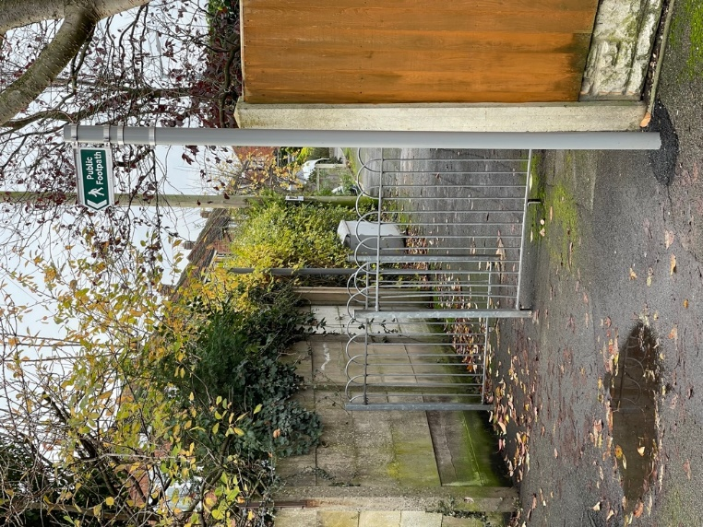

This gate structure needs to go entirely. It is an obstruction for people with disabilities including those with walking frames. It makes for unsafe wheelchair and cycle use.

WINSDOR CLOSE: SOLUTION – REMOVE BARIER COMPLETELY

This is out of control and very unsafe for everyone as if you are walking or cycling you can’t see traffic coming at you until you are around the obstruction.

CYCLE/FOOTPATH OFF ASHBROOK CENTRE – SOLUTION: CUT BACK OR REMOVE TREE/HEDGE

A picture showing a bush obstructing a pavement 


A picture containing the pavement access onto Deans Drive playground



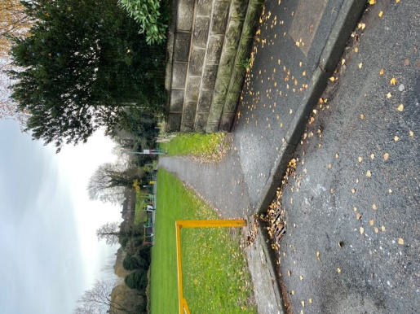

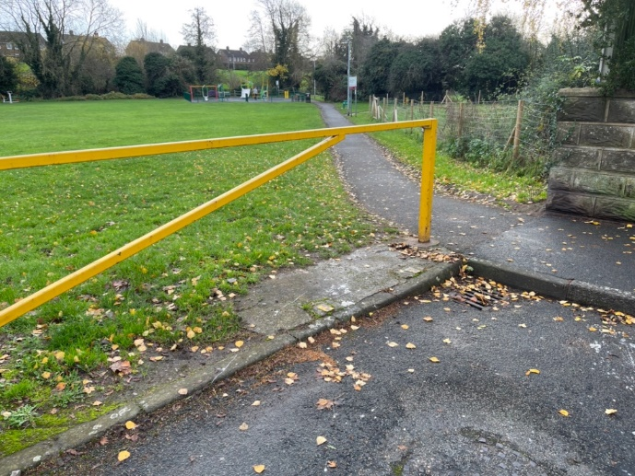

This just doesn’t make sense. The cycle/footpath comes down the hill and because of the gate one is forced to go along a footpath in front of the first house off the path and then finally find a dropdown point to the road off the apron of a private driveway. Meanwhile where the path is gated off there is indeed a dropdown curb for cyclists to use safely. This would also be a danger spot as it is for wheelchair users…

BOTTOM OF DEANS DRIVE PLAY AREA: SOLUTION – REMOVE GATE AND PAVE PATH TO LEAD OUT TO DROPDOWN CURB.

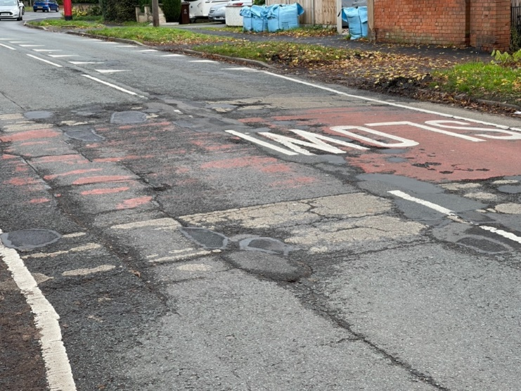

This isn’t safe for cyclists. The road is in very poor condition and full of holes that can cause serious falls for cyclists. It is noted that it is now Winter, and potholes will get worse, but this area has been poor for more than a year.

VICTORIA: SOLUTION – PREASURE DCCC TO FIX THIS AREA AS A MATTER OF URGENCY.

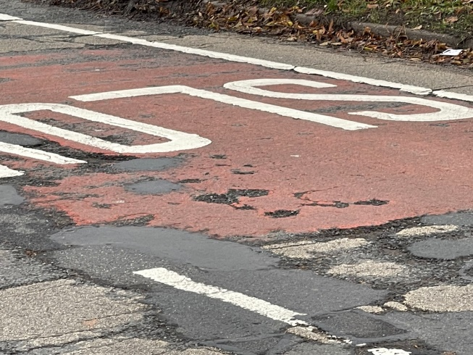

### **Appendix 6 –** Correspondence Received- Up to 01/12/22

Emails received from members of public:

* Enquiring whether planters on a grass verge were approved planning permission – Called Planning who have no information on these planters so will be writing to the landowners regarding their removal. (1)
* Carr Hill Farm Goods Vehicle Operators License – email forwarded to Cllrs 17/11/22. (2)
* Concern of drug usage in the Parish Carpark – monitoring the situation as only 1 group has mentioned this. (3)
* Complaining about the rubbish in the centre of Borrowash and pulling up of plants.(4)
* Noticeboard item requests. (5)
* Request for quiet sessions with Santa at the Christmas light switch on – the service was offered and will continue to be offered in the future. (6)
* Hall hiring enquiries, complaints and cancellations. (7)
* Christmas tree and table decorating requests. (8)
* Allotment enquiries and updates. (9)
* Memorial bench enquiry. (10)

Other emails received:

* Derbyshire Flood Warden Newsletter. (11)
* Request to tender for the Grounds Contract. (12)
* East Midlands Airport Community Funding workshop. (13)
* Refusal of the Parish Councils grant application to the Police and Crime Commissioners anti- social prevention grant. (14)
* Derbyshire Fire and Rescue Services 6-week consultation on their draft plan – forwarded to Cllrs and on Facebook. (15)
* Derbyshire Police proposed budget survey – forwarded to Cllrs and on Facebook. (16)
* Derbyshire Citizens Advice 6-month report. (17)
* LGC Roundtable invitation to discuss how local authorities can harness technology – forwarded to Cllrs. (18)
* Mentell Matters November newsletter. (19)

Emails received from EBC:

* Planning applications/amendments/appeal decisions:
  + 5 Mear Drive – first floor extension, with a room in the roof over the garage/utility and insertion of windows in the existing dwelling. (20)
  + 26 The Ridings - demolition of existing dwelling and construction of replacement dwelling, detached outbuilding and change of use of land. (21)
  + Land rear of 45 Nottingham Road – outline application for 5 dwellings with access off Nursery Close. (22)
  + 64 Derby Road – Roof extension and roof lights, front gable extension in height and single-story rear extension. (23)
  + 15 Victoria Avenue – Change of use from hairdressers to a bar. (24)
  + 3 Pares Way -Appeal decision. (25)
* Erewash Core Strategy review – forwarded to Cllrs. (26)
* Enquiry into the cemeteries we own so they can be checked they have the correct signage for public space protection orders. (27)
* Planning, Borough and Parish Council Forum, and ordinary meeting agendas and minutes. (28)

Emails received from DCC:

* Mobile library routes. (29)
* Parish and Town council liaison forum presentation slides – forwarded to Cllrs. (30)
* Community News. (31)

Emails received from DALC – Forwarded to Cllrs (32)

Numerous emails received from NALC - forwarded to Cllrs. (33)

SLCC updates. (34)

ICCM updates. (35)

Magazines:

* Bramm News. (36)
* Clerks and Councils Direct. (37)
* Allotment and Leisure Gardener. (38)