Minutes of the Ordinary Meeting of Ockbrook and Borrowash Parish Council.

Held at the Parish Hall, Ockbrook, on Wednesday 17th May 2023 at 19:00.

Public Speaking.

Members of Public
- A member of public mentioned the weeds growing on the footpaths on Nottingham Road near the bus stop, Councillor S Cresswell spoke to DCC, who will put a report together after an inspection, which might be sent back to EBC to deal with.
- A member of public asked what can be done about the potholes in the village? Cllr G Maskalick mentioned that the environment committee will be looking at this and Cllr G Markwell recommended all to keep reporting potholes to Highways.
- A member of public asked about the possibility of traffic calming on Green Lane, Ockbrook. Cllr G Maskalick mentioned this being a DCC issue, but we do have a speed watch group who are just waiting for their final training from the PCSO. If anyone is caught speeding, a maximum of two letters will be sent out, if they continue they will be visited by the Police.
- A member of public mentioned a planning application on Flood Street and the lack of notice from EBC, Cllr A Dunn mentioned the need to write to EBC with their objections. This will be discussed in the committee meeting.
- A resident mentioned their inability to get around Ockbrook in a wheelchair or with a walker, due to parking on pavements and drop-down kerbs, also the lack of disabled crossing areas. Cllr G Maskalick mentioned the cycling/walking survey, the 2nd survey will be released in September, and this will look at disabled access to help us achieve funding. Cllr G Markwell mentioned the parking warden has been going around Borrowash. Cllr A Dunn will contact the resident directly to talk through their fears.
- A resident mentioned the overhanging trees in the villages, Cllr G Maskalick informed all that a list of overhanging hedges and trees will be compiled with photographs to send to EBC and DCC.
- A resident requested an update on the application for a haulage business at Carr Hill Farm. Cllr G Maskalick will talk to them after the meeting, and as an EBC Councillor will approach planning.
- A resident asked if the Parish Council had plans to expand any local parks, Cllr C Millward commented on how expensive park equipment is.

Derbyshire County Council Report.
Nothing submitted this month.

Erewash Borough Council Report.
Nothing submitted this month.

Derbyshire Constabulary Report.
Figures obtained from the website – see appendix 1.

Ashbrook Trustees.
Councillor R Locke commented that the next meeting will be at the beginning of June and a report will be produced for Junes meeting.

Ashbrook Youth Group.
Nothing submitted this month.

Present.
Councillors G Maskalick (Chair), S Fraser-Burton (Vice Chair), S Cresswell, G Markwell, K Thomas, J Fazackerley, J Fraser-Burton, A Dunn, K Eaglesham-Atkins, C Millward and T Stevenson.

Also, Present.
S Kitchener (Clerk and RFO) and 25 members of public.

29/05/23 Noted Apologies for Absence.
None.

30/05/23 Declarations of Members Interests.
None.

31/05/23 Dispensations.
None.

32/05/23 Variation of Order of Business.
None.

33/05/23 Approve the Minutes of the Ordinary Parish Council Meeting, Held on the 5th April 2023.
RESOLVED Proposed by Councillor G Maskalick, seconded by Councillor T Stevenson and all unanimously agreed that the minutes be approved as a true record and were signed by the Chair at the meeting.

34/05/23 Items to be Taken into Private Session.
None.

35/05/23 Report of the Parish Clerk/RFO.
- After inputting all the information into the register of purchased graves, between 1995 and 2018 there are 52 plots where the exclusive rights have not been produced, these have now been produced.
- The new bin has been installed on the grass verge opposite Station Road, Borrowash.
- A Freedom of Information has been sent to the charity commission to obtain the governing documents of our old and present charities.
- Information on the Ashbrook Centre Trust has been sent to a Parish Council Charity specialist solicitor.
- Parish Councils are now able to pay in money at the Post Office until the 15th July, from the end of August we will be able to use a paying in book at the post office so there will be about 6 weeks where money will need paying into Long Eaton’s Nat West.
- On the 25th May between 8.00 and 13.00 the Shacklecross water supply will be off for about 30 minutes to replace the water metre.
- Two letters were given to the Clerk to read out as they were unable to attend the meeting, these included the state of the verges after EBC have cut them and their regrets that Wayne Peapell Consultancy LTD had handed in their notice, these letters will be in Junes Correspondence list.

36/05/23 Report of the Chairman.
I would first like to thank the previous Parish Council for their years of service to the Parish. We appreciate their hard work and effort over the years doing what they felt was best for the Parish to thrive. I wish them all the best of luck in their future endeavours.

I would also like to reiterate at this time how important community groups are to the life and fellowship of the Parish. Community groups no matter how large or small are a Parish asset that should be always supported. Moving forward, this shall be the case and views and criticisms (and that of any person or group) shall be met with professionalism, grace, and positive engagement by this new Parish Council.
Our other Parish assets such as cemeteries, allotments, Ashbrook Centre just to name a few must also be protected and made fit for purpose for this decade and beyond. Our most cherished Parish asset is our youth. This Parish Council will endeavour to build programmes that promote youth development and use Parish assets fully for youth projects. It is my pleasure to announce we are going to start a Youth Committee and have it up and running by September. We need to work on the Youth Committee remit and purpose and already we have excellent adult leadership lined up.
This Parish Council would like to invite all parishioners to become involved with any of the Parish Council committees. Yes, we can second unelected parishioners to committees and would welcome your involvement. There will be more on this on how to join a committee in the coming months.
What is very exciting is this Parish Council has a massive amount of talent on it and we will need that talent and expertise to negotiate all the challenges over the next few months and beyond. We will be working our way through and pass all financial scrutiny, rebuild our reserves and ensure all our Parish assets continue to flourish.
Lastly, I would like to bring your attention to some items that will be actioned in the very near future:
- I will be liaising with the police on the possibility of giving out polite notices for parking issues in Ockbrook and Borrowash.
- The pride flag will be flying on all 5 flag poles starting June 1st throughout Pride Month
- The Big Lunch Project for 2024.
- Elm Street Allotments projects
- Start a Parish Business Forum
- Notice Boards Outside Ashbrook Centre
- Coop Toilet Block – where is it now?
- Parish Concert featuring not only some PC Members but mainly our talented youth.

This is only the beginning. Each Committee has things they are going to do and achieve over the next several months. We are going to see a lot of hands-on action from this PC so stay in touch.
In conclusion as you know I am also one of three elected EBC for the Parish. I promise you I will represent our interests fully at EBC level. Thank you for listening and here’s to a very bright future for the Parish and Parish Council.

37/05/23 General Purposes.

Discuss and Consider a Residents Request for Changing the Car Charger at the Parish Hall to a Pay As You Go for Financial Year 2024/25.
Councillor G Markwell commented on the difference between the two quotes and would like to look into this further to discuss in a future meeting, all unanimously agreed to keep the charger turned off until decision has been made.

Consider Suppling .gov.uk Email Addresses to all Councillors at a Cost of £35.00 + VAT per year.
RESOLVED Proposed by Councillor Sarah Cresswell, seconded by Councillor C Millward and all unanimously agreed to the new email addresses. ACTION Clerk to organise.

38/05/23 Finance and HR.

Accept Accounts for Payment – see appendix 2.
RESOLVED Proposed by Councillor G Markwell, seconded by Councillor C Millward and all unanimously agreed to accept the payment list.

Accept the Income and Expenditure Breakdown for the Full Year – see appendix 3.
RESOLVED Proposed by Councillor K Eaglesham-Atkins, seconded by Councillor C Millward and all unanimously agreed to accept the breakdown.

Accept the Bank statement Reconciliations. – see appendix 4
- March 2023 HSBC Account.
- March 2023 n2 Unity Trust Account.
RESOLVED Proposed by Councillor C Millward, seconded by Councillor K Tomas and all unanimously agreed to accept the bank statement reconciliations.

Internal Annual Audit Report Noted and Received – see appendix 5.
RESOLVED Proposed by Councillor G Markwell, seconded by Councillor K Eaglesham-Atkins and all unanimously agreed to accept the audit.

Approval of the Annual Governance Statement 2022/23 Section 1 – see appendix 6.
RESOLVED Proposed by Councillor K Eaglesham-Atkins, seconded by Councillor A Dunn and all unanimously agreed that the annual governance statement 2022/2023 questions were approved, and the statement was signed by the Chair.

Approval of the Accounting Statements 2022/23 Section 2– see appendix 7.
RESOLVED Proposed by Councillor G Markwell, seconded by Councillor C Millward and all unanimously agreed that the accounting statements 2022/23 in the annual governance and accountability return are correct and approved, and the statement was signed by the Chair.

RESOLVED The Dates for the Notice of Public Rights and Publication of Unaudited Annual Governance and Accountability Return were Noted as Monday 5th June to Friday the 14th July 2023.

Consider the donation request of £386.00 to Cover Liability Insurance for the Open Gardens.
Further questions were asked to the group, RESOLVED proposed by Councillor T Stevenson to donate £200.00, seconded by Councillor A Dunn and all unanimously agreed.

Agree to Councillors G Maskalick, C Millward, S Fraser-Burton, G Markwell, A Dunn and K Thomas to be bank Signatories.
RESOLVED Proposed by Councillor A Dunn, seconded by Councillor K Eaglesham-Atkins and all unanimously agreed.

39/05/23 Contractors
Nothing to report.

40/05/23 Recreation.
Nothing to report.

41/05/23 Burials.
Nothing to report.

42/05/23 Halls.
RESOLVED Councillor G Markwell proposed to accept quote 1, seconded by Councillor C Millward and all unanimously agreed, ACTION Clerk to organise.

43/05/23 Allotment.
Nothing to report.

44/05/23 Environment and Neighbourhood Plan.
Nothing to discuss.

45/05/23 Planning.
Nothing to report.

46/05/23 Correspondence Received – see appendix 8.
The correspondence received and listed in the agenda were available at the meeting.

47/05/23 Date and Time of Next Meeting.
The next Parish Council meeting is scheduled to take place at the Ashbrook Centre, Borrowash on Wednesday 7th June 2023, commencing at 19:00.

48/05/23 Exclusion of Press and Public.
Nothing to report.
There being no further business the meeting concluded at 20:30.

Appendix 1 – Crime Statistics from the website

February March
Violence and sexual offences 20 11
Vehicle Crime 4 0 -
Anti-social behaviour 7 4
Burglary 4 0
Public Order 3 4
Criminal damage/arson 3 0
Shoplifting 1 0
Theft from a person 1 0
Vehicle crime 1 0
Other theft 2 7

Appendix 2 – Payment List May 2023
Invoices already paid | - | - | minute agreed
Wayne Peapell Consultancy LTD | £2100 | April works | 10/04/23
ARB & Grounds | £106.90 | Petrol | 10/04/23
Ashbrook Youth Group | £200.00 | Monthly donation | 270/12/22  10/04/23
EBC | £3591.51 | Wages | 10/04/23
Lisa’s | £294.30 | April Parish Clean | 10/04/23
Sarah Kitchener | £15.75 | Expenses Apr – mileage | 10/04/23
Karen Howe | £268.90 | Internal audit | 10/04/23
DALC | £1307.23 | Subs | 10/04/23
EBC | £330.00 | Bin | 296/02/23  10/04/23
ICCM | £95.00 | Subs | 10/04/23
PPL PRS | £884.23 | Music licence | 10/04/23
HSBC | £80000 |  | 10/04/23
Monthly direct debits | - | - | -
Engie | 474.20 | Mar gas | 27/05/22
British Gas | £60.88 | Elec | 27/05/22
Virgin | £64.80 | Broadband | 27/05/22
O2 | £33.58 | Mobile | 27/05/22
Lloyds Bank | £599.03 | Cleaning items, stamps, flags, bunting | 27/05/22
BT | £41.66 | Ashbrook phone | 27/05/22
Everflow | £141.11 | May | 27/05/22
EBC | £17.97 | Cem rates | 27/05/22
EBC | £299.00 | Ashbrook waste April-June | 27/05/22
EBC | £299.00 | Balmoral Rd Waste April – Jun | 27/05/22

Appendix 3 – Income and Expenditure breakdown
 | Budget 2022/23 | ¼ 4  Jan-Mar | Actual to date 2022/23 | Forecast to year end 2022/23 | Total forecast to year end  2022/23 | Variance to budget 2022/23 | Variance to budget 2022/23 | Notes
Income | £ | £ | £ | £ | £ | £ | % | -
Precept and Grant | 115,427 | 0 | 115,427 | 0 | - | 0 | 0 | -
Burials | 10,500 | 1,843 | 8,300 | - | - | -2,200 | -21 | Over budgeted
Recreation | 2,818 | 0 | 4,104 | - | - | 1,286 | 46 | Unexpected grants £1200 and £750 and refund £200
Hall/lettings | 11,080 | 3,909 | 11,884 | - | - | 804 | 7 | Extra bookings, class time increases and cancellations
Allotment | 3,797 | 2,153 | 3,803 | - | - | 6 | 0
Other | 11,692 | 0 | 1,396 | - | - | -10,296 | -88 | Over budgeted using average figures
Ashbrook | 12,228 | 3,033 | 8,770 | - | - | -3,458 | -28 | Extra bookings, class time increases and cancellations
Environment/NP | 2,000 | 0 | 800 | - | - | -1200 | -60 | Memorial blossom trees budgeted for 20 only have 13 due to increase in tree costs
VAT | 0 | 1,615 | 16,505 | - | - | 16,505 | 0 | -
Total Income | 169,542 | 12,554 | 170,988 | - | - | 1,446 | - | -
Expenditure | - | - | - | - | - | - | - | -
Parish Hall | 11,665 | 2,427 | 9,563 | - | - | -2,102 | -18 | Over budgeted using average figures
Ashbrook | 11,081 | 2,495 | 12,981 | - | - | 1,900 | 17 | Cleaning costs now allocated to ab not included in budget
Sal/miles/train/ chair allowance | 42,302 | 12,284 | 50,017 | - | - | 7,715 | 18 | 21/22 back dated payroll increase  22/23 back dated payroll increase
Rec/ events | 14,132 | 4,255 | 59,058 | - | - | 44925 | 318 | Wicksteed park £45,982 out of reserves
Environment | 36,055 | 4,695 | 20,060 | - | - | -15,995 | -44 | Over budgeted using average figures
S137/ donations | 5,000 | 1,465 | 10,140 | - | - | 5,140 | 103 | Room hire charges for 2 groups not budgeted for.
Gen/admin/bank charges/Subs/ ins/ utilities | 30,936 | 1,819 | 10,870 | - | - | -20,066 | -65 | Over budgeted using average figures
Burials | 16,203 | 3,968 | 15,989 | - | - | -214 | -1 | -
Allotments | 2,168 | 1,045 | 4,530 | - | - | 2,362 | 109 | Extra works needed to clear plots
VAT | 0 | 1,878 | 14,183 | - | - | 14,183 | 0 | -
Total Expenditure | 169,542 | 36,332 | 207,392 | 0 | 0 | 37,850 | - | -
- | - | - | - | - | - | - | - | -
Total Income and Expenditure 2022/2023 (+surplus/-deficit) | 0 | -23,778 | -36,404 | 0 | 0 | -36,404 | - | -
Balance carried forward from 2021/2022 | 11,050 | - | - | 2021/22 | 11,050 | - | - | -
HSBC A/c 21/22 | 49,951 | - | - | - | 24,899 | - | - | -
Forecast balances as at 31st March 2023 | 61,000 | - | - | 2022/23 outturn | 35,948 |  | - | -

RESERVES | £
Ashbrook Centre | -2,981
Bi election | 6,000
Wicksteed | 0
Charity amounts | 2,047
Queens green canopy | 0
General reserves | 30,883
- | 35,948

Appendix 4 – Bank Reconciliation
March 2023 Bank Reconciliation - HSBC Account

Bank Balance | - | - | -
Bank s/m bal as at 01/04/22 | - | 49,950.50 | -
+ total cash book receipts | - | 45,000.00 | -
- total Cashbook payments | - | 80,076.00 | -
Cashbook Closing Balance | - | 14,874.50 | -
- | - | - | -
Bank Balance at 31/03/23 | - | 14,874.50 | -
- outstanding payments | - | 0.00 | -
+ outstanding receipts | - | 0.00 | -
Net Balance | - | 14.874.50 | -
- | - | - | -
- | - | - | Difference: 0.00

March 2023 Bank Reconciliation - Unity Trust Account

Bank Balance | - | - | -
Bank s/m bal as at 01/04/22 | - | 21,925.66 | -
Less items related to 21/22 | - | 10,875.92 | -
- | - | 11,049.74 | -
+ total cash book receipts | - | 250,988.09 | -
- total Cashbook payments | - | 252,391.70 | -
Cashbook Closing Balance | - | 9.646.13 | -
- | - | - | -
Bank Balance at 31/03/23 | - | 20,760.24 | -
- outstanding payments | - | 11,114.11 | -
+ outstanding receipts | - | 0.00 | -
Net Balance | - | 9,646.13 | -
- | - | - | -
Balance per Cashbook | - | 9,646.13 | Difference: 0.00
- | - | - | -
Charity Accounts included in bank total: | - | - | -
Parochial Charities | 1634.53 | - | -
S Alcock | 0 | - | -
A Potter Dole | 346.56 | - | -
Burial Ground | 65.60 | - | -

Appendix 5 – Internal Auditors Report Ockbrook and Borrowash Parish Council
Year ending 31st March 2023

The internal audit is carried out in accordance with the Annual Governance and Accountability for Local Councils and Joint panel on Accountancy and Governance.
The audit has been carried out on a sample basis. The scope of the works undertaken and the areas examined cover the internal control objectives identified in the Annual Governance and Accountability Return for 2022-23, ensuring that the Parish Council obtain an adequate level of assurance.
To complete the audit the following areas have been analysed
- Appropriate accounting records, including cash book receipts and payments, income received and VAT refunded.
- Observation of financial regulations and standing orders
- Risk management/assessment
- Salaries to employees, PAYE and NI requirements
- Bank reconciliation of bank accounts
- Asset control, including fix asset register and adequate insurance provision
- Arrangements for the exercise of public rights
- Precept requirement, budget preparation and reserves were appropriate
- Year end procedures
- The authority has complied with the AGAR publication requirements

Outcome
My inspection of the Council’s records for the year ended 31st March 2023 found the following internal control objective did not comply with the Annual Governance and Accountability return.
Internal control objective D
The precept or rates requirement resulted from an adequate budgetary process; progress against the budget was regularly monitored; and reserves were appropriate.
I have observed an adequate budgetary process and noted the process against budget was regularly monitored, however the reserves do not meet the Councils reserves policy, which was adopted in November 2022. The minimum level of general reserves to be held by the Council is three twelfths of the annual revenue expenditure.
Therefore, this is an area of risk resulting in a No response.
The audit process was carried out with co-operation from the Parish Clerk/Responsible Finance Officer.
This concludes my report for Ockbrook and Borrowash Parish Council Mrs Karen Howe
Internal Auditor

Dated, 20th April 2023

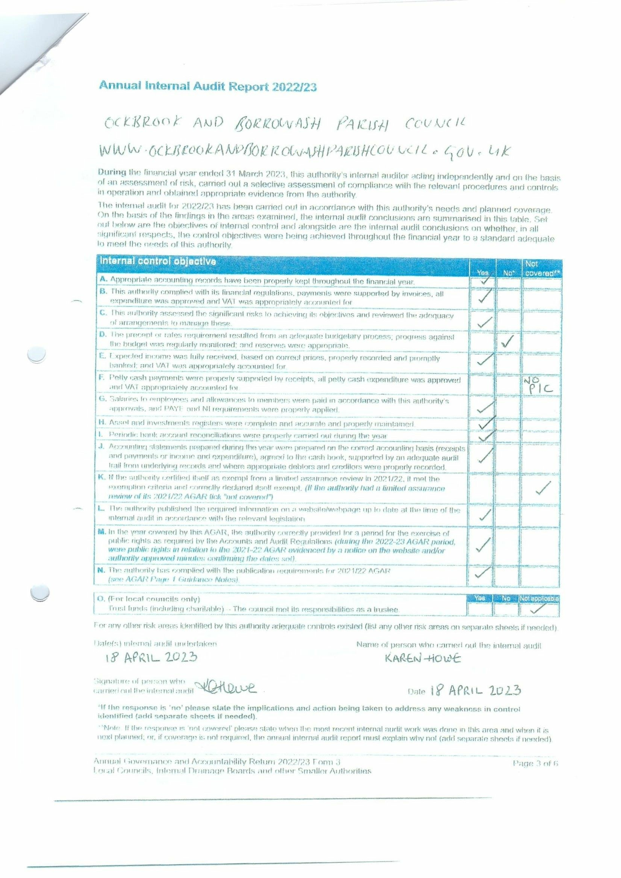

Appendix 6 Annual Governance Statement 2022/23 section 1.
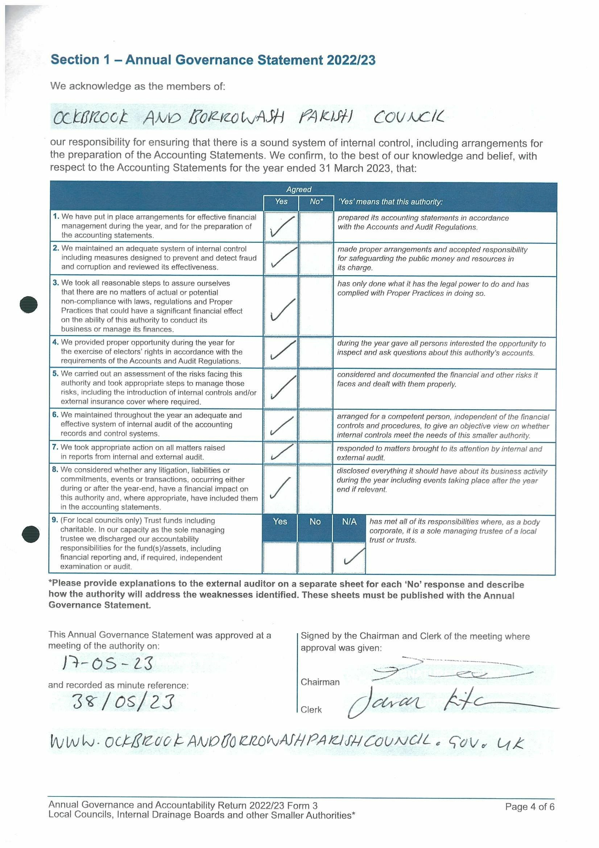

Appendix 7 Accounting Statement 2022/23
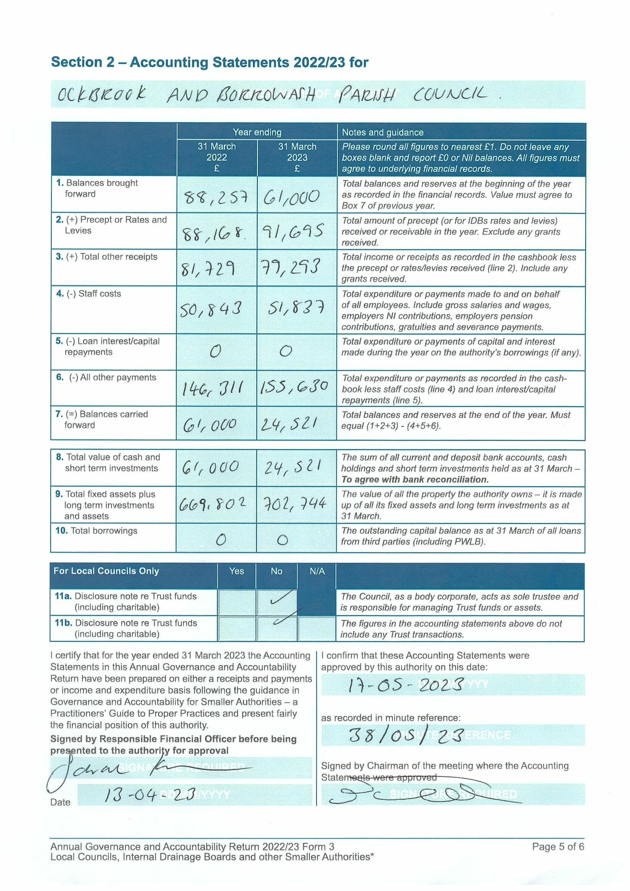

Appendix 8– Correspondence received up to the 28/04/23.
Emails received from members of public:
- Numerous planning objections to ERE/0323/0058 - The Ridings change of use of agricultural barn. (1)
- Numerous planning objections to ERE/0323/0060 – telecommunications mast. (2)
- Planning objections to ERE/0323/0009 – 26 The Ridings. (3)
- Planning objections to ERE/0323/0063 – Borrowash Tennis Club flood lights. (4)
- Information required on who to contact regarding the state of the roads in Ockbrook – Our DCC Councillor and Highways. (5)
- Copied into a complaint letter regarding the roads in Ockbrook. (6)
- Request for litter picking rings – we do not supply those to groups. (7)
- Update on the community speed watch group. (8)
- Freedom of information request from 1 resident (9):
  - 27th March – all information requested had been previously sent on the 10th January 2023, told to look again in their inbox.
  - 6th April – this email was originally responded to on the 2nd March, told to look back at their inbox for the information.
  - 12th April chasing up my response to a March FOI – this had already been answered that morning if they were unhappy told them to report it to the ICO.
  - 13th April – forwarded on all information requested.
- Stating their concerns on the state of the Queens canopy on Deans Drive and asked for the costings – updated that is gets tidied twice a year to encourage the wildlife and the figures were forwarded. (10)
- Concerns regarding Councillors behaviour – forwarded to all councillors. (11)
- Hall hiring payments, enquiries, cancellations and updates. (12)
- Notice board and website request. (13)
- Allotment enquiries and updates. (14)
- Interment enquiries. (15)
Other emails received:
- Domain Name detail review – all up to date. (16)
- Mentell Matters April newsletter. (17)
- East Midlands Community Flyer Spring newsletter. (18)
- ICO newsletters and updates. (19)
Emails received from EBC:
- Planning applications/amendments/appeal decisions:
  - 34 Conway Avenue – Ground floor flat roof extension. (20)
  - 10 Princess Drive – single storey rear extension. (21)
  - Ockbrook and Borrowash Tennis Club 10 floodlights. (22)
  - Cricket Ground, Bakehouse Lane – telecommunications mast. (23)
- Borrowash litter bin – informed it has installed opposite Station Road. (24)
- Meet the funder Erewash event – on Facebook, noticeboards and website. (25)
- Planning, financial and ordinary meeting agendas and minutes. (26)
Emails received from DCC:
- Borrowash bus stop upgrade notification. (27)
- Electric vehicle charging survey. (28)
- Road Closure notification – Elm Street 15/04/23-21/04/23. (29)
- Update on the Clerks request for a dangerous bump on the pavement to be removed. (30)
- Community news x 2 – on website. (31)
Emails received from DALC, including April and Mays newsletter – Forwarded to Cllrs (32)
Numerous emails received from NALC - forwarded to Cllrs. (33)
SLCC updates. (34)
Magazines:
- Local Councils Update, May. (35)
- Bramm News. (36)

