# OCKBROOK & BORROWASH PARISH COUNCIL

# The Parish Hall, Church Street, Ockbrook, Derby DE72 3SL

Tel: 01332 664100/ 07860 702904 Email: Clerk@ockbrookandborrowashparishcouncil.gov.uk

14th September 2023

To the Chair and Councillors of the Finance, HR, Contractors and General Purposes Committee for Ockbrook and Borrowash Parish Council,

You are summoned to attend the Finance, HR, Contractors and General Purposes Committee Meeting of the Ockbrook and Borrowash Parish Council to be held in the Parish Hall, immediately after the Burials Committee meeting on Wednesday 20th September 2023.

Yours sincerely,

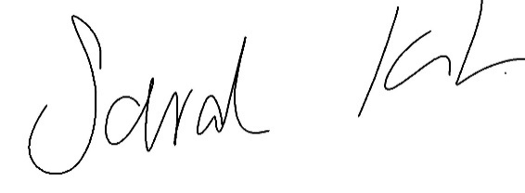

Sarah Kitchener

Clerk and RFO

Ockbrook and Borrowash Parish Council

## Agenda.

1. To receive apologies for absence.
2. To confirm the minutes of the previous meeting held on the 19th July 2023.
3. Variation of the order of business.
4. Declaration of members interests.
5. Committee Items for Discussion/Action/Update.

* Agree to sell off the unwanted gardening equipment, keeping the trailer, pump and generator.

1. Date of the next meeting.