# OCKBROOK & BORROWASH PARISH COUNCIL

# The Parish Hall, Church Street, Ockbrook, Derby DE72 3SL

Tel: 01332 664100/ 07860 702904 Email: Clerk@ockbrookandborrowashparishcouncil.gov.uk

14th September 2023

To the Chair and Councillors of the Planning and Environment Committee for Ockbrook and Borrowash Parish Council,

You are summoned to attend a Planning and Environment Committee meeting of the Ockbrook and Borrowash Parish Council to be held in the Parish Hall, Ockbrook, immediately after the Recreation Committee meeting, on Wednesday 20th September 2023.

Yours sincerely,

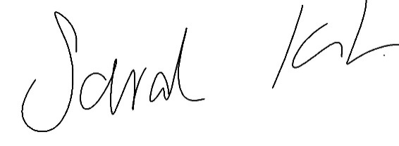

Sarah Kitchener

Clerk and RFO, Ockbrook and Borrowash Parish Council

## Agenda.

1. To receive apologies for absence.
2. To confirm the minutes of the previous meeting held on the 24th May 2023.
3. Variation of the order of business.
4. Declaration of members interests
5. Committee items for Discussion/Action/Update.

* Discuss the possibility of additional tree planting on Deans Drive and other areas.
* Look into the production of a biodiversity action plan for the parish.
* Discuss and agree the proposed budget for 2024/25, to go to the Finance Committee meeting in November – see appendix 1.

1. Date of the next Environment and Neighbourhood Plan Committee meeting.

### **Appendix 1**

budget proposal