OCKBROOK & BORROWASH PARISH COUNCIL
The Parish Hall, Church Street, Ockbrook, Derby DE72 3SL
Tel: 01332 664100/ 07860 702904 Email: clerk@ockbrookandborrowashparishcouncil.gov.uk

September 2023 PARISH COUNCIL MEETING.

14th August 2023
To the Chair and Councillors of Ockbrook and Borrowash Parish Council,
You are summoned to attend the ordinary meeting of Ockbrook and Borrowash Parish Council on Wednesday 13th September 2023 at 19:00, to be held at the Ashbrook Centre, Borrowash.
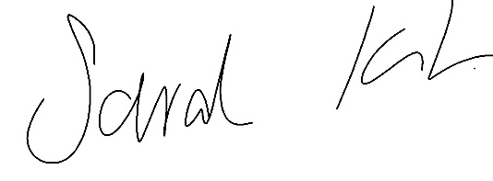
Sarah Kitchener
Clerk and RFO
Ockbrook and Borrowash Parish Council

Agenda.

Public Speaking.
A period of 30 minutes will be made available at the beginning of the meeting to hear comments from:
- Public.
- Derbyshire County Council Report.
- Erewash Borough Council Report.
- Derbyshire Constabulary Report taken from the website – see appendix 1.
- Ashbrook Trustees.
- Ashbrook Youth Group.

To Receive Apologies for Absence.

Declaration of Members Interests.
To enable members to declare the existence and nature of any personal or disclosable pecuniary interests they have in agenda items, in accordance with the Parish Councils Code of Conduct. Interests that become apparent at a later stage in the proceedings may be declared at that time.

Dispensations.
To consider any dispensation requests received.

Variation of Order of Business.

To Approve the Minutes of the Ordinary Parish Council Meeting, Held on the 5th July 2023 and the Extraordinary Meeting Held on the 26th July 2023.

Items to be Taken in Private Session.

Report of the Parish Clerk /RFO.- see appendix 2.

Report of the Chair.

Finance, HR, Contractors and General Purposes.
- Note the minutes from the committee meeting held on the 19th July 2023.
- Accept Accounts for Payment - See appendix 3.
- Accept the bank statement reconciliations – see appendix 4.
  - HSBC account, June and July 2023
  - Unity Trust account, June number2 and July 2023
- Accept the invoice and expenditure breakdown for the 1st quarter – see appendix 5.
- Consider the request from Erewash Borough Council for the Parish Council to take over the running of the public toilets in the Coop car park.
- Agree to accept the external audit – see appendix 6.
- Accept the Grievance policy – produced for the Local Council Award Scheme – see appendix 7.
- Agree to sign up to the Civility and Respect Pledge – Civility and Respect Project (nalc.gov.uk)
- Acceptance of the insurance quote – to follow.
- Agree to transferring the outstanding balance to the Ashbrook Centre trustees for the years 2018/19-2022/23, leaving Year 2023/24 still to be paid – see appendix 8.

Recreation
- Agree for the Christmas trees at the Royal Oak and the Coop to be removed by Mr Christmas tree at a cost of £75.00 per tree.

Cemeteries.

Halls.

Allotment.
- Agree to accept the new allotment tenancy agreement – see appendix 9.

Planning and Environment.
- Consider the request from the Hedgehog Highway project to purchase a box of hedgehog highway surrounds, costing £150.00 – see appendix 10.
- Consider a residents request of purchasing name plates for two twitchells in Ockbrook – see appendix 11.
- Funding is now available for the neighbourhood plan – discuss and agree as to if the Parish Council is going to continue with this project.
- Cycling survey part two – discuss and resolve to either produce a second online survey or start with a parish wide cycle ride with members of the public to get their views before producing the 2nd survey.
- Declare a climate and ecological emergency for Ockbrook and Borrowash.

Charity Accounts.
See appendix 12 for the Clerks charity report.
Agree to:
- Appoint 4 trustees for the charity accounts, recommended that the trustees are the same for all the charity accounts.
- Reinstate the charity meetings.
- Look at closing the Samual Alcock Chairty as this has a zero balance with nothing being paid into it.
- Clerk to set up separate bank accounts for the William James Charity and the Borrowash Burial Ground charity.

Correspondence Received.
Letters of correspondence – see appendix 13.

Date and Time of Next Meeting.

Exclusion of Press and Public

Appendix 1 – Police report – taken from the website.

 | May | June
Violence and Sexual Offences | 17 | 9
Anti-social behaviour | 7 | 8
Public order | 6 | 7
Burglary | 5 | 4
Criminal damage and arson | 2 | 3
Other theft | 4 | 2
Possession of a weapon | 1 | 2
Shoplifting | 1 | 0
Vehicle crime | 3 | 1
Other crime | 2

Appendix 2 – Clerks Report.
Updates on my work since Julys meeting.
Remembrance.
- The new lamppost poppies have been ordered and delivered, the application has gone into DCC for installation and has been accepted.
- The Ambassadors Showband have confirmed their attendance for the parade.
- All groups have confirmed their attendance and accepted doing the readings.
- The bagpiper has confirmed their attendance.
- GTM Traffic Management have been informed of the rolling road closure and have confirmed they will be attending, and the DCC road closure form has been received and accepted.
- The Coop Funeral Care have agreed to produce the order of service again this year, just awaiting the changes from the recreation committee to forward to them.

Christmas.
- The large Christmas trees for the Coop and the Royal Oak have been ordered, the Ashbrook Centre tree has been cancelled. Leisure lights have been informed of the above and will be using the Ashbrook lights for the Royal Oak tree going forward.
- The Long Eaton Silver Prize Band has been booked for both events.
- EBC have confirmed the Mayor will be attending Ockbrook and the Deputy Mayor will be attending Borrowash.
- St Johns Ambulance has been booked for Borrowash and will require the use of the Coop again for the event.

The Ashbrook Centre hand over.
- All groups were informed of the handover and the trustees have started producing the invoices since August.
- August payroll will be the last one the Parish Council do.
- BT - the trustees will call to transfer the account in September as the contract ends on the 27th October and if we make the change before there will be charges to pay.
- EBC Trade Waste – were unable to transfer the account so this has been cancelled from August, the trustees have been informed.
- Active Washrooms – This gets paid a year in advance in February, the trustees are awaiting the forms to complete for the change.
- The music license – another yearly bill paid in advance in October, have been informed of the changes.

Miscellaneous.
- The external audit has been completed for the first time with no amendments to be made.
- Attended the ICCM memorial testing training day – more information to follow.
- A grant of £1,500 has been received from EBC for the summer activities.
- The Local Council Award scheme new information has been forwarded to the panel.
- I have taken over the charity field work and have signed and returned the statement of truth.
- The tree surgeon has been booked into Balmoral for the 4th and 5th of September, both residents have been contacted regarding access to their gardens.
- Chasing quotes for quarterly and annual playground inspections.
- Items passed to DCC and EBC:
  - Slippy and dangerous steps from the A52 road bridge – awaiting an update.
  - Acceptance of the amenity in the highway for the Ridings planters – still outstanding.
  - Hedge outside 67 the Ridings – DCC wrote to them and will check the progress after 4 weeks.
  - Jitty by Redhill School – EBC have cut all the foliage back.
  - Trees in All Saints Church yards – will be looked at in Autumn.
  - Road markings on Victoria Avenue slip road – been chasing this since December, should be completed by October.
  - Hedge outside 3,5 and 7 Flood Street – DCC wrote to them and will check the progress in 4 weeks.
  - Jitty from Yew Tree Avenue to Top Manor Close – DCC have contacted the owner and will monitor the situation.
  - Damaged pavement on Pare Way – DCC have repaired.

Appendix 3 – September 2023 payment list – to follow.

Appendix 4 – Bank Reconciliation
June 2023 Bank Reconciliation - HSBC Account

Bank Balance | - | - | -
Bank s/m bal as at 01/04/22 | - | 14,874.50 | -
+ total cash book receipts | - | 80,000.00 | -
- total Cashbook payments | - | 24.00 | -
Cashbook Closing Balance | - | 94,850.50 | -
- | - | - | -
Bank Balance at 04/07/23 | - | 94,850.50 | -
- outstanding payments | - | 0.00 | -
+ outstanding receipts | - | 0.00 | -
Net Balance | - | 94,850.50 | -
- | - | - | -
- | - | - | Difference: 0.00

July 2023 Bank Reconciliation - HSBC Account

Bank Balance | - | - | -
Bank s/m bal as at 01/04/22 | - | 14,874.50 | -
+ total cash book receipts | - | 80,000.00 | -
- total Cashbook payments | - | 10,032.0 | -
Cashbook Closing Balance | - | 84,842.50 | -
- | - | - | -
Bank Balance at 04/08/23 | - | 84,842.50 | -
- outstanding payments | - | 0.00 | -
+ outstanding receipts | - | 0.00 | -
Net Balance | - | 84,842.50 | -
- | - | - | -
- | - | - | Difference: 0.00

June n2 2023 Bank Reconciliation - Unity Trust Account

Bank Balance | - | - | -
Bank s/m bal as at 01/04/23 | - | 20,760.24 | -
Less items related to 22/23 | - | 11,114.11 | -
- | - | 9,646.13 | -
+ total cash book receipts | - | 160,609.18 | -
- total Cashbook payments | - | 119,886.27 | -
Cashbook Closing Balance | - | 50,369.04 | -
- | - | - | -
Bank Balance at 30/06/23 | - | 58,668.38 | -
- outstanding payments | - | 8,837.00 | -
+ outstanding receipts | - | 537.66 | -
Net Balance | - | 50,369.04 | -
- | - | - | -
Balance per Cashbook | - | 50,369.04 | Difference: 0.00
- | - | - | -
Charity Accounts included in bank total: | - | - | -
William James | 1,981.09 | - | -
S Alcock | 0 | - | -
B/W Burial Ground | 65.60 | - | -

July 2023 Bank Reconciliation - Unity Trust Account

Bank Balance | - | - | -
Bank s/m bal as at 01/04/23 | - | 20,760.24 | -
Less items related to 22/23 | - | 11,114.11 | -
- | - | 9,646.13 | -
+ total cash book receipts | - | 172,897.83 | -
- total Cashbook payments | - | 127,307.46 | -
Cashbook Closing Balance | - | 55,236.50 | -
- | - | - | -
Bank Balance at 01/08/23 | - | 63,941.91 | -
- outstanding payments | - | 8,903.41 | -
+ outstanding receipts | - | 198.00 | -
Net Balance | - | 55,236.50 | -
- | - | - | -
Balance per Cashbook | - | 57,200.34 | Difference: 0.00
- | - | - | -
Charity Accounts included in bank total: | - | - | -
William James | 1981.09 | - | -
S Alcock | 0 | - | -
BW Burial Ground | 48.61 | - | -

Appendix 5 - Income and Expenditure breakdown 1st quatre
 | Budget 2023/24 | ¼ 1  Apr – Jun | Actual to date 2023/24 | Forecast to year end 2023/24 | Total forecast to year end  2023/24 | Variance to budget 2023/24 | Variance to budget 2023/24 | Notes
Income | £ | £ | £ | £ | £ | £ | % | -
Precept and Grant | 147,886 | 147,886 | 147,886 | 0 | 147,886 | 0 | 0 | -
Burials | 11,550 | 2,913 | 2,913 | 8,638 | 11,550 | 0 | 0 | -
Recreation | 2,741 | 0 | 0 | 2,741 | 2,741 | 0 | 0 | -
Hall/lettings | 18,264 | 3,518 | 3,518 | 13,824 | 17,342 | -922 | -5 | Extra bookings, class time increases and cancellations
Allotment | 3,707 | 95 | 95 | 3,612 | 3,707 | 0 | 0 | Rent comes in Dec onwards
Other | 791 | 415 | 415 | 376 | 791 | 0 | 0 | under budgeted using average figures
Ashbrook | 7,666 | 2,421 | 2,421 | 5,746 | 8,167 | 501 | 7 | Extra bookings, class time increases and cancellations
Environment/NP | 0 | 0 | 0 | 0 | 0 | 0 | 0 | -
VAT | 0 | 2,824 | 2,824 | 0 | 2,824 | 2,824 | 0 | -
Total Income | 192,605 | 160,072 | 160,072 | 34,936 | 195,008 | 2,403 | - | -
Expenditure | - | - | - | - | - | - | - | -
Parish Hall | 13,189 | 8,274 | 2,611 | 10,578 | 13,189 | 0 | 0 | -
Ashbrook | 17,116 | 1,645 | 1,645 | 15,471 | 17,116 | 0 | 0 | overbudgeted
Sal/miles/train/ chair allowance | 51,810 | 11,536 | 11,536 | 40,274 | 51,810 | 0 | 0 | -
Rec/ events | 13,716 | 546 | 546 | 13,170 | 13,716 | 0 | 0 | Spends normally later in the year
Environment | 25,298 | 3,931 | 3,931 | 21,367 | 25,298 | 0 | 0 | Over budgeted first quatre
S137/ donations | 8,000 | 1,159 | 1,159 | 6,841 | 8,000 | 0 | 0 | -
Gen/admin/bank charges/Subs/ ins/ utilities | 18,901 | 5,313 | 5,313 | 13,589 | 18,901 | 0 | 0 | -
Reserve build up | 20,000 | - | - | 20,000 | 20,000 | - | - | -
Burials | 20,782 | 3,143 | 3,143 | 17,639 | 20,782 | 0 | 0 | Over budgeted first quatre
Allotments | 3,793 | 756 | 756 | 3,037 | 3,793 | 0 | 0 | -
VAT | 0 | 2,301 | 2,301 | - | 2,301 | 2,301 | 0 | -
Total Expenditure | 192,605 | 38,604 | 32,942 | 161,964 | 194,906 | 2,301 | - | -
- | - | - | - | - | - | - | - | -
Total Income and Expenditure 2023/2024 (+surplus/-deficit) | 0 | 121,467 | 127,130 | -127,028 | 102 | 102 | - | -
Balance carried forward from 2022/2023 | 9,646 | - | - | 2022/23 | 9,646 | - | - | -
HSBC A/c 22/23 | 14,875 | - | - | - | 94,851 | - | - | -
Forecast balances as at 31st March 2024 | 24,521 | - | - | 2022/23 outturn | 104,598 |  | - | -

RESERVES | £
Ashbrook Centre | 3,355
Reserve build up | 20,000
Bi election | -663
Charity amounts | 2,030
General reserves | 79,877
- | 104,598

Appendix 6 – External Audit.
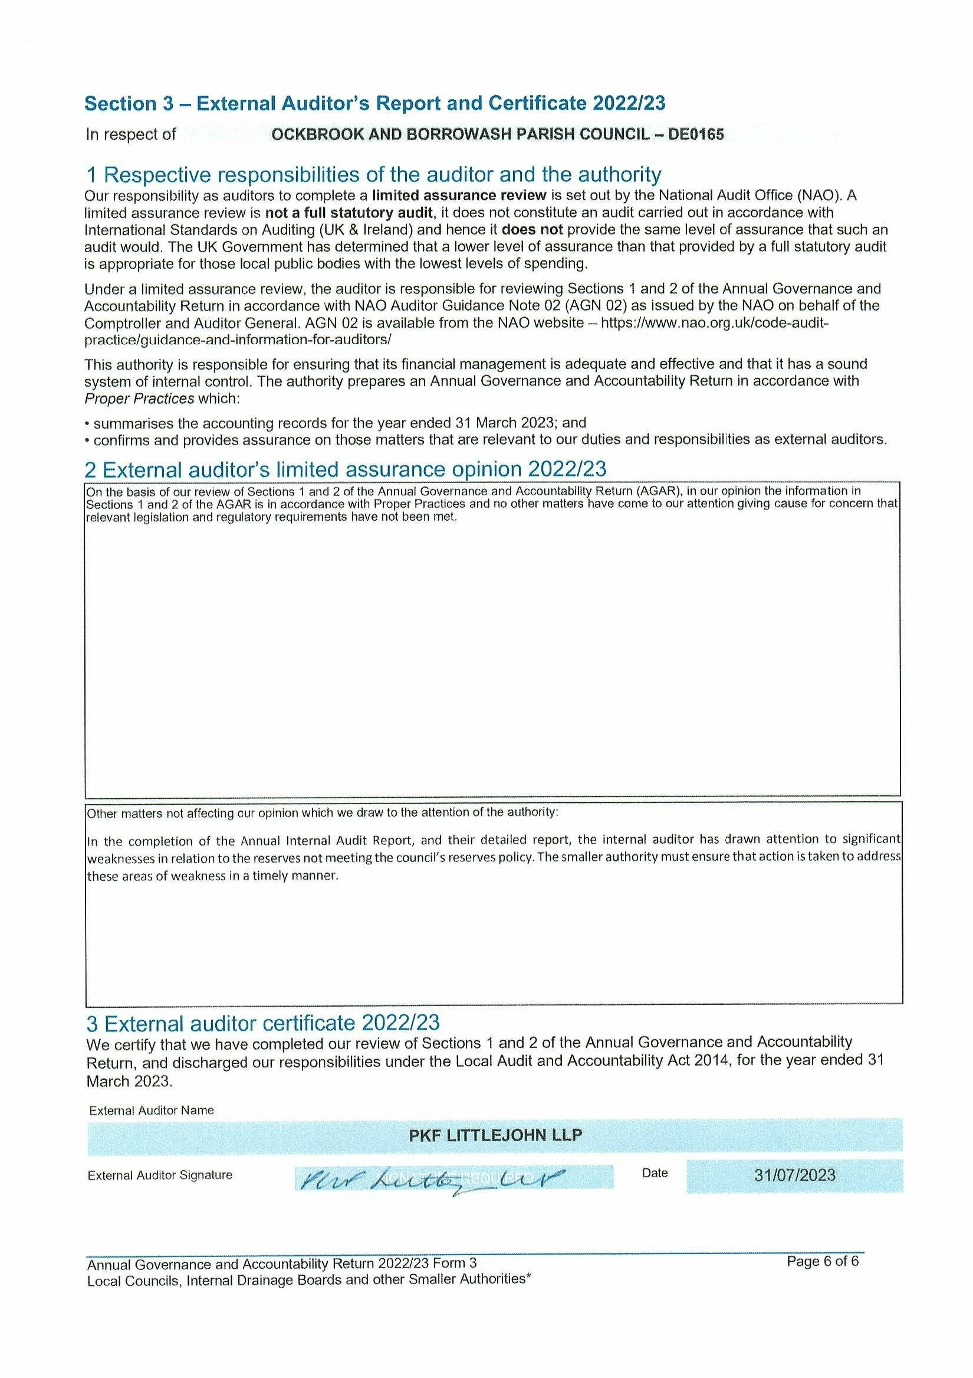

Appendix 7 – Grievance Policy.

Ockbrook and Borrowash Parish Council

GRIEVANCE POLICY.

Introduction.

This policy is based on and complies with the 2015 ACAS Code of Practice
http://www.acas.org.uk/index.aspx?articleid=2174. It also takes account of the ACAS guide on discipline and grievances at work. Disciplinary and grievance procedures | Acas. It aims to encourage and maintain good relationships between the Council and its employees by treating grievances seriously and resolving them as quickly as possible. It sets out the arrangements for employees to raise their concerns, problems or complaints about their employment with the Council. The policy will be applied fairly, consistently and in accordance with the Equality Act 2010.
Many problems can be raised and settled during the course of everyday working relationships. Employees should aim to settle most grievances informally with their line manager.
This policy confirms:
• employees have the right to be accompanied or represented at a grievance meeting or appeal by a companion who can be a workplace colleague, a trade union representative or a trade union official. The companion will be permitted to address the grievance/appeal meetings, to present the employee's case for his /her grievance/appeal and to confer with the employee. The companion cannot answer questions put to the employee, address the meeting against the employee’s wishes or prevent the employee from explaining his/her case.
• the Council will give employees reasonable notice of the date of the grievance/appeal meetings. Employees and their companions must make all reasonable efforts to attend. If the companion is not available for the proposed date of the meeting, the employee can request a postponement and can propose an alternative date that is within five working days of the original meeting date.
• any changes to specified time limits must be agreed by the employee and the Council
• an employee has the right to appeal against the decision about his/her grievance. The appeal decision is final.
• information about an employee’s grievance will be restricted to those involved in the grievance process. A record of the reason for the grievance, its outcome and action taken is confidential to the employee. The employee’s grievance records will be held by the Council in accordance with the General Data Protection Regulation (GDPR)
• recordings of the proceedings at any stage of the grievance procedure are prohibited, unless agreed as a reasonable adjustment that takes account of an employee’s medical condition
• if an employee who is already subject to a disciplinary process raises a grievance, the grievance will normally be heard after completion of the disciplinary procedure
• if a grievance is not upheld, no disciplinary action will be taken against an employee if he/she raised the grievance in good faith
• the Council may consider mediation at any stage of the grievance procedure where appropriate, (for example where there have been communication breakdowns or allegations of bullying or harassment). Mediation is a dispute resolution process which requires the Council’s and the employee’s consent.
• Employees can use all stages of the grievance procedure If the complaint is not a code of conduct complaint about a councillor. Employees can use the informal stage of the council’s grievance procedure (paragraph 4) to deal with all grievance issues, including a complaint about a councillor Employees cannot use the formal stages of the council’s grievance procedure for a code of conduct complaint about a councillor. If the complaint about the councillor is not resolved at the informal stage, the employee can contact the monitoring officer of Erewash Borough Council who will inform the employee whether or not the complaint can be dealt with under the code of conduct. If it does not concern the code of conduct, the employee can make a formal complaint under the council’s grievance procedure (see paragraph 5).
• If the grievance is a code of conduct complaint against a councillor, the employee cannot proceed with it beyond the informal stage of the council’s grievance procedure. However, whatever the complaint, the council has a duty of care to its employees. It must take all reasonable steps to ensure employees have a safe working environment, for example by undertaking risk assessments, by ensuring staff and councillors are properly trained and by protecting staff from bullying, harassment and all forms of discrimination.
• If an employee considers that the grievance concerns his or her safety within the working environment, whether or not it also concerns a complaint against a councillor, the employee should raise these safety concerns with his or her line manager at the informal stage of the grievance procedure. The council will consider whether it should take further action in this matter in accordance with any of its employment policies (for example its health and safety policy or its dignity at work policy) and in accordance with the code of conduct regime. Informal grievance procedure

Informal Grievance Procedure.
The Council and its employees benefit if grievances are resolved informally and as quickly as possible. As soon as a problem arises, the employee should raise it with his/her manager to see if an informal solution is possible. Both should try to resolve the matter at this stage. If the employee does not want to discuss the grievance with his/her manager (for example, because it concerns the manager), the employee should contact the Chair of the staffing committee or, if appropriate, another member of the staffing committee. If the employee’s complaint is about a councillor, it may be appropriate to involve that councillor at the informal stage. This will require both the employee’s and the councillor’s consent.

Formal Grievance Procedure.
If it is not possible to resolve the grievance informally and the employee’s complaint is not one that should be dealt with as a code of conduct complaint (see above), the employee may submit a formal grievance. It should be submitted in writing to the Chair of the staffing committee.
The staffing committee will appoint a sub-committee of three members to investigate the grievance. The sub-committee will appoint a Chair from one of its members. No councillor with direct involvement in the matter shall be appointed to the sub-committee.

Investigation.
The sub-committee will investigate the matter before the grievance meeting which may include interviewing others (e.g. employees, councillors or members of the public) .

Notification.
Within 10 working days of the Council receiving the employee’s grievance, the employee will be asked, in writing, to attend a grievance meeting. The subcommittee’s notice will include the following:
• the names of its Chair and other members
• a summary of the employee’s grievance based on his/her/their written submission
• the date, time and place for the meeting. The employee will be given reasonable notice of the meeting which will be within 25 working days of when the Council received the grievance.
• the employee’s right to be accompanied by a workplace colleague, a trade union representative or a trade union official
• a copy of the Council’s grievance policy
• confirmation that, if necessary, witnesses may attend (or submit witness statements) on the employee’s behalf and that the employee should provide the names of his/her witnesses at least five working days before the meeting
• confirmation that the employee will provide the Council with any supporting evidence at least five working days before the meeting.

The Grievance Meeting.
At the grievance meeting:
• the Chair will introduce the members of the sub-committee to the employee
• the employee (or companion) will set out the grievance and present the evidence
• the Chair will ask the employee what action does he/she/they want the Council to take
• any member of the sub-committee and the employee (or the companion) may question any witness
• the employee (or companion) will have the opportunity to sum up the case
• the Chair will provide the employee with the sub-committee’s decision, in writing, within five working days of the meeting. which will notify the employee of the action, if any, that the Council will take and of the employee’s right to appeal
• a grievance meeting may be adjourned to allow matters that were raised during the meeting to be investigated by the sub-committee.

The Appeal.
If an employee decides that his/her/their grievance has not been satisfactorily resolved by the sub-committee, he/she/they may submit a written appeal to the staffing committee. An appeal must be received by the Council within five working days of the employee receiving the sub-committee’s decision and must specify the grounds of appeal.
Appeals may be raised on a number of grounds, e.g.:
• a failure by the Council to follow its grievance policy
• the decision was not supported by the evidence
• the action proposed by the sub-committee was inadequate/inappropriate
• new evidence has come to light since the grievance meeting.
The appeal will be heard by a panel of three members of the HR committee who have not previously been involved in the case. There may be insufficient members of the HR committee who have not previously been involved. If so, the appeal panel will be a committee of three Council members who may include members of the HR committee. The appeal panel will appoint a Chair from one of its members.
The employee will be notified, in writing, within 10 working days of receipt of the appeal of the time, date and place of the appeal meeting. The meeting will take place within 25 working days of the Council’s receipt of the appeal. The employee will be advised that he/she/they may be accompanied by a workplace colleague, a trade union representative or a trade union official.
At the appeal meeting, the Chair will:
• introduce the panel members to the employee
• explain the purpose of the meeting, which is to hear the employee’s reasons for appealing against the decision of the staffing sub-committee
• explain the action that the appeal panel may take.
The employee (or companion) will be asked to explain the grounds of appeal.
The Chair will inform the employee that he/she/they will receive the decision and the panel’s reasons, in writing, within five working days of the appeal meeting.
The appeal panel may decide to uphold the decision of the HR committee or substitute its own decision.
The decision of the appeal panel is final.

Appendix 8 – Ashbrook financial breakdown – to follow

Appendix 9 – Allotment tenancy agreement – to follow

Appendix 10 – Hedgehog Highway Project
Firstly, thank you for taking the time to read this letter!
I am writing to all Councils, Parishes, Towns and Wards in the UK to ask them to take part in this amazing project!
With Hedgehog numbers in decline and Hedgehog awareness on the rise, there has never been a better time to get involved in Hedgehog conservation.
A Hedgehog Highway is a 5 inch gap in a fence and is essential in the battle to prevent the extinction of our endangered spiky friends. This gap allows them access to forage for food and meet mates.
Hedgehog shaped fence surrounds raise awareness to the plight of Hedgehogs, create a talking point and encourage others to take part in the project. Fence surrounds are made from recycled plastic and can themselves be recycled.
I am asking for each area of the UK to use a small portion of their assigned funds to purchase a box of hedgehog highway surrounds and make them available for their residents.
Each box of 50 is £150 and includes:
* 50 Hedgehog Highway surrounds & 50 information leaflets
*A display box & window sticker showing you are part of the project.
Ideas of how to benefit your community include:
*Donate the Highways and leaflets to your local school to educate in wildlife conservation
*Swap the Highways for a donation of Hedgehog food which can then be given to your local Hedgehog Rescue Centre
The project will be receiving a lot of publicity in the coming months via Social Media and I really hope that you choose to take part.
My dream is to make the whole of the UK one giant Hedgehog Highway and for that dream to come true, it needs EVERYONE to take part.
Money is donated to Hedgehog Conservation for every box sold too!
If you would like to order or have any questions please do not hesitate to get in touch and thank you for caring.
Linda Cook, Founder of Hedgehogs R U

Appendix 11 – residents letter
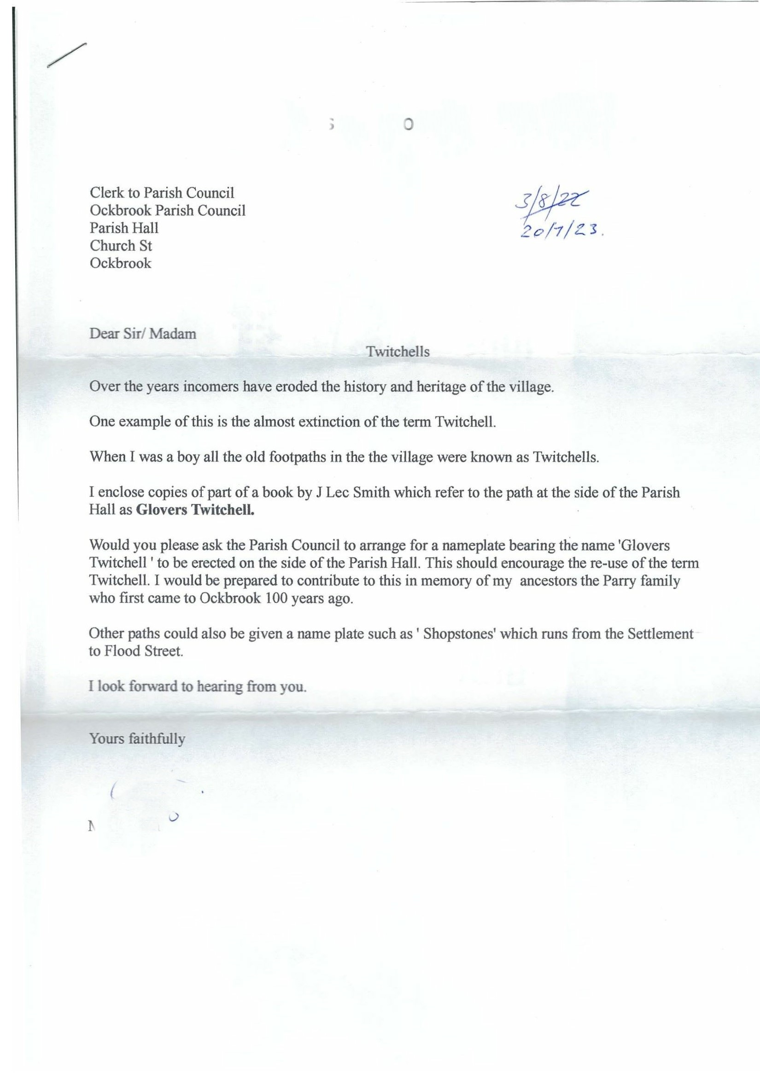

Appendix 12- Ockbrook and Borrowash Charity Report.

Introduction.
Ockbrook and Borrowash Parish Council is the sole trustee to three charities these include:
- The William James Charity for Ockbrook residents suffering hardship and distress who are in need of financial help.
- The Samual Alcock Charity for Borrowash residents in need of financial help.
- The Borrowash Burial Ground Charity for the upkeep of the cemetery.
Even though the PC is the sole trustee they are two separate entities and charity rules apply.
Charities must have their own set of accounts, therefore their own bank accounts, they also have separate meetings to the PC (which need to be minuted) and these meetings are not open to the public.

Ockbrook and Borrowash Parish Council Charity History and information.

William James Charity – governing documents found.
In 1986 the below charities were amalgamated into the William James Charity.
- Anne Potter Dole Charity
- Edward James Charity
- Ockbrook Parochial Charity
- Robert Piggin Charity

The only income for this charity is the yearly Camp Farm field rental of £150.00.
For some reason when the original bank accounts were set up they had separate accounts for Anne Potter and the Parochial charity even though they should be in the one account under William James, ACTION I have now amended that on the statement reconciliations, the new balance is £1981.09.
Governing rules –
- 4 trustees appointed by the parish council for a four-year term, these trustees do not need to be councillors.
- Each trustee must sign a declaration of acceptance.
- There must be two meetings per year, the first meeting of the year being when the chair gets appointed.
- Two trustees are needed for a meeting to be quorate.
- If a trustee is absent for all meetings in one year the PC can remove and replace them.
- The Clerks time on the charity would be classed as a grant from the PC.

The Samual Alcock Charity – governing documents found.
Since 2018 The Borrowbrook Homelink donation has come out of this charity, which now has a £0.00 balance and there is no money coming into the charity.
Governing rules –
- 5 trustees appointed by the parish council for a four-year term, these trustees do not need to be councillors.
- Each trustee must sign a declaration of acceptance.
- There must be two meetings per year, the first meeting of the year being when the chair gets appointed.
- Two trustees are needed for a meeting to be quorate.
- If a trustee is absent for all meetings in one year the PC can remove and replace them.
- The Clerks time on the charity would be classed as a grant from the PC.

The Borrowash Burial Ground Charity – governing documents missing.
This charity cannot be closed due to the asset of the cemetery and any monies spent on the cemetery has to come out of the charity account. If work is needed to be done the charity trustees will need to apply for grants/donations from organisations as well as the PC, they should not assume the PC will fund the charity.
No money is being paid into this and the balance will be £48.61 once the new lock and bolt have been taken out.
Governing rules – these are missing but looking at past minutes there were 4 trustees.

The Charity Commission.
All our charity accounts were removed from the charity commission in 2010 due to the year end accounts not being submitted. We do not need to reinstate them with the charity commission as they only want charities with an income of £5,000 a year. Even though they have been removed by the charity commission they are still active charities.

My Recommendations.
Close the Samual Alcock charity, there will be no more money coming in as this was set up following the sale of a house and all the funds have been spent.
Set up individual bank accounts for the William James charity and the Borrowash Burial Ground charity.
Appoint the trustees – I believe it should be the same trustees for all the charities, then all the meetings can be held after each other, makes it less complicated. The previous PC did vote for the burial committee to be the burial trustees but after looking into all of this I think that was wrong and if Tim joins the committee it would mean 7 trustees when they only need 4.

Appendix 13 – Correspondence list to follow.

