OCKBROOK & BORROWASH PARISH COUNCIL
The Parish Hall, Church Street, Ockbrook, Derby DE72 3SL
Tel: 01332 664100/ 07860 702904 Email: clerk@ockbrookandborrowashparishcouncil.gov.uk

December 2023 PARISH COUNCIL MEETING.

27th November 2023
To the Chair and Councillors of Ockbrook and Borrowash Parish Council,
You are summoned to attend the ordinary meeting of Ockbrook and Borrowash Parish Council on Wednesday 6th December 2023 at 19:00, to be held at the Parish Hall, Ockbrook.
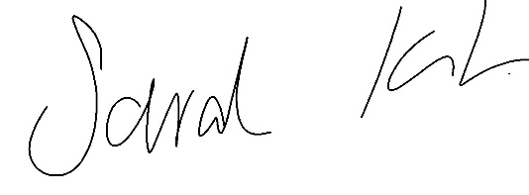
Sarah Kitchener
Clerk and RFO
Ockbrook and Borrowash Parish Council

Agenda.

Public Speaking.
A period of 30 minutes will be made available at the beginning of the meeting to hear comments from:
- Public.
- Derbyshire County Council Report.
- Erewash Borough Council Report.
- Derbyshire Constabulary Report taken from the website – See appendix 1
- Ashbrook Youth Group.

To Receive Apologies for Absence.

Declaration of Members Interests.
To enable members to declare the existence and nature of any personal or disclosable pecuniary interests they have in agenda items, in accordance with the Parish Councils Code of Conduct. Interests that become apparent at a later stage in the proceedings may be declared at that time.

Dispensations.
To consider any dispensation requests received.

Variation of Order of Business.

To Approve the Minutes of the Ordinary Parish Council Meeting, Held on the 1st November 2023.

Items to be Taken in Private Session.

Report of the Parish Clerk /RFO.- see appendix 2.

Report of the Chair.

Finance, HR, Contractors and General Purposes.
- Note the minutes from the committee meeting held on the 29th November 2023.
- Accept Accounts for Payment - See appendix 3.
- Accept the bank statement reconciliations – see appendix 4.
  - HSBC account, October 2023
  - Unity Trust account, October 2023
- Agree on the budget figures submitted by the finance committee - see appendix 5.
- Agree to allow the Clerk to make Decembers invoice payments in the month of January, to be ratified in Februarys Parish Council meeting .
- Accept Karen Howe as next year’s internal auditor.
- Consider the grant request from the Ockbrook Flood Prevention Committee, if they are unable to get a bank account would the Parish Council agree to buying the items on the application? - see appendix 6.
- Consider the request from Borrowash Youth Development – see appendix 7.
- Agree to transferring the outstanding balance to the Ashbrook Centre Trustees for financial year 2023/24 – see appendix 8.

Recreation
- Agree to split the £100 donation from the Showman’s Guild between Borrowash In Bloom, Borrowash Youth Development and the Ockash Trust.
- Agree to split the left-over selection boxes between Brair Close Care Home and Borrowbrook Homelink.

Cemeteries.
- Consider the request to plant a tree in Balmoral Road Cemetery – see appendix 9.

Halls.

Allotment.

Planning and Environment.
- Agree to accept the tree survey quote for the Parish - see appendix 10.
- Agree to accept the Climate Emergency Document - see appendix 11.

Communication.
- Agree to placing monthly adverts into the DE72 magazine.
Costings are: ¼ page no charge.
½ page for the full year, £68 per month with a 20% discount.
Full page for the full year, £119 per month with a 50% discount.
- Discuss and vote on:
- Social Media Expansion to YouTube Channel.
- CANVA video app and account.
- Discussion on other ways to engage in consultation more fully with the public.

Correspondence Received.
Letters of correspondence – see appendix 12.

Date and Time of Next Meeting.

Exclusion of Press and Public

Mince pies and refreshments will be available at the end of the meeting.

Appendix 1 – Police report – taken from the website.

 | September
Violence and Sexual Offences | 9
Public order | 3
Bicycle theft | 2
Other theft | 4

Appendix 2 – Clerks Report.
Updates since Novembers meeting:
- The extra tree works on Deans Drive and Shacklecross were completed on the 21st November.
- PAT testing for the village hall and office, gave 3 failures,
  - The laminator - a new one has been purchased.
  - One of the portable lights – now out of action.
  - Christmas tree lights adaptor – this will be fixed for next year.
- Wrote to the Planning Inspectorate regarding ERE/0323/0058, The Ridings Farm.
- Mitchell and Wilde were informed that they can now act on our behalf regarding the Borrowash public toilets.
- Erewash Brough Council have been informed of the £500 contribution that the Parish Council are willing to make towards the Borrowash public toilets, awaiting an invoice from them to be able to pay this.
- Accepted the memorial bench plinth quote - awaiting a date for installation.
- Accepted the quote for the parish hall lights – the work has been completed and they are now on a timer.
- The pay award amendment which applies to two members of staff as per their contract of employment has been implemented and back dated to April 2023.
- Informed the two carpark quoters that the Parish Council would like these to be retendered for financial year 24/25, and they will be contacted February 2024.
- DE72 magazine have sent quotes in for adverts – this is to be discussed within the communication section of this meeting.
- The allotment tenancy agreements have all be produced, thanks go to Councillor Sarah Cresswell, Julie and Dave Smith and other allotment holders for getting them distributed, saving the Parish Council the cost of postage.
- The Parish defibrillators had their quarterly check, two needed replacement battery packs which have now been replaced.
- The sandbags and sand have been delivered by Erewash Borough Council this has been advertised on Facebook.
- Started working on what needs to be done for memorial testing in Balmoral Road Cemetery and All Saints – an update will come later.
- The annual playground inspection has been completed – awaiting the report.
- Informed Zero Hour that in Novembers meeting the Parish Council unanimously agreed to support the climate and ecology bill, this has gone onto our website, Facebook and the newsletter.
- The public consultation tab and quick link is now on the website.
- The notice of conclusion of audit was removed from the 3 noticeboards, after being in place for two months.
- Finally been given the decision in principle to accept the three planters on the Ridings (this started back in February 2023). The legal team should be producing the license in the near future.
- Items passed to DCC and EBC:
  - Road marking on Victoria Avenue – been chasing this since December 2022 this should now be completed 4-7 December 2023.
  - Lifted kerb stones on Priorway Avenue – this is now showing it has been transferred to another enquiry.
  - Overgrown hedge at 67 The Ridings, they have not answered DCCs request to get the hedge trimmed, DCC have now served an enforcement action giving the resident 28 days to complete the works or DCC will do it and recharge the associated costs to them.

Appendix 3 – December 2023 Meeting Payment List.

Invoices to be paid | - | - | minute agreed
The Royal Oak | £63.50 | Flood plan meeting food | -
Ashbrook Youth Group | £200.00 | Monthly donation | 270/12/22
Computer Lifeline | £149.85 | Annual charges | -
EBC | £5579.31 | Nov payroll | -
EBC | £500.00 | Contribution to Public toilets | 205/11/23
Simply Sparkle | £15.00 | Parish windows | -
Watsonfire | £135.00 | PAT | -
GTM | £1020.00 | Road closure - Remembrance | -
Defib4life | £477.60 | Battery pack x2 | -
P Sadler | £80.00 | Interment fee Foster | -
Fox Grounds Maintenance | £888.00 | Tree works | 188/10/23
DCC | £2133.00 | Paid to us in error | -
Long Eaton Silver Prize Band | £200.00 | OB and BW light switch on | -
Lisa’s | £233.20 | Parish hall clean Nov | -
Leisurelites LTD | £930.00 | Install/removal Xmas tree lights x2 | -
Guiding Sparks Circus | £400.00 | BW light switch on entertainment | -
Wastell – plot 12a | £84.35 | Overpayment on plot – 5 yrs | -
DCC | £105.00 | The Ridings planter license | 296/02/23
Sarah Kitchener | £30.60 | Expenses - mileage | -
Fox Grounds Maintenance | £2155.99 | Nov works | -
Invoices already paid | - | - | -
Lisa’s | £334.45 | Parish Hall clean – Oct | -
Fox Grounds Maintenance | £2155.99 | Oct works | -
Monthly direct debits | - | - | -
British Gas | -£74.43 | Elec 18/09-23/10 | 26/05/23
British Gas | £66.51 | Elec 18/09-21/11 | 26/05/23
British Gas | £374.48 | Gas 27/09-01/11 | 26/05/23
British Gas | -£374.48 | Gas 27/09-01/11 | 26/05/23
British Gas | £959.47 | Gas 27/09-28/11 | 26/05/23
Virgin | £64.80 | Broadband and phone Nov/Dec | 26/05/23
O2 | £33.58 | Mobile Nov | 26/05/23
Lloyds Bank | £676.70 | Plastic gloves / diary / poster/cable ties/Xmas chocs | 26/05/23
EBC | £21.00 | Cem rates Nov | 26/05/23
Everflow | £101.53 | Water Dec | 26/05/23

Appendix 4 – Bank Reconciliation
October 2023 Bank Reconciliation - HSBC Account

Bank Balance | - | - | -
Bank s/m bal as at 01/04/22 | - | 14,874.50 | -
+ total cash book receipts | - | 80,000.00 | -
- total Cashbook payments | - | 40,056.00 | -
Cashbook Closing Balance | - | 54,818.50 | -
- | - | - | -
Bank Balance at 04/11/23 | - | 54,818.50 | -
- outstanding payments | - | 0.00 | -
+ outstanding receipts | - | 0.00 | -
Net Balance | - | 54,818.50 | -
- | - | - | -
- | - | - | Difference: 0.00

October 2023 Bank Reconciliation - Unity Trust Account

Bank Balance | - | - | -
Bank s/m bal as at 01/04/23 | - | 20,760.24 | -
Less items related to 22/23 | - | 11,114.11 | -
- | - | 9,646.13 | -
+ total cash book receipts | - | 216,157.17 | -
- total Cashbook payments | - | 174,024.64 | -
Cashbook Closing Balance | - | 51,778.66 | -
- | - | - | -
Bank Balance at 01/11/23 | - | 61,387.92 | -
- outstanding payments | - | 10,226.76 | -
+ outstanding receipts | - | 617.50 | -
Net Balance | - | 51,778.66 | -
- | - | - | -
Balance per Cashbook | - | 51,778.66 | Difference: 0.00
Notes | - | Difference | -
- | - | - | Difference 0.00
- | - | - | -
Charity Accounts included in bank total: | - | - | -
William James | 1,981.09 | - | -
S Alcock | 0 | - | -
B/W Burial Ground | 48.61 | - | -

Appendix 5 – Proposed Budget.

- | - | Actual | Actual | Actual | Budget | Actual | Budget | Actual | Budget | Actual | Budget | Actual | Budget | expected forecast | Proposed Budget | Proposed Budget | Proposed Budget
- | - | 2016/ 17 | 2017/ 18 | 2018/ 19 | 2019/ 20 | 2019 / 20 | 2020/ 21 | 2020/ 21 | 2021/ 22 | 2021/ 22 | 2022/ 23 | 2022/ 23 | 2023/ 24 | 2023/24 | 2024/25 | 2025/26 | 2026/27
Income | - | £ | £ | £ | £ | £ | £ | £ | £ | £ | £ | £ | £ | £ | £ | £ | £
- | Precept | 102375 | 100991 | 87730 | 111462 | 87730 | 111462 | 87730 | 88168 | 88168 | 91695 | 91695 | 126527 | 126527 | 137341 | - | -
- | Environment | - | - | 6386 | - | 770 | - | - | - | 600 | 2000 | 800 | - | 0 | 0 | 0 | 0
- | burials | 12235 | 7543 | 20930 | 11868 | 10911 | 11610 | 9955 | 12000 | 17190 | 10500 | 8300 | 11550 | 11550 | 11985 | 11985 | 11985
- | recreation | 13590 | 6363 | 5305 | 5388 | 4376 | 7046 | 2705 | 3800 | 2519 | 2818 | 4104 | 2741 | 2741 | 2605 | 2605 | 2605
- | hall/lettings | 5622 | 5893 | 8150 | 8568 | 7332 | 8143 | 2102 | 11000 | 7469 | 11080 | 11884 | 18264 | 14503 | 14337 | 14337 | 14337
- | allotment | 3205 | 3373 | 3368 | 3870 | 3666 | 3814 | 3797 | 3700 | 3628 | 3797 | 3803 | 3707 | 3707 | 4088 | 4088 | 4088
- | Other | 22014 | 17705 | 12682 | 34122 | 800 | 10373 | 279 | 13000 | 469 | 11692 | 1396 | 791 | 791 | 575 | 575 | 575
- | Ashbrook | - | - | - | - | - | - | 160 | 16290 | 12689 | 12228 | 8770 | 7666 | 2820 | 0 | 0 | 0
- | Concurrent Functions | - | - | 24981 | - | 23732 | - | 23732 | 23732 | 23732 | 23732 | 23732 | 21359 | 21359 | 2000 | 0 | 0
- | VAT | 7701 | 11435 | 14996 | - | 3801 | - | 4227 | - | 13434 | - | 16505 | - | 2824 | - | - | -
 | Total Income | 166742 | 153303 | 184528 | 175278 | 143118 | 152448 | 134688 | 171690 | 169898 | 169542 | 170989 | 192605 | 186822 | 172931 | 33590 | 33590
spends | - | - | - | - | - | - | - | - | - | - | - | - | - | - | - | - | -
- | Parish Hall | 3655 | 17830 | 14408 | 15016 | 10961 | 13948 | 21946 | 15000 | 19765 | 11665 | 9823 | 13189 | 13189 | 15824 | 14901 | 16600
- | Ashbrook | - | - | 12058 | 20000 | 10430 | 25061 | 9786 | 15000 | 20980 | 11081 | 12981 | 17116 | 2390 | 0 | 0 | 0
- | Salaries/ mileage/ training/ chair allowance | 60168 | 47743 | 33722 | 55363 | 24592 | 23222 | 37266 | 33000 | 48933 | 42302 | 50078 | 51810 | 51810 | 50884 | 52839 | 54873
- | Recreation Events | 19091 | 24715 | 11927 | 14240 | 8897 | 11462 | 6575 | 16190 | 28803 | 14132 | 59165 | 13716 | 13716 | 11117 | 11531 | 11962
- | Environment and NP | 8506 | 24108 | 27784 | 20000 | 27639 | 27769 | 28152 | 33000 | 24245 | 36055 | 20060 | 25298 | 25298 | 12321 | 11576 | 11996
- | Grants | 8870 | 3750 | 1200 | - | 1775 | 5000 | 1618 | 5000 | 9168 | 5000 | 10140 | 8000 | 8000 | 8000 | 8000 | 8000
- | General/admin/ bank charges/ subs/insurance / utilities | 51378 | 47512 | 18652 | 33403 | 21278 | 32050 | 11355 | 36000 | 13038 | 30936 | 10371 | 18901 | 18901 | 22466 | 22084 | 22740
- | Burials | 8754 | 11044 | 20766 | 14108 | 18150 | 11571 | 17653 | 16000 | 16133 | 16203 | 16138 | 20782 | 20782 | 21048 | 21176 | 22409
- | Allotments | 157 | 3282 | 5231 | 3148 | 941 | 2365 | 1719 | 2500 | 4003 | 2168 | 4530 | 3793 | 4996 | 6750 | 7166 | 7631
- | Reserve Build up | - | - | - | - | - | - | - | - | - | - | - | 20000 | 20000 | 20000 | 20000 | -
- | VAT | 11435 | 11755 | 5854 | - | 3733 | - | 8565 | - | 12085 | - | 14182 | - | 3396 | - | - | -
Total spends | - | 172015 | 191740 | 151602 | 175278 | 128397 | 152448 | 144636 | 171690 | 197154 | 169542 | 207468 | 192605 | 182478 | 168409 | 169275 | 156212
- | - | - | - | - | - | - | - | - | - | - | - | - | - | - | - | - | -
Total Income and spends | - | -5272 | -38437 | 32926 | - | 14721 | - | -9948 | - | -27256 | - | -36479 | 0 | 4344 | 4522 | -135685 | -122622
- | - | - | - | - | - | - | - | - | - | - | - | - | - | - | - | - | -
Reserve carried forward | - | - | - | - | - | 83484 | - | 98205 | - | 88257 | - | 61000 | - | 24521 | 28865 | - | -
- | - | - | - | - | - | - | - | - | - | - | - | - | - | - | - | -
Reserve | - | - | - | - | - | 98205 | - | 88257 | - | 61000 | - | 24521 | - | 28865 | 33388 | - | -

Precept Calculation
 | Budgeted Income | Budgeted Expenditure | Net
Parish Hall | 14337 | 15824 | 1486
Ashbrook | 0 | 0 | 0
Salaries/mileage/training/chair | 0 | 50884 | 50884
Recreation/ events | 2605 | 11117 | 8512
Environment and neighbourhood plan | 0 | 12321 | 12321
Toilets – note 1 |  | 6522 | 6522
reserve build up | 0 | 20000 | 20000
Concurrent functions – note 2 | 2000 | 0 | -2000
Donations | 0 | 8000 | 8000
General/admin/bank charges/ subscriptions/utilities/ other | 575 | 22466 | 21891
Burials | 11985 | 21048 | 9063
Allotment | 4088 | 6750 | 2662
 |  |  | 0
 | 35590 | 174931 | 139341 | precept required

Notes
Note 1. Figures from EBC £3222 for running costs and £2400 cleaning/opening and closing + £900 solicitor fee.
Note 2. Figure received from EBC.

Appendix 6 - Grant request from Ockbrook Flood Prevention Team.
 | Name and address of organisation |  | Ockbrook Flood Prevention Committee
 | Contact name. role of contact. |  | Chair
 | Telephone number of contact Email address of contact
 | Is the organisation a registered charity? |  | No
 | Aims and objectives of your organisation. What does your organisation do and how does it benefit the residents of Ockbrook and Borrowash? |  | To devise and implement a short-term flood reaction/protection plan.  To devise and implement a strategic flood protection plan.
 | Amount of Grant requested.  Please make sure you give a full breakdown of what the funding will be spent on |  | £378.91  3 x Flood Road Closure Signs £94.47 16 x Traffic Cones £103.84  Delivery £69.96  25 x Broom Handles £110.64
 |  | Note prices may vary depending on when orders are actually placed. Copies of suggested orders for attached.
For what purpose or project is the grant required for? |  | When Cole Lane and Collier Lane flood in the future the signs and traffic cones will be used to restrict vehicular access for the driver’s safety and to stop any bow way created by cars driving through the flood water flooding homes.  The broom handles will be placed into road gullies before they become covered by the flood water so the gullies can easily be located so they can be kept clear of debris.
What will be the total cost of the above project? |  | £378.91
If the total cost of the project is more than the grant, how will the residue be financed? |  | N/A
Have you applied for a grant for the same project to another organisation?  If so. Which organisation and how much |  | No  N/A
How is your organisation normally funded? |  | This committee was only formed on Friday 3rd November and currently has no funding.
Who will benefit from the project? |  | The residents for Cole Lane and Collier Lane at risk of flooding.
Approximately how many of those who will benefit are parishioners? |  | All those who benefit are parishioners
Signed  Dated |  | 26th November 2023
You may use a separate sheet of paper to submit any other information which you feel will support this application.

Please give us details of the bank account that the grant should be paid into if approved.
Name of Account To Follow (The Committee first meets
on Monday 27th November and will decide if an account should be set up).
Account number ……………………………………………..
Sort Code …… - …… - ……

Please ensure the following supporting documentation accompanies your application;
- Your most recent bank account statement & details of any other investments/savings;
- Details of your organisation’s officers;
- Any other documentation you feel may help in assessing your application.

7. Privacy Notice
In accordance with the General Data Protection Regulation (GDPR), I agree that Ockbrook and Borrowash Parish Council will process and hold personal information about me only in relation to my grant application. I consent to my personal information, including that contained in this form, being stored manually and/or electronically. It will be held securely and treated confidentially for 6 years after an application is made. I understand that it will only be accessed by authorised staff members to manage the grant application process.

I also understand that Ockbrook and Borrowash Parish Council may pass details onto official organisations where required to do so by law or contract. I understand that my data will be disposed of securely 6 years after the application and that I have the right to correct the information at any time. I have been made aware of my rights under GDPR.

Declaration: I/we declare that the information confirmed in this application is correct and that any grant received will be applied as detailed in the request. Signed

Date 26th November 2023

Signs and Cones https://streetsolutionsuk.co.uk
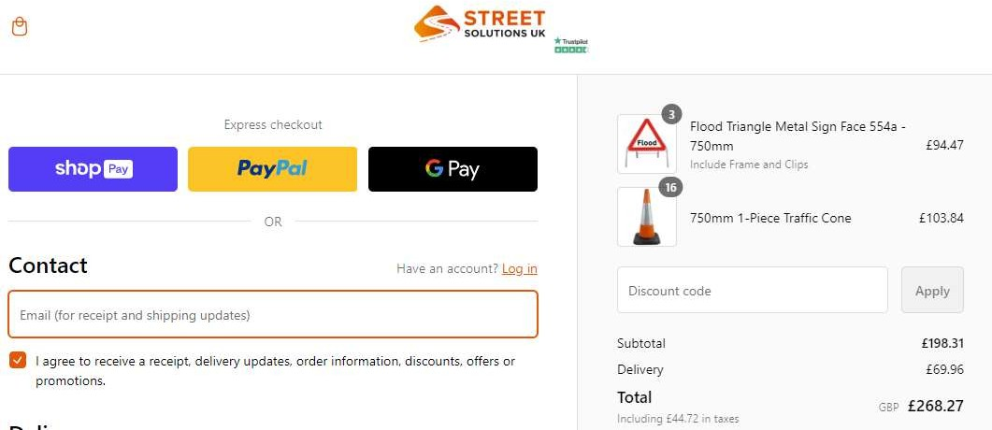

Broom Handles https://www.getools.co.uk/cart/
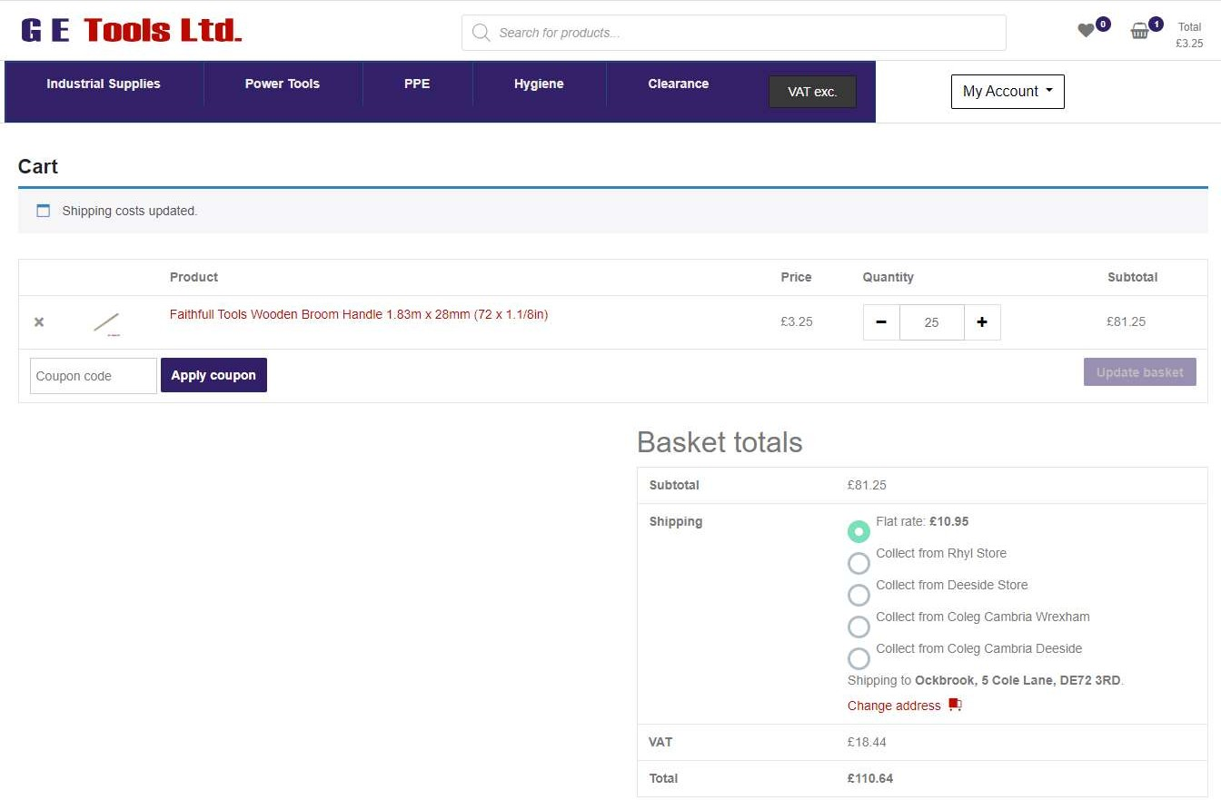

Appendix 7 – Borrowash Youth Development Request.
Dear Ockbrook & Borrowash Parish council
I am writing to ask you for assistance. As you are aware I have been marking out pitches on Borrowash park deans drive side for our teams / development groups to play on.
We have been unable to get back on our u8s pitch / u9s pitch for well over a month now since the first flood. Both pitches have never dried out and are holding water in puddles / dips and is boggy all over. As much as I have tried different methods to help like forking the puddles, leaf blowing them and even putting sand in to try and help. Unfortunately nothing has worked. I have to still paint the 3 pitches and training shapes every 2 weeks, so we don’t lose the lines whether we play on them or not.
We have had to reverse some of our matches to the oppositions ground and we have also had to hire other pitches to keep us going. We brought some portable floodlights to help keep the cost down for all the groups but at the moment we can’t fit all our groups on the park as there is not enough dry grass for all of them. We have had to move the u8s training and all of our development groups onto the muga so we don’t have to cancel the sessions.
As much as i am willing to put all the free hours in this is just something I can’t do on my own or self-fund. Me and my wife do everything for the club, but we have a young family and a business to run as well.
We have over 50 active kids in our football club with the development group and 2 football teams and I hate having to take them out of our community.
As a community I feel we are way behind our surrounding villages with sports facilities for our youth and need to start taking advantage of sport grants like the other villages do. We had more back when I was a kid growing up in Borrowash.
I feel the deans drive side needs levelling out better to get rid of all the dips and also I believe the drainage needs redoing. I was told the drainage was done a few years ago but it doesn’t drain away. I will attach a link at the bottom of the page to just one of many grant websites. I am happy to assist on behalf of our local football club if needed.
With our side of the park failing, I looked at the other local playing areas in our community to see if we could possibly move. Unfortunately, we can’t.
Ockbrook park – too much of a slope, boggy and nowhere to park.
Borrowash park Kimberly roadside – Erewash own that side and after getting in touch with the lady who takes the bookings unfortunately it is rented out to another team not from our community. We have never seen them training or playing a match, but it does get marked out.
Derwent meadow playing fields Borrowash – Erewash own the pitch and the changing rooms, after contacting the lady that rents it out we were turned down as another team rents it not from our community, I have heard that the club that rent it have got a 25 year lease on it. Whether that is true I don’t know, but if that is correct it is shocking that a club that’s not from our community can take away the option or opportunity to ever play on our communities best footballing asset. The pitch and changing rooms were built for us locals to play on. It was the home of our Borrowash UTD and last community team.

We aim to bring through new teams, add different ages to the development groups each year and hopefully build something to last this time. We are going great, and I couldn’t be prouder but we can’t do everything and need a little help.

I Look forward to hearing from you.
Many Thanks
Borrowash Youth FC
Grant Links
Football foundation - https://footballfoundation.org.uk/looking-for-funding
Derby FA grants - https://www.derbyshirefa.com/leagues-and-clubs/finance/grants-and-funding

Appendix 8 – Ashbrook Financial Breakdown 2018-2023.
- | 2018/19 | 2019/20 | 2020/21 | 2021/22 | 2022/23 | 2023/24 | -
b/f | 0 | -2058 | -2488.38 | -3700.56 | 4454.81 | 0 | -
OBPC grant | 10,000 | 10,000 | 10,000 | 10,000 | 10,000 | 5, 000 | -
Receipts | 0 | 0 | 160 | 12,689 | 87,69.94 | 2,820.46 | Up to 31/07/23
Payments | 12,058 | 10,430.38 | 11,372.18 | 14,533.63 | 13,643.28 | 2,425.90 | Up to 03/10/23
Yr end | -2,058 | -2,488.38 | -3,700.56 | 4,454.81 | 9,581.47 | 5,394.56
Paid to trustees 15/09/23 | - | - | - | - | -9,581.47 | - | -
c/f | - | - | - | - | 0 | - | -

Appendix 9 – Tree Request- photographs for the requested position will be available at the meeting.
With reference to our telephone conversation, could you please ask the committee if it would be possible to plant a tree in memory of my husband James Lidington who passed away on 26/06/23.

Please find details below:

If possible, we would like to plant a tree in line with the bench and trees already at the cemetery and in parallel with the headstone of Timothy Spencer Harrington. Please see the attached photos for reference. I am standing in the position we would like to plant the tree.

We would like to plant one of the following if possible please: Yew, Oak, Beach, Ash, or Sweet Chestnut tree - whichever the committee would prefer.

My family and I would also love to plant the tree on my Husband’s birthday, 19th March, if possible please, along with a small plaque with his name on it at the tree’s roots.

Thank You in advance. I look forward to hearing from you.

With Kind Regards,

Appendix 10 – Tree Survey Quotes.

Quote 1 – £2004.00 inc VAT

Quote 2 - £895.00

Quote 3- £1400.00

Appendix 11- Ockbrook & Borrowash Climate Change Strategy 2023-2024
As you know back in September, we voted to declare a Climate Emergency, being the first government body in Derbyshire to do so. Now Erewash Borough Council has done the same and other Parish Councils are doing so as well. Now, we need to think of how we enact measures PC wide to track, mitigate and preferably help our local environment.

I would predict that the first steps we take will be the smallest steps. This will get us use to the idea of new ways we will be doing things and then followed by a bedding-in period after which we can move forward in our overall strategy. I would also envision that our overall strategy would be in three phases. Of course, this is not written in stone and is up to the full PC to create, approve and implement. What I offer here is just a starting point.

Some things to consider when putting our strategy together are:
- Consistent in approach across all levels of government
- Acknowledge other work streams.
- Overlap with other work streams and gain knowledge and understanding of those activities and their impact.

If we keep the above in mind when planning, we will be:
- Better sighted on what the future will be based on.
- Aware of current trends and their implications on the future.

With the above said, it is important to know the sea of change that is happening government-wise with the introduction of the Devolved Government (previously known as Combined Authority) and elected super mayor. Here is how the flow of information is going to go in future.

Central Government then audits and scrutinises
everything and provides funding for what needs
to be done. This funding goes directly to Devolved
Government who then disperses it lower down.

Environmental Agency then takes all Midlands
plans and recommends to Central Government
the best solutions and funding as to fulfilling
the plans of the many.

Devolved Government takes both county plans and
draws up a wholistic plan for the devolved area.
This is fed to the Environmental Agency.

DCC takes all borough, district and town plans and
draws up a county strategy. This is then fed to the
Devolved Government

EBC takes all PC plans and draws up borough-wide
strategy. Feeds this to DCC

Parish Council feeds info and plan to EBC.
This is the route things will take in future when funding environmental projects. As you can see, we are just one piece of a bigger puzzle. The hope is that all the pieces come together slowly but in sync where projects are not doubling up or harming another project. Also, it is hoped because a holistic view is achieved, solutions will be targeted that will work for everyone.

TO DISCUSS AND AGREE AT PC MEETING

Public Consultation
- Initially agree to set up public consultation dates and venues on social media channels and DE72 Magazine.
- Talk to public and get their viewpoints on environmental concerns within the Parish and how we as a Council can work in a more environmentally friendly way.
- Put an online survey on our website.

Public /PC Working Group
Out of the initial consultation we then set up a working group of Parish residents and PC members. They would meet to discuss best way forward in planning to resolve environmental concerns within the Parish.

Below are examples of what other authorities are doing. You can see the main themes in policy are:
- Carbon Reduction Planning
- Net Zero Strategy
These would be a MEDIUM TERM goal and also ongoing throughout time.

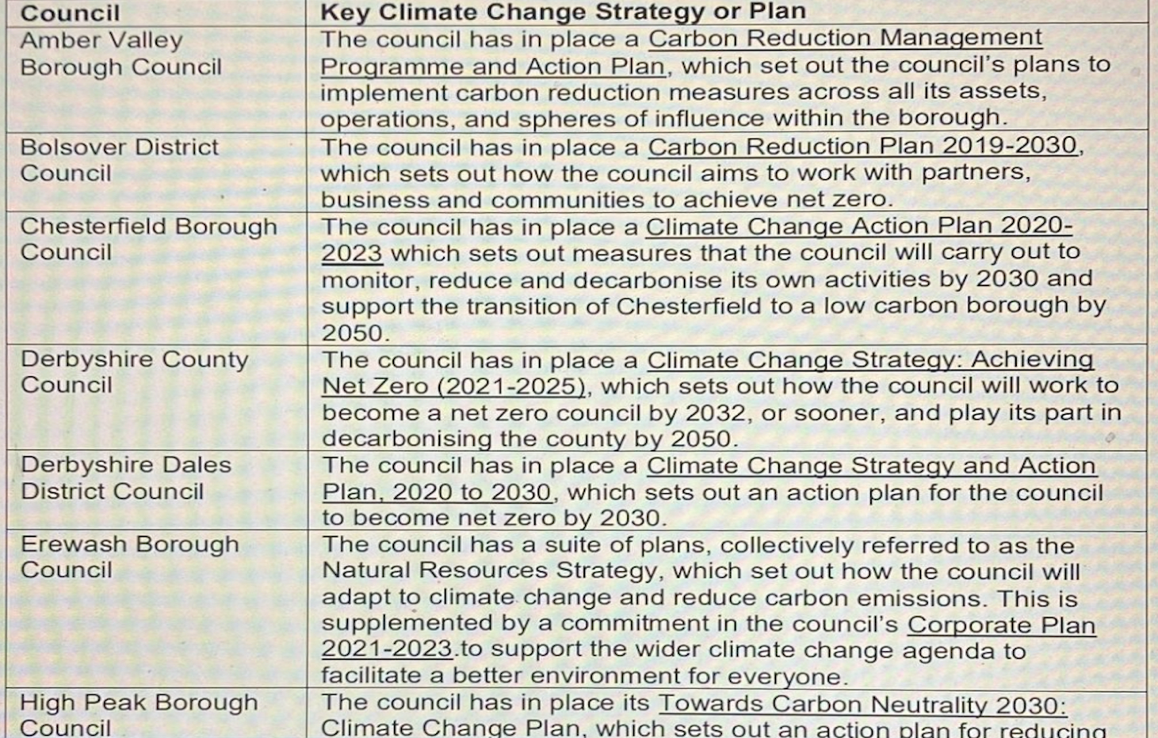

Small Steps We Can Take Now For Financial Year 25/26.
- Digital replacing paper for councillors.
- Lighting In PC Buildings
- Carbon Literacy Training
- Tree Planting
- Green Energy Used by PC
- Incorporate Carbon and Climate Impact Assessment on All PC Council Matters
Here is a Carbon Impact Assessment sheet with guidance notes. It is quite easy to fill out and can be digital based so we all can access it at any time. It would be a great way to collect data, analyse the data and come up with plans that support the environment when we want to do certain PC activities.
Guidance for climate and ecological impacts reporting
All officers should now complete the below question in council reports.
CLIMATE AND ECOLOGICAL IMPLICATIONS
(Pick an option for 7.1, if required see report guidelines to fill out table below, move the ‘x’ in the left-hand column to the relevant impact)
7.1 ‘This report is administrative and does not have any known direct Climate and Ecological impact (e.g. policy review)’
Or
‘Does the proposal/project/activity affect the environment in any of the following ways? Fill out table and mitigation question’ Add explanatory text as required in the table below
Type of impact |  | Long lasting positive impact | Short term or limited positive impact | No known impact | Short term or limited negative impact | Long lasting negative impact
Land use | x
Soil and waterbody health | x
Biodiversity | x
Greenhouse gas emissions | x
Water resources | x
Pollution | x
Air quality | x
Materials economy | x
Climate change adaptation | x

If the proposal will have a negative impact, can this mitigated and if so how?
Guide to climate and ecological impacts tableThe impact levels are as follows:
Long Lasting or Extensive Positive Impact – will the impacts of this decision have a large scale, long term effect? This might include projects affecting thousands of people or large areas in the town being affected.
Short Term or Limited Positive Impact – This is positive but could be limited in its effects or one with a short lifespan. This might include an engagement event or a small-scale energy efficiency improvement project.
No impact or Neutral Impact – Will not affect any discernible positive or negative change
Short Term or Limited Negative Impact – these are negative impacts but may be short term, such as with construction work using fossil fuel powered machinery, or small scale but longer-lasting, say resulting from the loss of a few trees.
Long Lasting or Severe Negative Impact – These are actions we most want to avoid, where there will be a long lasting, measurable effect. This might include large scale projects or policy changes. These impacts should receive the most attention in terms of potential mitigation efforts.
When considering the impact you should also consider direct and indirect impacts. For example, whilst organising an event might not involve a direct increase in carbon emissions, if it is held at a location without public transport it will still lead to higher carbon emissions as a consequence of visitors having no option but to drive.
Environmental Sections
Land Use:
This would include any change in the use of land. Categories of land include;
- Built on, meaning urban environments with human-made structures including housing, businesses, organisations and industrial sites.
- Farmland, which may be mainly empty of structures but still managed by human activities and impacted by the use of agricultural chemicals.
- Natural, meaning land that is inhabited only by plants or wildlife and sees minimal or seasonal management.
- Green urban, meaning green spaces within a settlement that is managed for human activities e.g. parks and cemeteries.
Any changes would need to be considered. A move towards more developed land would be considered negative whereas an increase in natural land would be positive. Any change of use of derelict developed land into it being reused could also be considered a positive impact and vice versa. Questions to ask:
Will this project increase or decrease the amount of natural land or green urban space?
Will this project improve derelict urban land and reuse redundant buildings?
Does this project make the most use of existing building space e.g. co-locating services; bringing under-used space into use; using buildings out-of-hours?
Soil Health:
Soil is a living system made up of insects, micro-organisms, plants and animals. Healthy soil provides the foundation for all life on earth, including us. It maintains water and air quality, it sustains plants, wildlife and crops and sequesters carbon. Its importance cannot be overstated.
Soil health is affected by land use change (concreting over it would be negative), chemicals especially agricultural chemicals like pesticides which cause significant damage. It can also be affected by flooding and erosion from rainwater, agricultural run-off or pollution from sewerage, other chemicals and plastics.
Biodiversity:
This is the huge range of life and species on earth including plants, animals, birds, insects, aquatic life and micro-organisms, all of which we need for clean water, air and food. As a general principle, the greater the number of different habitats, the greater number of species – that’s the diversity part – and the stronger and healthier and more resilient an eco-system is.
Factors that affect biodiversity include land use change, pollution of the natural environment, habitat damage including loss of green corridors or removal of plant life, excess noise and light, invasive species or species migration as an effect of global warming or loss of habitat elsewhere.
Ways to increase biodiversity include increasing the number or size of habitats, connecting existing habitats e.g. with green corridors which makes the wildlife there more resilient and gives them space to expand, and enhancing the habitat e.g. adding trees, hedgerows, wildflower areas and ponds to urban green spaces.
Will this project increase or decrease the amount of habitats for biodiversity?
Will this project degrade or improve existing habitats?
Will this project affect existing habitats through changes in the levels of noise, pollution, proximity to people or other factors that might cause problems?
Will this project increase or decrease the risk of invasive species?
Greenhouse Gas Emissions:
This refers to any direct or indirect impacts of the project that may increase or decrease net greenhouse gas emissions such as burning gas and oil for transport, machinery and heating as well as sequestering carbon through tree planting. Questions to ask:
Will this project create an ongoing increase or decrease in greenhouse gas emissions, e.g. an increase in emissions from heating using a gas boilers or retrofitting council buildings to reduce energy use?
Will this project use fossil fuel vehicles/machinery? (this could be an opportunity at the start of a project to ask a supplier if they can use any electric vehicles for the project)
Will this project actively sequester carbon from the atmosphere, e.g. by planting trees, hedges, or wildflower areas?
Waterbody heath and water resources:
Waterbodies include rivers, canals, ponds and wetlands and are essential habitats for a wide range of wildlife. Waterbody health can be affected by industrial pollutants, agricultural run-off, sewerage overflows, plastics, household chemicals and drought.
Water resources includes sewerage systems and ground and surface water aquifers. Treating waste-water and providing clean drinking water already requires immense amounts of energy and the changing climate will put additional pressure on our water resources. Questions to ask:
Will this project affect the health of any water bodies?
Will this project affect our demand on water resources or the amount of water needed to be treated as sewage?
Chemical and plastic pollution:
This category would include chemical pollutants, plastics and litter but not air pollution which is a separate category.
Plastic is made from fossil fuels like gas and oil. The most toxic chemicals are used in their production as well as all the energy involved in their manufacture. Most plastic is single use packaging which breaks down into microplastics and absorbs chemical pollutants. These pieces of plastic contaminate our waterways and soil, the food we eat and the water we drink. They last for many hundreds of years.
Less than 10 % of everyday plastics gets recycled in the UK. The problem isn’t that people aren’t recycling enough. The problem is that there is still far too much throwaway plastic being produced. Questions to ask:
Will this project lead to an increase or decrease in the level of pollutants in the environment (excluding air pollution)?
Will these pollutants be long or short lived?
Air Quality:
Air quality is affected by harmful substances both indoors and outdoors. The World Health Organisation produces guidelines on the safe levels of fine particulates, nitrogen dioxide, sulphur dioxide, carbon monoxide and ozone. They also cover indoor mould, dampness, emissions of gases and chemicals from furnishings and building materials, emissions from cooking and heating stoves and clean fuel use. Air pollution is linked to around 40,000 deaths in the UK each year with vehicle emissions as one of the main sources. Questions to ask:
Will this project lead to any temporary or permanent changes to the amount and length of fossil fuel car journeys?
Will this project increase or decrease the production or use of pollutants?
Will this project improve air quality e.g. by planting trees?
Materials Economy:
Our planet is a limited resource and is currently being over-exploited. This category is about the stuff that we use and our aim to move to a circular economy – where materials are kept in circulation as long as possible to minimise use of unsustainable materials which harm the environment and reduce carbon emissions from manufacturing and shipping. This includes waste, repair, reuse, refurbishment, recycling and the use of sustainable materials. It would also include the repurposing of structures, buildings and infrastructure rather than their replacement.
Will this project increase waste and unsustainable consumption? E.g. using more plastic
Will this project support a more circular economy in Chippenham?
Climate Change Adaptation:
This last category is about preparing for the future and how we can make our organisation and our town resilient to the effects of the climate crisis. This includes but is not limited to increased risk of flooding, drought and wildfires, extreme weather events and species migration. Some actions may make us more vulnerable to these issues whereas other may make us more resilient or help mitigate their effects. Questions to ask:
Will the project increase or decrease vulnerability to extreme weather e.g. incorporating permeable surfacing, green roofs and living walls, Sustainable Drainage Systems and rain gardens into new building works to reduce flood risks?
Has the project considered its own resilience to extreme weather e.g. during a summer event how would visitors stay safe in extreme heat?

Larger Steps for The Future
- Solar Panels on Parish Hall, Public Toilets or Other Options for Power
- Secure funding from Gov Schemes, City of Nottingham administered grant programme, EMA Funding, Devolution Funding,

CONCLUSION
As was said in the beginning, declaring a climate emergency was done with a unanimous vote. Now, as a Parish Council we need to start moving in the direction we voted for. It won’t be easy, and it will take some time to do. This is only a starting point.
Someone will have to lead on this and if no one is interested I will be more than happy to take on the role. But please if you want to lead then I welcome that.

RESOLUTION
I hope we can vote this whole package through for actioning on the proviso that it is a fluid project and document and things can change. If we can’t agree to vote the whole package through then I hope we can vote singular items through for actioning.

Appendix 12 – CORRESPONDENCE RECEIVED- Up To 30/11/23.
Emails/letters received from members of public:
- Questioning if Borrowash Tennis Club have been given permission to use temporary floodlights – informed them that the original application to install floodlights was withdrawn and they would need to contact EBC for more information. (1)
- Request for the MUGA at the Ashbrook Centre to be opened on a Sunday – forwarded the trustees contact details. (2)
- Request for contact details of an Ashbrook Trustees to be removed from the website – actioned. (3)
- Request for the name of who I sent the complaint regarding the 9 and 9a bus to within DCC and a copy of their complaint they sent to DCC – forwarded the email address I was told to use. (4)
- Copied into an objection regarding ERE/0323/0058. (5)
- Complaint regarding being locked in the cemetery – apologised and spoke to the person locking up, reminding them to walk around the whole of the cemetery before locking the gates. (6)
- Copied into a complaint to EBC regarding land being moved to green belt status. (7)
- Request for information on the logging company on Brook Road – unable to help as have no information on the business. (8)
- Request for the new contractor to forward photos of their work to be attached to their invoices and confirmation of their costs for extra works – responded that some photos are being supplied and confirmed their extra day rate. (9)
- Complaint regarding the Remembrance Service organised by the Parish Council and not lowing the flag to half-mast on the day of Mike Wallis’ funeral – forwarded to the Chair as requested, who responded. (10)
- Request for copies of the minutes where an item they wanted to be discussed was mentioned – the minutes were not forwarded because the item of transferring the money given to Borrowbrook Homelink from one of the charity accounts wasn’t discussed. This is because information was found in the office where in the past this person had agreed to the actioning of the money coming from the charity account. (11)
- Request for help with a garden being flooded from fields behind their house – I emailed DCC for suggestions, they wouldn’t help, informed the resident and mentioned they could try and talk to the field owner. (12)
- Request for information on what is happening to the Gordon Lacey Hall – told them to email Tim Sumpter as the hall doesn’t belong to the Parish Council. (13)
- Complaint into paving slabs being lent on a residents fence and brambles growing from the allotment over the fence – forward to Cllr S Cresswell, then spoke to the allotment tenant asking them not to lean items on the fence and to cut down the brambles. (14)
- Request to borrow some traffic cones – not needed in the end. (15)
- Request for information on the hedgehog surrounds – forwarded to them. (16)
- Request for information on the new PCSO – I didn’t have the information but forwarded our local Policeman details to them. (17)
- Thanks regarding the recent tree cutting on Shacklecross by Fox Grounds maintenance – forward to the Councillors. (17)
- Request for potential community work between the Parish Council and the Ashbrook Junior Schook – asked for some more information on what they had in mind. (18)
- Copied into an objection to EBC regarding ERE/0323/0058 – informed them the objection needed sending to the Planning Inspectorate and the date had expired for objections to be sent in. (19)
- Request for a date for the memorial bench plinth to be installed and mentioned again they would get a friend to do it- responded the contractor would be in a better position to give me a date on the 1st December and they are not allowed to get a friend to install the plinth. (20)
- Complaint regarding a structure being built on an allotment plot – forwarded to Councillor S Cresswell who responded via the Clerk. (21)
- Request for a copy of minutes from December 2016 and the Samul Alcock Charity trustee minutes - December minutes forwarded unable to send the charity minutes unless they ask it as a freedom of information request. (22)
- Request to look into over payments made on an allotment plot – I can see since 2019 they were charged a full plot fee for half a plot and would issue a refund. I am unable to look before 2019 due to how payments were recorded in the cashbook as they were put in as a lump sum not stating individual payments, but if they could produce evidence before this date a further refund could be made. (23)
- FOI request for the agenda’s for the charity trustee meetings – they did not give dates so assumed they meant the meetings in 2023, which were forwarded. (24)
- Request for information of where a grave is in Balmoral Road Cemetery – forwarded. (25)
- Request for a copy of the application to the Environment agency to enlarge the culvert under Cole Lane and their rejection – unable to find this in the office. (26)
- Request for the 2015 Borrowash Flood report – forwarded. (27)
- Request for confirmation that the Parish Hall does not have a store for flood equipment as the 2015 Ockbrook Flood plan states – confirmed we have no store. (28)
- Copied into emails from a resident to EBC regarding flooding. (29)
- Numerous emails regarding Christmas trees. (30)
- Stall requests for the Borrowash light switch on – forward to Councillor J Fraser-Burton. (31)
- FOI request for charity trustee minutes – will be answered in the required time. (32)
- Hall hiring enquiries and updates. (33)
- Allotment updates. (34)
- Interment and EROB transfer enquiries. (35)
Other emails received:
- Proposed radio base station installation- forward to Councillors. (36)
- Hydro-Logic Services maintenance report. (37)
- East Midlands Airport airspace change stage 2 – sent to Councillors. (38)
- Policing budget, have your say – forwarded to Councillors and on the Website and Facebook. (39)
Emails received from EBC:
- Planning applications/amendments/appeal decisions:
  - ERE/1023/0047 Scotland Farm, Far Lane, Ockbrook - Conversion and change of use of 4 redundant agricultural buildings into 3 residential dwellings with associated works.(40)
  - ERE/1123/0023 258 Victoria Avenue, Ockbrook – Single storey rear and side extensions and extended raised path. (41)
  - ERE/1123/0028 6 Cole Lane, Ockbrook – Retrospective planning for retention of development of converted detached garage into attached habitable annexe, including increased ridge height to roof, single storey side extension and single storey infill extension adjoining existing dwelling. (42)
  - ERE/1123/0034 172 Cole Lane, Ockbrook - Conversion of garage to office/guest room. (43)
- Tree preservation order – 6 Cedar Drive, Ockbrook. (44)
- Offer of 1000 empty sandbags and 2 tonnes of sand – accepted the offer and all delivered. (45)
- Polling station review – forwarded to Councillors. (46)
- Core strategy review – forwarded to Councillors. (47)
- Parish Council forum request for items to be discussed – forwarded to Councillors. (48)
- Ordinary meeting, extraordinary meeting and planning meeting agenda/minutes. (49)
Emails received from DCC:
- Update on the Clerks complaint regarding the 9 and 9a bus service – forwarded to the resident and Councillor G Maskalick, DCC are happy with the service. (50)
- Update on the Clerks request to help a resident being flooded by a neighbouring field – unable to help, forward response to the resident. (51)
- Update on the Clerks request for information as to why the upgrade of the culvert on Cole Lane was rejected – the cost exceeded the benefits at the time but options for Ockbrook will continue to be considered – forwarded to Councillor G Maskalick. (52)
- Update on the Clerks request for the road markings on Victoria Avenue to be remarked – Will be completed 4-7 December. (53)
- Update on the Clerks request for a hedge to be cut – an enforcement notice will be served giving the resident 28 days to complete the works. (54)
- Bus shelter provision information. (55)
- Copied into a request for a hedge to be trimmed on the Ridings, Ockbrook. (56)
- Community news x 3 – on website and Facebook. (57)
Emails from DALC including November and Decembers newsletter – Forwarded to Cllrs (58)
Numerous emails received from NALC - forwarded to Cllrs. (59)
SLCC updates and news bulletins. (60)
ICCM updates and news bulletins. (61)
ICO updates. (62)
Rural action newsletters. (63)
Mentall Matters newsletter. (64)
National Allotment Society newsletter. (65)
Magazines:
- Local Councils Update, December. (66)
- Clerk and Council Direct. (67)
- The Clerk. (68)
- Allotment and Leisure Gardener. (69)
- ICCM Journal. (70)

