# OCKBROOK & BORROWASH PARISH COUNCIL

# The Parish Hall, Church Street, Ockbrook, Derby DE72 3SL

Tel: 01332 664100/ 07860 702904 Email: [Clerk@ockbrookandborrowashparishcouncil.gov.uk](mailto:Clerk@ockbrookandborrowashparishcouncil.gov.uk)

12th March 2024

To the Chair and Councillors of the Planning and Environment Committee for Ockbrook and Borrowash Parish Council,

You are summoned to attend a Planning and Environment Committee meeting of the Ockbrook and Borrowash Parish Council to be held in the Parish Hall, Ockbrook, immediately after the Allotment Committee meeting, on Wednesday 20th March 2024.

Yours sincerely,

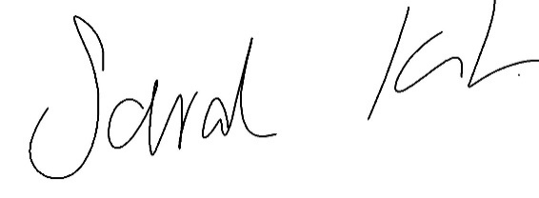

Sarah Kitchener

Clerk and RFO, Ockbrook and Borrowash Parish Council

## Agenda.

1. To receive apologies for absence.
2. To confirm the minutes of the previous meeting held on the 20th September 2023.
3. Variation of the order of business.
4. Declaration of members interests
5. Committee items for Discussion/Action/Update.

* To decide how the Parish Council can promote road surfacing improvements on Green Lane, Ockbrook.
* To discuss and decide on the next steps for creating the Biodiversity Action Plan.
* To decide on the Parish Councils action towards resolving failing bridge on coach road off The Ridings, Ockbrook.
* To decide on the Prish Councils action towards resolving complaints to Councillors about the electric fence adjacent to public right of way at Windmill Stables, Ockbrook.
* To decide on the Parish Councils action towards resolving failing pavement surfacing at bottom of Green Lane, Ockbrook.

1. Date of the next Planning and Environment Committee meeting.