# OCKBROOK & BORROWASH PARISH COUNCIL

# The Parish Hall, Church Street, Ockbrook, Derby DE72 3SL

Tel: 01332 664100/ 07860 702904 Email: Clerk@ockbrookandborrowashparishcouncil.gov.uk

1st May 2024

To the Chair and Councillors of the Cemeteries Committee for Ockbrook and Borrowash Parish Council,

You are summoned to attend a **confidential** Cemeteries Committee meeting of the Ockbrook and Borrowash Parish Council to be held in the Parish Hall, Ockbrook, at 19:00 on Wednesday 8th May 2024.

Yours sincerely,

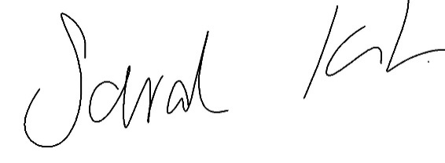

Sarah Kitchener

Clerk and RFO

Ockbrook and Borrowash Parish Council

## Agenda.

1. To receive apologies for absence.
2. To confirm the minutes of the previous meeting held on the 20th September 2023.
3. Variation of the order of business.
4. Declaration of members interests
5. Committee items for Discussion/Action/Update.

* Meeting to be held between the committee and family members to consider their thoughts on allowing kerbs back into the cemetery.

1. Date of the next Cemeteries Committee meeting.