# Minutes of the Ordinary Meeting of Ockbrook and Borrowash Parish Council.

# Held at the Parish Hall, Ockbrook on Wednesday 1st May 2024 Immediately After The Annual Parish Council Meeting.

## Public Speaking.

### Members of Public

* A member of public commented that the income for the allotments is more then the expenditure so wanted to object to the agenda item regarding the stopping of the discount, they also wanted to comment on their disappointment regarding the grass swamping the planters on Victoria Avenue.
* A member of public commented that they are pleased that the closure of Briar Home is on the agenda and hope the council will oppose the potential closure.
* A member of public wanted to back the first speaker; they are very annoyed that the Council think pensioners can afford an increase in the rent.

### Derbyshire County Council Report.

Councillor R Parkinson submitted a report, see appendix 1.

### Erewash Borough Council Report.

Councillor G Maskalick submitted a report, please see appendix 2.

### Derbyshire Constabulary Report – The website hasn’t been updated since the last meeting.

Ashbrook Youth Group

No report was submitted.

### Kevin Mathieson – Chief Executive of Over The Wall Charity.

* The charity was founded by Paul Newman in 1999, to provide free residential camps for children with long tern illnesses, through the school holidays and weekends.
* So far they have rented premises throughout the UK, but now they have a permanent base at the Moravian School.
* A forty- year lease has been signed and they have the first right to buy if the property goes up for sale.
* Their plan is for the charities needs to come first but when it’s not in use they are going to allow other charities, groups and the local community to use the site, income generated from this will go back into the site.
* The site is quite run down they will need to spend £1 million on repairs over the next 5 years.
* £3 million will be invested over the next 2.5 years to make the site camp ready and will be applying for planning permission in the next few weeks to transform the nursey school into residential accommodation for the beneficiaries.
* Long term plans include more residential accommodation, make it visually more appealing with more gardens and to have an adventure park.
* A community information day will be held on the 16th May 2024, at 14:00 and 18:30.
* They will be speaking to local schools regarding all the old school equipment they have inherited from the site.

## Present.

Councillors G Maskalick (Chair), S Fraser-Burton (Vice Chair), S Cresswell, A Dunn, J Fraser-Burton, T Stevenson, G Markwell and K Eaglesham-Atkins.

## Also, Present.

S Kitchener (Clerk and RFO), Councillors W Major and R Parkinson and 10 members of public.

## 25/05/24 Noted Apologise for Absence.

Councillors K Thomas, J Fazackerley (family commitment) and C Millward (family matter).

## 26/05/24 Declarations of Members Interests.

None

## 27/05/24 Dispensations.

None.

## 28/05/24 Variation of Order of Business.

None.

## 29/05/24 Approve the Minutes of the Ordinary Parish Council Meeting, Held on the 3rd April 2024.

**RESOLVED** Proposed by Councillor S Cresswell, seconded by Councillor S Fraser-Burton and all unanimously agreed that the minutes be approved as a true record and were signed by the Chair at the meeting.

## 30/05/24 Items to be Taken into Private Session.

None.

## 31/05/24 Report of the Parish Clerk/RFO.

Updates since Aprils meeting:

* Informed Ockbrook in Bloom that their grant request was denied, stating the reasons why.
* Accepted the quote for Fox to infill the soil around the gym equipment on Deans drive and to commence with the relevelling of plots and reseeding in Balmoral Road Cemetery – Deans Drive has been completed which I will check during my next playground inspection and Balmoral Road cemetery is being started on the 2nd May.
* Accepted the hanging basket quote from Dale Abbey, Councillor J Fazackerley will contact them to organise the baskets being installed.
* Informed the resident next to Deans Drive that we will not be cutting the tree down as they requested, stating the reasons why.
* Paid Mr Anderson 75% of the costs for his work done on plot 46 Elm Street.
* Went to the DCC Parish Council Liaison Forum on the 16th April, all the slides have been forwarded to the Councillors.
* The portrait of His Majesty the King has arrived.
* Accepted the Elm Street Allotments gate quote, informed them that we will need to obtain a grant for this.
* Logged the damaged pavement on Green Lane, Ockbrook with DCC.
* Logged the failing bridge on The Coach Road, Ockbrook with DCC.
* The community booklet has been produced following the annual parish meeting, this can be found on our website.
* The refurbished noticeboard has been installed at Prior Way.
* The concurrent function return has been completed and sent back to EBC.
* Contacted EBC regarding the hand washing facilities at the Borrowash Public toilets, the water is running for too long.
* Started working on the letters from the photographs sent to me by Councillor K Thomas regarding ornaments and wooden crosses in Balmoral Road Cemetery.

## 32/05/24 Report of the Chair.

**SEVERAL BIG ISSUES ALL AT ONCE**

**BRIAR CLOSE CARE HOME**

Derbyshire County Council has put to consultation two options for 11 care homes in the county. Briar Close is in both options as either selling it on to a private company or closing it if a company does not come forward. This is not a consultation by any stretch of the imagination. We do not have a third choice to keep it running as a County Council facility. In fact the papers approved by the DCC Executive quite clearly state that no other options will be considered.

I have met with several families who have loved one’s in Briar Close. The workforce is demoralised, the families are beside themselves all because there was no warning of this going to happen at all. Once again, Ockbrook and Borrowash were kept from matters arising at DCC that would directly affect them by the councillors who represent them. In this instance it is very disappointing that Councillor Parkinson, who has not come to a meeting for a full year or more could not be bothered to keep us, the people who voted him in to office informed.

I held an informal public surgery on the matter and I will be announcing a further surgery so that we all can come up with a plan to save affordable care for the elderly who have worked all their lives and paid into the system expecting the system to be there for when they need it most, not cut out from under them due to inept management at DCC to keep the books balanced. More information on this surgery will be put out to the public via the socials.

I would ask the Parish Council to vote on this matter as that we object to the sale/closure of Briar Close and send a united letter to DCC Leader and Wayne Major and Robert Parkinson. I would also ask that this letter be an open letter published on our website and socials.

**RE-WILDING SCHEME – EBC**

Erewash Borough Council has now committed itself to a re-wilding scheme very much based on Pewit and working with the Derbyshire Wildlife Trust who will do ecological surveys. There is a twofold reason behind all this: budget to cut everything in the Borough is massive and when you inherit a £1.5m revenue debt and a shortfall in your reserves something must give. Also, EBC is working hard to become carbon neutral, and this certainly will help as lawn mowers and trucks to deliver them will not be polluting the air as often.

2010 saw EBC get £4m in revenue support and in 2024 EBC got £250,000.00. With this kind of draconian cutting year on year the choice is simple – re-wild or shut down services such as DCC has done like care homes and youth services.

Verges will be maintained because its law, parks and play areas will still get cut. Sports pitches, cemeteries and church yards, roundabouts, leisure centre, museum grounds will be cut. Won’t be using herbicides.

We have all become use to golf course mowed parks… but those days are at an end for the reasons above. At least we can say we are doing our bit to help save the environment for our children. The first two years it will look a bit scruffy, but after that it should start to really take shape and will be something we all enjoy. So, I would ask the Parish Council to consider throwing its support behind the EBC re-wilding scheme with a public declaration letter to EBC and published on our website and socials. Also, that as a PC we help EBC in any way possible to make re-wilding as much a positive impact as possible for our Parish. That way we have ownership and can help the direction it takes.

**POTHOLE & HGV WEIGHT LIMIT RESTRICTION UPDATE**

Councillor Major and I have been working hard and collecting letters from the public about the impact the state of the roads and HGV’s are having on their lives and property. I would like to thank everyone who has helped deliver the leaflets and to the community pages for allowing us to post our letter to the public as well.

**PARISH SURGERIES**

We held 3 Parish Surgeries over the past few months, and they were not well attended at all. Out of all three surgeries we got 2 people. I think this is something that has seen its day and people tend to communicate very well with us on social media and email. Surgeries have proven a very poor way to communicate with the public and certainly is a time draining exercise.

I think calling the occasional informal consultation surgery when an issue crops up where the public need to act quickly is more effective. Examples of this are Harrington Green issue, Briar Close and Collier Lane Flood Prevention meetings. All three of these meetings were very well attended and the Harrington Green people came to about 5 meetings in total and are still involved. The Collier Lane meeting formed a public committee which meets every few months for updates.

**BALMORAL CEMETERY GATES AND RUBBISH BINS**

Since we lost our litter picker, I have taken on the responsibility of emptying the bins in the cemetery on a weekly basis. I have also asked the Cemetery Committee Chair and Chair of Finance to look into getting the entrance cleared of the ivy. I have also spoken to Borrowash in Bloom on taking over the plants on either side of the entrance and making it more welcoming. They are doing a survey of it and then talking about it as a committee if they want to take it on. If they do want to take it on they will give us a price for yearly upkeep of the entrance area.

**BELMONT CEMETERY**

The Board of Trustees are now functioning as they should be and we are going after grants and even now have a website [www.friendsofbc.uk](http://www.friendsofbc.uk). More anon.

**YOUTH CONCERT**

So far we have three entrants for the Youth Concert and we will be making a final push for it through the month of May. Please let us know if you know of someone who would like to perform at the concert. Details: Friday 24th May 2024, 7:30pm at All Saints Church, Ockbrook.

**NATIONAL DIVERSITY AWARDS**

Councillor Tania Stevenson has been nominated for the National Diversity Awards 2024 for Positive Role Model for Gender. Her work in this area is amazing and we wish her the best of luck that she gets to the finals. Regardless we are all very proud to be amongst such an amazing person who promotes the good in all.

## 33/05/24 Finance, HR, Contractors and General Purposes.

### Accept Accounts for Payment – see appendix 3.

**RESOLVED** Proposed by Councillor A Dunn, seconded by Councillor S Cresswell and all unanimously agreed to accept the payment list.

### Accept the Income and Expenditure Breakdown for the Full Year. – see appendix 4.

Councillor G Markwell wanted to thank the committee chairs and the Clerk on being able to reduce the expenditure over the last year.

**RESOLVED** Proposed by Councillor A Dunn, seconded by Councillor T Stevenson and all unanimously agreed to accept the income and expenditure breakdown.

### Accept the Bank Statement Reconciliations. – see appendix 5.

* March 2024 HSBC Account.
* March n2 2024 Unity Trust Account.

**RESOLVED** Proposed by Councillor S Fraser-Burton, seconded by Councillor S Cresswell and all unanimously agreed to accept the bank statement reconciliations.

### Internal Annual Audit Report Received and Noted – see appendix 6.

**RESOLVED** The report was noted as being received and accepted by all.

### Approval of the Annual Governance Statement 2023/24 Section 1 – see appendix 7.

**RESOLVED** proposed by Councillor S Fraser-Burton, seconded by Councillor G Markwell and unanimously agreed that the annual governance statement 2023/24 questions were approved, and the statement was signed by the chair.

### Approval of the Accounting Statement 2023/24 Section 2 – see appendix 8.

**RESOLVED** proposed by Councillor S Fraser-Burton, seconded by Councillor K Eaglesham-Atkins and all unanimously agreed that the accounting statements 2023/24 in the annual governance and accountability return are correct and approved, and the statement was signed by the chair.

### Note the Dates for the Notice of Public Rights and Publication of Unaudited Annual Governance and Accountability Return, being Monday 3rd June 2024 to Friday the 12th July 2024.

**RESOLVED** the dates were noted.

### Consider a Request to Purchase 3 Pieces of Gardening Equipment from the Parish Council.

Councillor G Markwell updated members that the equipment should be going to auction with Bagshaw Agriculture on the 4th June 2024.

**RESOLVED** proposed by Councillor G Markwell, seconded by Councillor A Dunn that we do not sell the items directly but to inform them when they will be going to auction.

## 34/05/24 Recreation.

### Consider the Purchase of D Day Lamppost Signs.

Councillor J Fraser-Burton informed the members that the cost will be £216.99 for 50 signs, these will go onto the 47 lamppost on Victoria Avenue. Members of public can sponsor the signs with a dedication for £5.00, any monies raised above the purchase costs will be donated to the Royal British Legion.

**RESOLVED** Proposed by Councillor K Eaglesham-Atkins, seconded by Councillor T Stevenson and all unanimously agreed to purchase the signs. **ACTION** Clerk to purchase the signs and obtained permission for them to be placed on the lampposts, Councillor J Fraser-Burton to produce the dedication form and a poster to advertise the signs.

## 35/05/24 Cemeteries.

### Consider Increasing the £100 Fee for a Memorial Bench, to Help Cover the Increased Costs of the Plinth.

Councillor S Cresswell updated members of the quote from Fox of £270.00+ VAT with a discount of £50 if four are done at the same time and the previous company we used charged £495+ VAT.

**RESOLVED** proposed by Councillor S Cresswell, seconded by Councillor J Fraser-Burton and all unanimously agreed to change the bench fee to £270.00 and to use Fox. **ACTION** Clerk to amend the appropriate policies.

## 36/05/24 Halls.

Councillor S Fraser-Burton thanked the Clerk for obtaining His Majesty the Kings Portrait for the parish hall.

## 37/05/24 Allotment.

Councillor S Cresswell submitted a report:

Inspections were carried out at the end of April and it is great to see that most plots are being well looked after.

The number of people currently on the waiting list for a plot is 18.

**Shacklecross**

Cllr Thomas, Cllr Markwell, his truck and made a second visit to Shacklecross to remove and dispose of unwanted carpeting from plot 6b and clear a large quantity of broken glass and other debris from plot 21. Thanks one again to my colleagues for their time and effort.

Both plots now have new tenants who have set to work and in just a couple of weeks, have made a huge difference to what were, sadly, very neglected plots.

Following complaints received about an overhanging tree and rotten fence panels that need to be replaced, Cllr Thomas and I cut back the overhanging branches and have been to look at the fence panels.

**Elm Street**

I am delighted to say that the whole of KS1 from Ashbrook Infant School will be visiting Elm Street on Friday to coincide with the Food & Farming topic that they are doing this half term. At least three tenants will be on site to talk to the children in addition to myself and Cllr Thomas. Going forward, I would like 2 or 3 visits taking place each year at regular intervals between March and the end of October/early November.

**Ladysmith Road Gate**

Julie Smith and I had a very useful meeting with Steve Irwin, who has experience of applying for grants. He shared lots of useful information with us about funders and the application process. On Monday, Cllr Thomas, Julie and I met to decide which fund/s it would be best for us to apply to.

### Consider Stopping the Rent Discount from 2026 Onwards.

Councillor S Cresswell updated members that 7 emails against this proposal have been received and the Clerk read out objections from a phone call she received.

A brief discussion was held points raised include:

* Councillor K Eaglesham-Atkins suggested another option of the discount applying to all on a lower income. Councillor J Fraser-Burton commented that this would be very difficult to administer.
* Councillor S Fraser-Burton mentioned the need to consider the mental health and social side of the allotments.
* Councillor G Markwell mentioned that as this suggestion had come from the allotment associations meeting, with one person raising the query and the Parish Council have received numerous objections why is it even being considered?
* Councillor A Dunn mentioned that some people are still nervous of going out due to Covid, so these outdoor spaces are very important.

**RESOLVED** All unanimously agreed to leave the rent as it is.

Councillor S Fraser-Burton wanted to thank Councillors S Cresswell, K Thomas and G Markwell and any others for giving up their free time to work on the allotments.

## 38/05/24 Planning and Environment.

### Consider the Parish Councils Stance on Derbyshire County Councils Proposal for Briar Close Care Home.

Standing orders were suspended.

Councillor G Maskalick asked why has the notification of the proposal come out so last minute? Councillor R Parkinson commented that the first he heard about it was from a resident and he contacted DCC as he should have been informed on this. When the consultation starts please make a representation to this proposal asking for an additional option, so far he has received three representations which have been forwarded to DCC.

Councillor W Major stated his surprise that Councillor R Parkinson had not been informed of the proposal but reiterated that once the consultation starts to make representations. It will be a 12-week consultation period with sessions open to the public to answer any questions. The expectation is that this will be sold off as a going concern. At the moment the demand for Briar Close is low with only 19 residents for a home of up to 40. DCC want to deliver specialist services rather than services the public sector can provide, if it goes ahead and residents are moved their fees will not increase and they will be able to decide where they want to go.

Councillor S Fraser-Burton commented that he was looking at Briar Close for someone with dementia and was informed that the home was full, Councillor W Major commented that Briar Close does not provide dementia care.

Councillor G Markwell commented that as stated there is low demand for the facilities, and £3.1 million was spent on the refurbishment this is gross incompetence. Councillor W Major commented that if the refurbishment hadn’t happened the home would have had to be closed rather than being sold on.

Councillor J Fraser-Burton commented that on the CQC website the types of service included dementia care.

Councillor K Eaglesham-Atkins stated that people won’t make representation due to there only being 2 options. The concern is that if residents move out of the area friends and family members will not visit as much as if they stay in Borrowash, so they will be losing a level of support.

Councillor S Fraser-Burton commented that there are 11 homes in Derbyshire under this proposal with 3 of these being in Erewash.

A member of public stated that beds aren’t being fully accommodated due to the alterations, one block has been completely shut with staff being moved to other homes. This home does deal with dementia patients. This is a great home.

Standing orders were reinstated.

**RESOLVED** proposed by G Maskalick to send a letter against the proposal, seconded by Councillor G Markwell and all unanimously agreed. **ACTION** Clerk and the chair to work on the letter for the Clerk to forward to the DCC ward Councillors and the leader.

### Consider the Request from Borrowash Youth Development to Allow them to Aerate Deans Drive Football Pitch Using A Tractor and Pull Along Roller.

A brief discussion was held, points raised include:

* Councillor G Markwell stated that there are health and safety issues, there is a risk to the public as this is a public open space, it would need to be done by a competent qualified driver.
* The Clerk commented that they would need public liability insurance to cover themselves.
* Councillor S Fraser-Burton asked if this is something Fox could do for us?
* Councillor G Markwell spoke to local farmers and there is someone in the area who provides this service.

**RESOLVED** all unanimously agreed to delay this request at the moment. **ACTION** Councillor G Markwell to contact Fox and the farmer for quotes.

## 39/05/24 Correspondence Received – see appendix 9.

The correspondence received and listed in the agenda were available at the meeting.

## 40/05/24 Date and Time of Next Meeting.

The next Parish Council meeting is scheduled to take place at the Ashbrook Centre, Borrowash on Wednesday 5th June 2024 at 19:00.

## 41/05/24 Exclusion of Press and Public.

Nothing to report.

There being no further business the meeting concluded at 20:55.

**Appendix 1 - Ockbrook & Borrowash Parish Council, Wednesday 1st May 2024, DCC Report (Cllr Robert A Parkinson)**

**Victoria Avenue Crossing**

A proposal has been published for the promised Crossing at the southern end of Victoria Avenue.

**Carers' events and activities**

This is to let our communities know about the activities, training and events taking place this month for unpaid carers hosted by Derbyshire Carers Association (DCA).

Events and activities include:

•        Exercise to music, online via Zoom

•        Chair-based yoga, online via Zoom

•        Male carers cuppa and chat, online via Microsoft Teams

•        The Carers Circle, online via Zoom

•        Benefits advice talk, online via Zoom

•        Arts and crafts, Long Eaton

•        Memory loss carers support group, online via Microsoft Teams

•        Crafts with Spiral Arts, Erewash Museum

•        And carers support groups held across the county in-person.

To access the events and activities, you’ll need to be registered with the Derbyshire All Age Carers Support Service.

The Derbyshire All Age Carers Support Service – which is delivered by DCA on DCC’s behalf – includes:

•        information and advice helpline

•        face-to-face, home visits and telephone support

•        Planning for emergencies

•        support groups

•        carer’s assessments

•        skills for caring

•        financial advice and grants

•        social activities and events

•        volunteering and more.

Follow DCA on Facebook and X for news, updates, and events.

**Council to consult on future of discretionary grants.**

Cabinet has agreed to consult on the future of two types of grant funding to voluntary and community groups.

People will be asked their views on proposals to end adult social care discretionary grant funding and corporate services and transformation discretionary grant funding in March 2025.

The county council has been funding voluntary organisations with annual grants for several years, over which time it has experienced growing financial pressures.

The council is due to launch a joint consultation on the future sustainability of both sets of grants on 28 May 2024. It will last for 12 weeks, finishing on 20 August 2024.  DCC will share details in due course about how everyone can have their say.

### **Appendix 2 –** EBC COUNCILLOR GREG MASKALICK

**PEWIT SELL-OFF REVERSED**

The issue surrounding Pewit Golf Course has been resolved and it was decided by the Exec to not sell it off after all and keep it part of a nature reserve. More than £500,000 will be invested into what will now be called The Coronation Meadows Local Nature Reserve. The money will not be coming from taxes but instead half will be from the Shared Prosperity Fund (which is part of Levelling Up from Central Gov) and money paid to the town hall by businesses involved in the redevelopment of the old Stanton ironworks.

**NEW OPENING HOURS FOR TOWN HALLS**

New weekday opening hours at Erewash council’s two town halls are being brought in from Monday, 13 May. The reception areas – where the public can raise queries in person with customer services teams – will close at midday instead of 2pm.

The move comes as residents increasingly make use of the council’s online services – which are more efficient and save money.

The reception area at **Ilkeston Town Hall** will continue to open four days a week. From 13 May the new times will be **10am until 12 noon**. It is closed on Wednesdays.

At **Long Eaton Town Hall**, the reception is closed on Thursdays. Like Ilkeston, the new opening hours on the four other days will be **10am to 12 noon**.

The council’s telephone Contact Centre is open from 8.30am to 5pm Monday to Thursday, and 8.30am to 4.30pm on Fridays on **0115 907 2244**.

**EBC TRACKER SURVEY**

These surveys ask general questions about Erewash Borough Council, the services it provides and their methods of communication. The same questions are used on a regular (quarterly) basis to allow the council to monitor and compare its performance over time.

Tracker Surveys will be available during the following months:

* Q1. May and June.

**NEXT FULL COUNCIL MEETING – ANNUAL COUNCIL MEETING**

Thursday, 16th May 2024 7:00PM. This will be held at Long Eaton Town Hall and is the first full Council meeting of the new year which will see the investiture of a new Mayor of Erewash and any changes to the front benches of each party. The agenda will be published a week before the meeting. You can obtain a copy of the agenda at: <https://moderngov.erewash.gov.uk/ieListDocuments.aspx?CId=283&MId=2186>

**EBC COUNCILLOR GREG MASKALICK SURGERY – HAVE A CUPPA!**

I will be at Café Torta, Borrowash from 10am-12pm to listen to your concerns and ideas for the future of our Parish. Please stop by and share a cuppa and good conversation.

### **Appendix 3 -** May 2024 payment list.

|  |  |  |  |
| --- | --- | --- | --- |
| **Invoices to be paid** | - | - | minute agreed |
| Ashbrook Youth Group | £280.00 | Monthly donation –May | 229/12/23 |
| DALC | £1,411.09 | Annual subs | - |
| EBC | £3,695.40 | April payroll | - |
| Lisa’s | £244.00 | April hall clean | - |
| Fox Grounds Maintenance | £2155.99 | April works | - |
| Sarah Kitchener | £37.13 | April expenses – mileage | - |
| Hydro International | £96.00 | 2 x SMS bundle | - |
| ICCM | £100.00 | Years membership | - |
| PPL PRS | £387.26 | Music license | - |
| Karen Howe | £268.90 | Internal audit | - |
| Borrowbrook Homelink | £2500.00 | Yearly donation | 229/12/23 |
| Rynat | £168.00 | Nov playground inspection | 189/10/23 |
| Rynat | £168.00 | Feb playground inspection | 189/10/23 |
| **Invoices already paid** | - | - | - |
| National Allotment Society | £66.00 | Years membership | - |
| Mitchell Sports LTD | £300.00 | OBCC donation | 247/02/24 |
| Anthony Whitehurst | £469.92 | Noticeboard repairs | - |
| Jeremy Anderson | £96.48 | Woking on plot 46 | 278/03/24 |
| HSBC account | £93688.00 | Tfr from unity | - |
| **Monthly direct debits** | - | - | - |
| British Gas | £63.20 | Elec 20/03-18/04 | 26/05/23 |
| British Gas | £469.78 | Gas 28/03-29/04 | 26/05/23 |
| Virgin | £64.80 | Broadband and phone Apr/May | 26/05/23 |
| O2 | £35.22 | Mobile | 26/05/23 |
| Lloyds Bank | £304.73 | Annual parish meeting snack and drinks, temperature gauge, flags, training course | 26/05/23 |
| Everflow | -£82.19 | Credit for invoice 2823127 | 26/05/23 |
| Everflow | £82.56 | Replacement invoice for 2823127 | 26/05/23 |
| Everflow | -£80.76 | Credit for invoice 2929996 | 26/05/23 |
| Everflow | £82.64 | Replacement invoice for 2929996 | 26/05/23 |
| Everflow | £84.22 | Water 06/05-05/06 | 26/05/23 |
| EBC | £20.67s | April cem rates | 26/05/23 |

### **Appendix 4 –** Income and Expenditure Breakdown.

|  |  |  |  |  |  |  |  |  |
| --- | --- | --- | --- | --- | --- | --- | --- | --- |
|  | ***Budget 2023/24*** | ***¼ 4***  ***Jan-Mar*** | ***Actual to date 2023/24*** | ***Forecast to year end 2023/24*** | ***Total forecast to year end***  ***2023/24*** | ***Variance to budget 2023/24*** | ***Variance to budget 2023/24*** | ***Notes*** |
| **Income** | £ | £ | £ | £ | £ | £ | % | - |
| Precept and Grant | 147,886 | 0 | 147,886 | - | - | 0 | 0 | - |
| Burials | 11,550 | 1,684 | 13,561 | - | - | 2,011 | 17 | Under budgeted |
| Recreation | 2,741 | 0 | 2,246 | - | - | -495 | -18 | Less Xmas trees sold than expected |
| Hall/lettings | 18,264 | 3,117 | 13,126 | - | - | -5,138 | -28 | Extra bookings, class time increases /decreases and cancelled bookings |
| Allotment | 3,707 | 1,879 | 4,163 | - | - | 456 | 12 |  |
| Other | 791 | 89 | 717 | - | - | -75 | -9 | - |
| Ashbrook | 7,666 | 0 | 2,820 | - | - | -4,846 | -63 | Extra bookings, class time increases, cancellations, handed back to trustees from Aug |
| Environment/NP | 0 | 3 | 6 | - | - | 6 | 0 | - |
| VAT | 0 | 0 | 6,220 | - | - | 6,220 | 0 | - |
| **Total Income** | **192,605** | **6,772** | **190,746** | **-** | **-** | **-1,859** | **-** | **-** |
| **Expenditure** | - | - | - | - | - | - | - | - |
| Parish Hall | 13,189 | 5,271 | 11,720 | - | - | -1,469 | -11 | Overbudgeted |
| Ashbrook | 17,116 | 0 | 2,426 | - | - | -14,690 | -86 | Overbudgeted and handed back to trustees from Aug |
| Sal/miles/train/ chair allowance | 51,810 | 12,383 | 49,702 | - | - | -2,108 | -4 | - |
| Rec/ events | 13,716 | 3,409 | 9,353 | - | - | -4,363 | -32 | Overbudgeted |
| Environment | 25,298 | 3,411 | 13,211 | - | - | -12,087 | -48 | Over budgeted, new contractor making savings |
| S137/ donations | 8,000 | 950 | 5,834 | - | - | -2,166 | -27 | Overbudgeted |
| Gen/admin/bank charges/Subs/ ins/ utilities | 18,901 | 2,329 | 13,134 | - | - | -5,767 | -31 | Overbudgeted |
| Reserve build up | 20,000 | - | - | - | - | - | - | - |
| Burials | 20,782 | 6,113 | 20,582 | - | - | -200 | -1 |  |
| Allotments | 3,793 | 503 | 3,864 | - | - | 71 | 2 | - |
| VAT | 0 | 3,349 | 8,957 | - | - | 8,957 | - | - |
| **Total Expenditure** | **192,605** | **37,719** | **138,783** | **-** | **-** | **-53,822** | **-** | - |
| - | - | - | - | - | - | - | - | - |
| **Total Income and Expenditure 2023/2024 (+surplus/-deficit)** | **0** | **-30,946** | **51,963** | **-** | **-** | **51,963** | **-** | **-** |
| **Balance carried forward from 2022/2023** | 9,646 | - | - | 2022/23 | 9,646 | - | - | - |
| **HSBC A/c 22/23** | 14,875 | - | - | - | 24,779 | - | - | - |
| **Forecast balances as at 31st March 2024** | **24,521** | - | - | 2023/24 outturn | **86,387** |  | - | - |

|  |  |
| --- | --- |
| **RESERVES** | £ |
| Reserve build up | 20,000 |
| Bi election | -663 |
| Charity amounts | 2,180 |
| General reserves | 64,870 |
| - | **86,387** |

### **Appendix 5 –** Bank Reconciliation

**March 2024 Bank Reconciliation - HSBC Account**

|  |  |  |  |
| --- | --- | --- | --- |
| **Bank Balance** | - | - | - |
| Bank s/m bal as at 01/04/22 | - | 14,874.50 | - |
| + total cash book receipts | - | 80,000.00 | - |
| - total Cashbook payments | - | 70,096.00 | - |
| **Cashbook Closing Balance** | - | **24,778.50** | - |
| - | - | - | - |
| **Bank Balance at 31/03/24** | - | **24,778.50** | - |
| - outstanding payments | - | 0.00 | - |
| + outstanding receipts | - | 0.00 | - |
| **Net Balance** | - | **24,778.50** | - |
| - | - | - | - |
| **-** | - | **-** | **Difference: 0.00** |

**March 2024 No2 Bank Reconciliation - Unity Trust Account**

|  |  |  |  |
| --- | --- | --- | --- |
| **Bank Balance** | - | - | - |
| Bank s/m bal as at 01/04/23 | - | 20,760.24 | - |
| Less items related to 22/23 | - | 11,114.11 | - |
| - | - | 9,646.13 | - |
| + total cash book receipts | - | 260,745.86 | - |
| - total Cashbook payments | - | 239,421.69 | - |
| **Cashbook Closing Balance** | - | **38,970.30** | - |
| - | - | - | - |
| **Bank Balance at 31/03/24** | - | **39,302.63** | - |
| - outstanding payments | - | 8,332.33 | - |
| + outstanding receipts | - | 0.00 | - |
| **Net Balance** | - | **30,970.30** | - |
| - | - | - | - |
| **Balance per Cashbook** | - | **30,970.30** | **Difference: 0.00** |
| - | - | - | - |
| Charity Accounts included in bank total: | - | - | - |
| William James | 2,131.09 | - | - |
| B/W Burial Ground | 48.61 | - | - |

### **Appendix 6 –** Internal Audit report.

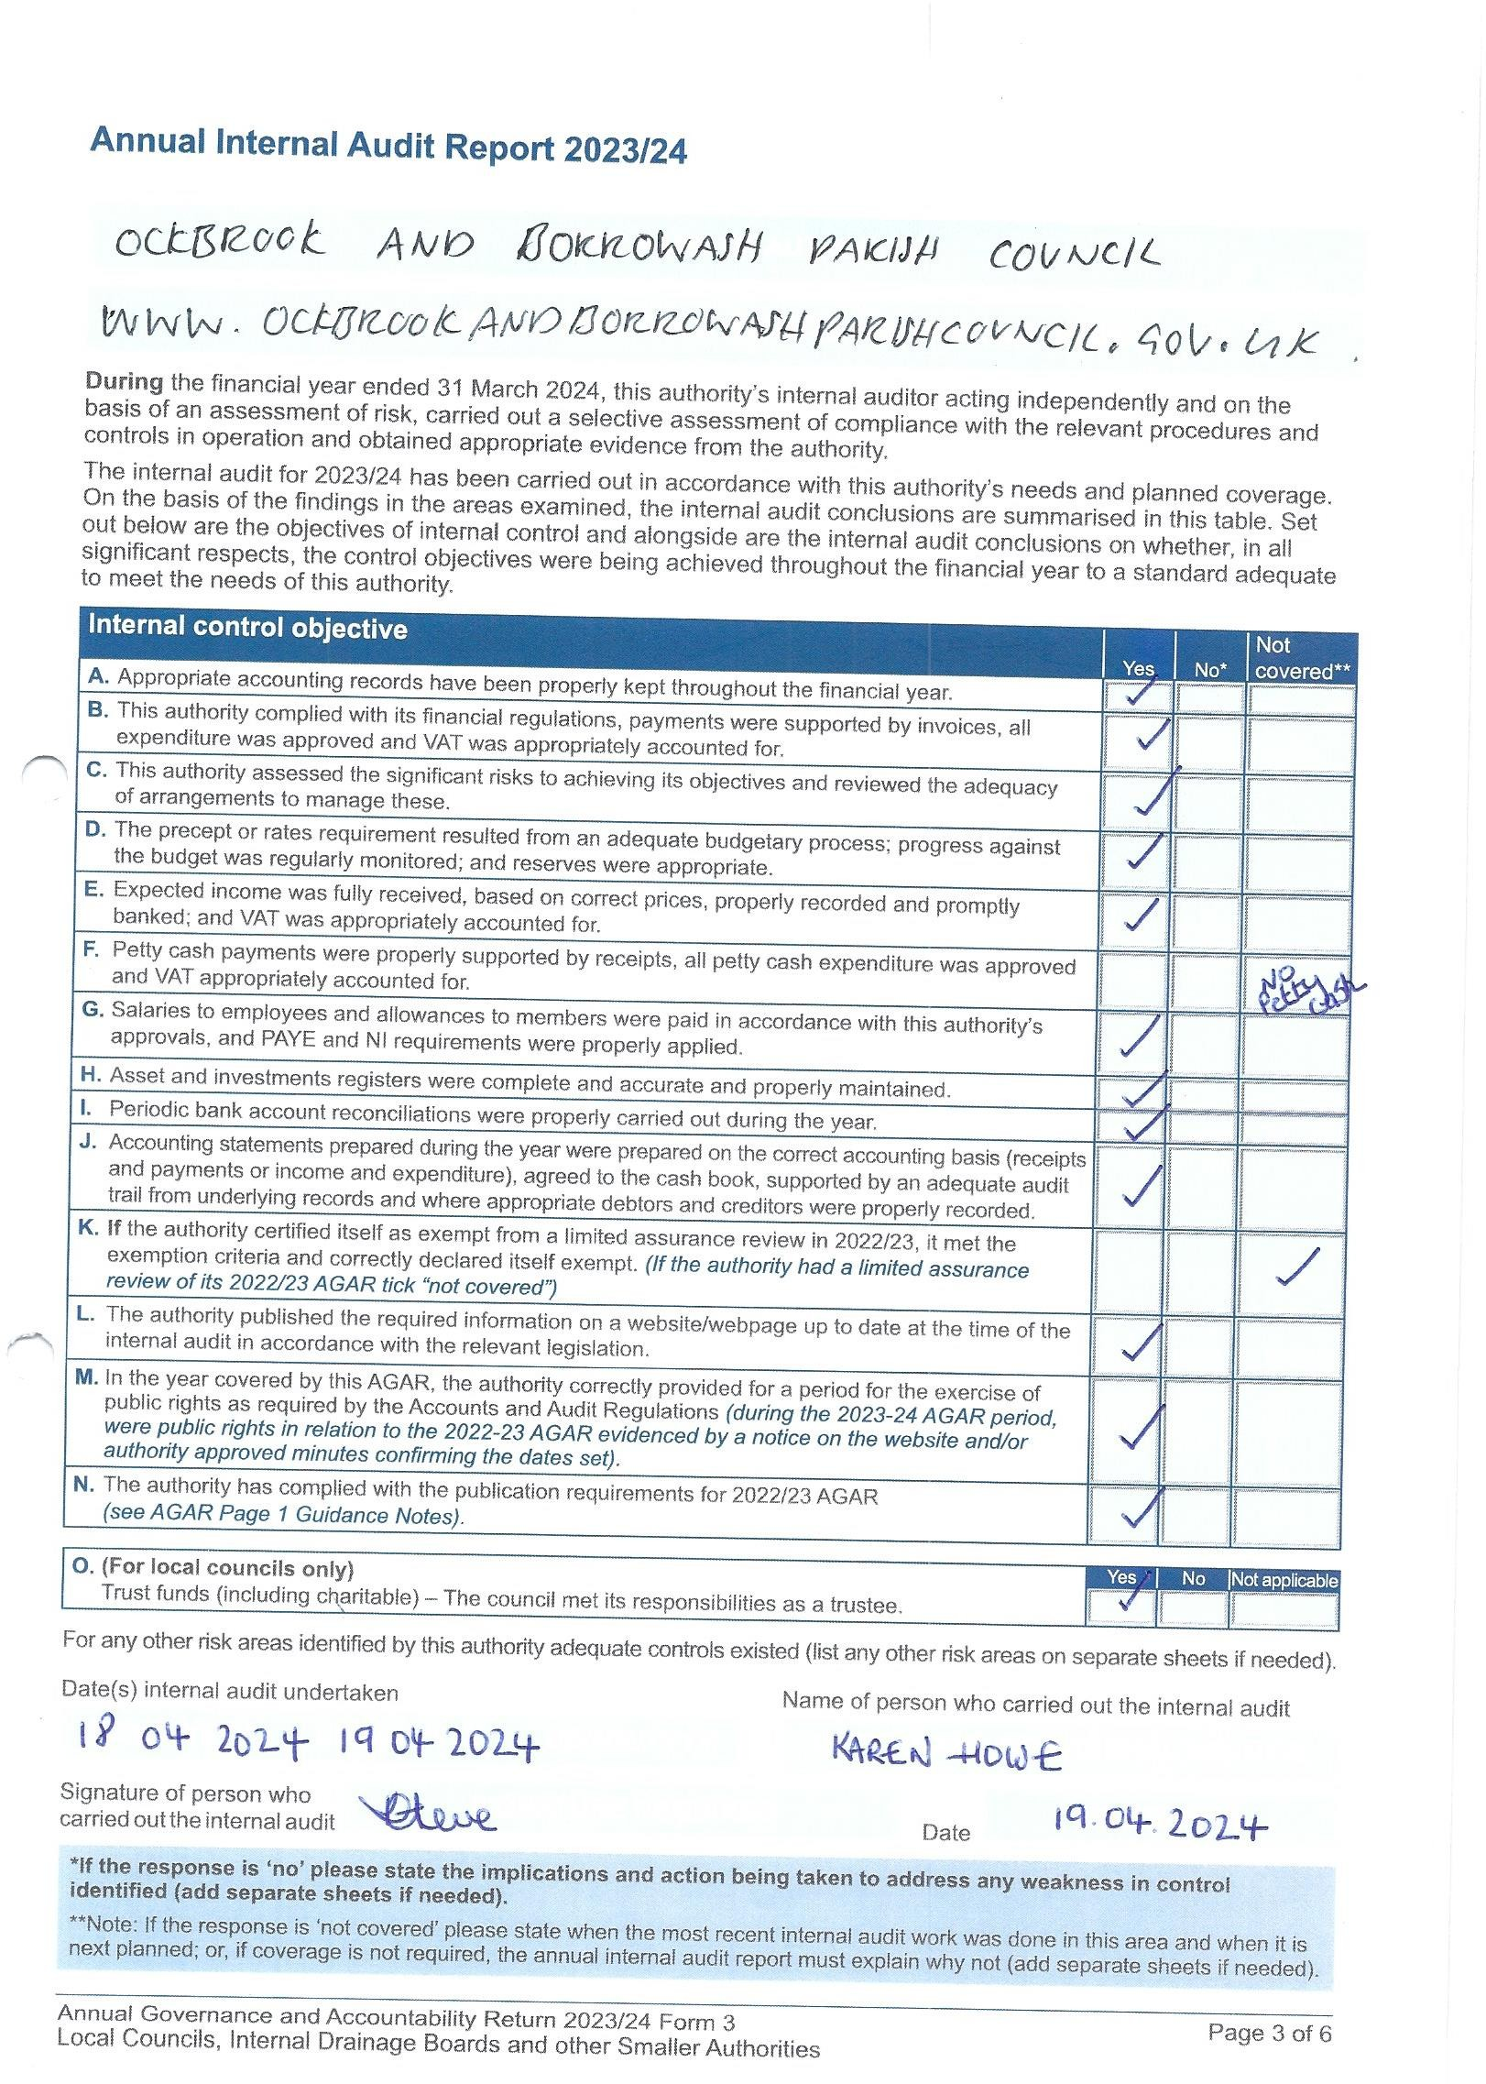

### **Appendix 7 –** Section 1 Annual Governance Statement 2023/24.

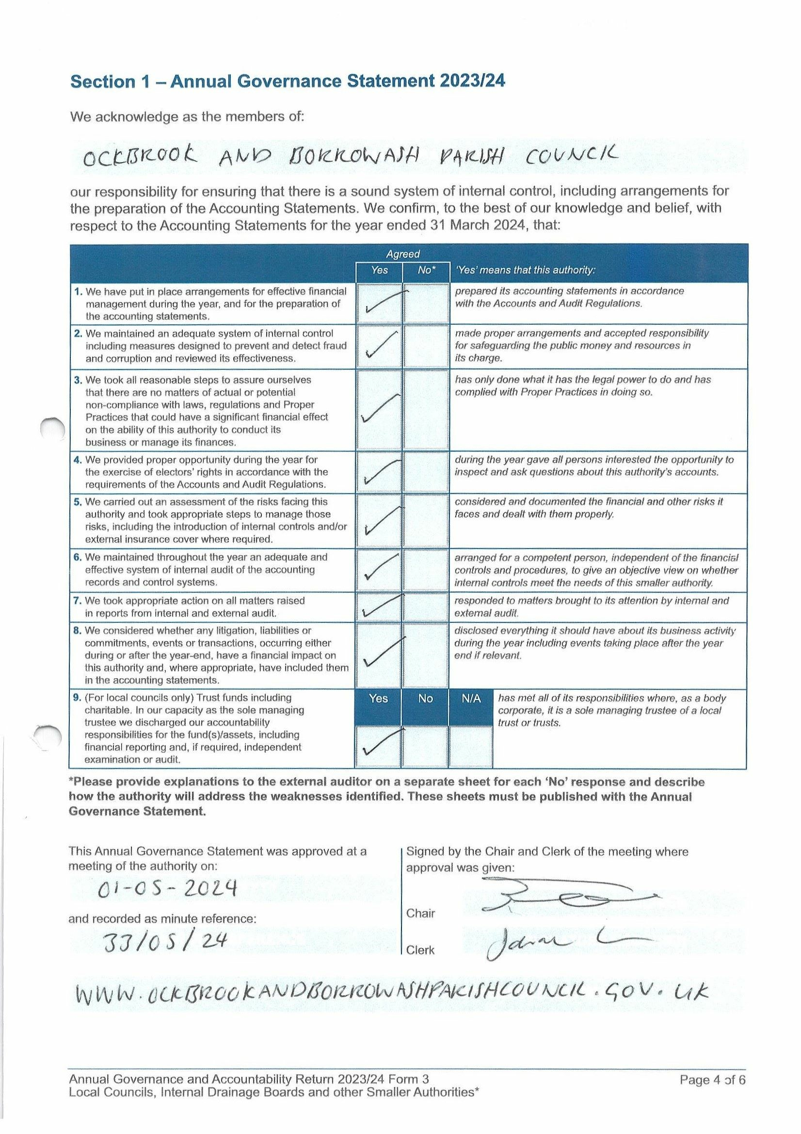

### **Appendix 8 –** Section 2 Accounting Statements 2023/24.

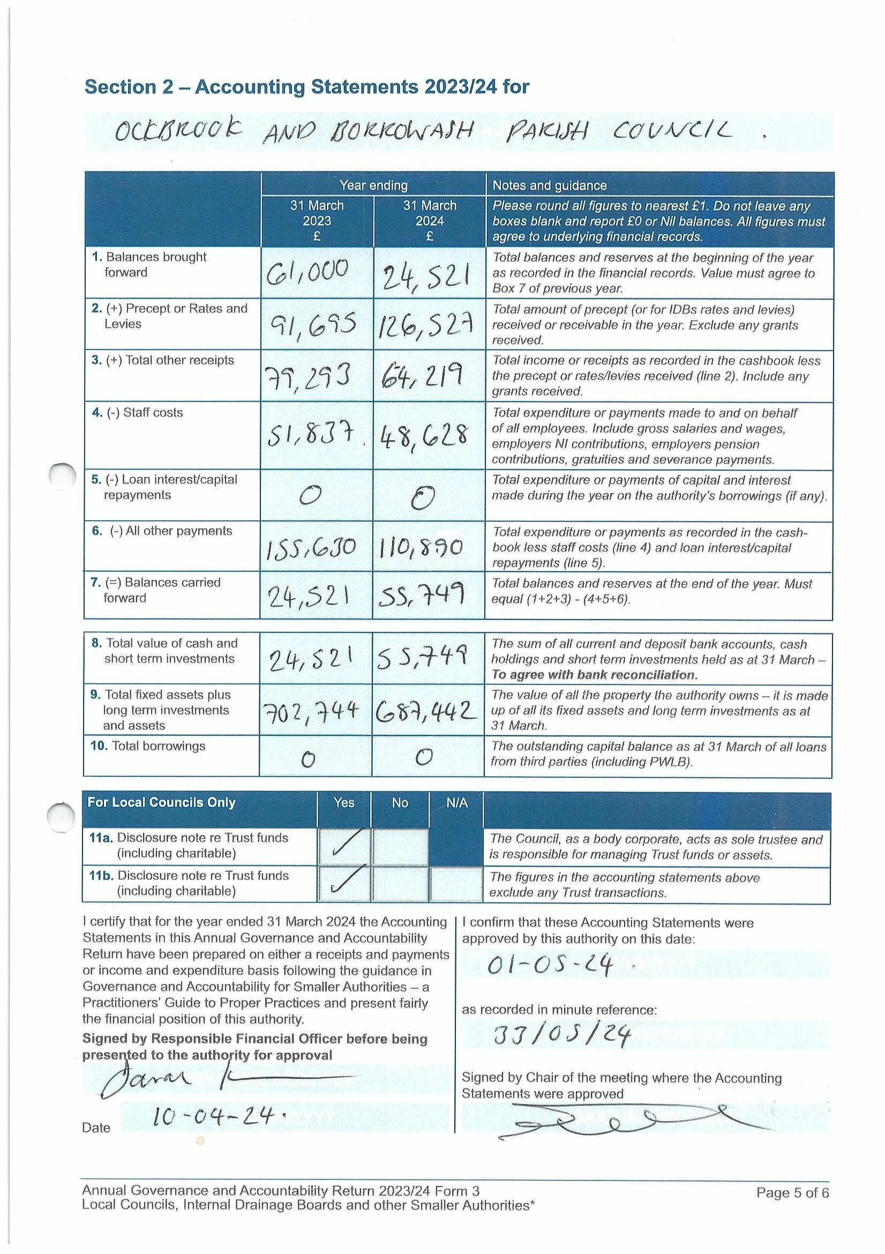

### **Appendix 9 –** Correspondence receivedUp To 21/04/24.

Emails/letters received from members of public:

* Request for information as to why the Parish Council have increased the precept – answered, mainly due to loss of concurrent functions and the Borrowash toilet and normal yearly increases. (1)
* Informed of two dangerous potholes – logged with DCC and informed resident how they can log them themselves. (2)
* Request for information on what the concurrent functions covers and how else the Parish Council receive income –concurrent functions covers a proportion of ground maintenance, wages, playground repairs, allotment water, hanging baskets, Christmas lights and cemetery running costs. Income comes via the precept, burials, allotments and hall hiring. (3)
* Thank you for organising the annual parish meeting and for the donation from the chair. (4)
* Thank you for the donation from the chair. (5)
* Request for information on what each house band pays for their council tax – suggested they contact EBC for the information. (6)
* FOI request for all information on the change of the green belt for two areas in Ockbrook – only information in the office to mention this was minutes from 2012-2019 which were forwarded. (7)
* Cc’d into emails between a resident and EBC regarding their land. (8)
* Request for further information held in the office regarding their land to be forwarded – no information could be forwarded as the information is not in the office. (9)
* Cc’d into emails between a resident and EBC regarding their concerns of their neighbours house being rennervated. (10)
* Request for information as to why the office isn’t holding certain information, why items were not minuted and what audits are done when a new set of Councillors come into power- unable to answer about the information and recording of information in the minutes as this was before my time and that when new Councillors start there are no audits done just the normal yearly ones. (11)
* Letters regarding the weight limit campaign – all forwarded to Councillor G Maskalick. (12)
* Thank you for the donation given to the group from the chair. (13)
* Query if permission is needed to install no dog fouling signs on the grass verges- would need to talk to DCC as the verges belong to them. (14)
* Will EBC reduce concurrent functions again? – none will be available 2025/26. (15)
* Hall hiring enquiries and updates. (16)
* Allotment enquiries, complaints and updates. (17)

Other emails received:

* Clerks and Councils direct – informed the Local Councils Update will no longer be issued. (18)
* Information from Over The Wall. (19)
* Connecting Erewash Week events – advertised on Facebook and the notice boards. (20)
* Request for information as to the requirements the council need to open an aesthetic clinic – informed them to contact EBC. (21)
* Yearly domain name confirmation - all correct. (22)
* Request for grounds work within the parish. (23)
* Community information and advice event – will be advertised after the election. (24)
* Email from the PCSO regarding setting up a speedwatch group – informed them one had been sent up by a community group. (25)
* Response from the Crime Commissioner regarding reducing the speed to 30mph between Borrowash and Spondon – would need to contact DCC. (26)
* Response from a Spondon ward Councillor regarding reducing the speed to 30mph between Borrowash and Spondon – they would also like to see this being reduced and have asked their traffic offices to contact me. (27)
* Response from a Spondon Ward Councillor regarding reducing the speed to 30mph between Borrowash and Spondon – They agree and will contact highways/traffic management and get back to me. (28)
* Enquiry as to if we would like a CWGC green sign installed at Balmoral Road Cemetery due to having a commonwealth war grave – Yes. (29)

Emails received from EBC:

* Tree preservation conformation order – 6 Cedar Drive, Ockbrook. (30)
* Notification of tree preservation order – Youth Community Centre, Borrowash. (31)
* Walking week information – on Facebook and Notice boards. (32)
* Core strategy new hearing date – forwarded to Councillors. (33)
* Cc’d into an email regarding the playpark gate – in the process of being fixed. (34)
* Response to the Clerks email regarding a residents concern about very large trees on someone else’s land at the bottom of their garden – they need to carry out a land registry search to find the owner, EBC can only help if the tree is in danger of failing, updated resident. (35)
* Planning meeting agenda and minutes. (36)

Emails received from DCC:

* Reminder of the Parish and Town Council Liaison forum on the 16th. April – forwarded to Councillors. (37)
* Free online safety event on the 29th. April – forwarded to Councillors. (38)
* Update on the Clerks and Councillor R Parkinsons request for information on the proposed pedestrian crossing in Borrowash – will chase up the final proposed drawing. (39)
* Proposed pedestrian crossing design – forwarded to Councillors to comment on by the 29th. April. (40)
* Parish and Town Council liaison forum slides – forwarded to Councillors. (41)
* Community news x 2 – on website and Facebook. (42)

DALC updates and April newsletter – Forwarded to Cllrs (43)

Numerous emails received from NALC - forwarded to Cllrs. (44)

SLCC updates and news bulletins. (45)

ICO updates. (46)

Rural action newsletters. (47)

The Countryside Charity Derbyshire newsletter. (48)

Local Councils Update. (49)