# OCKBROOK & BORROWASH PARISH COUNCIL

The Parish Hall, Church Street, Ockbrook, Derby DE72 3SL

Tel: 01332 664100/ 07860 702904 Email: [clerk@ockbrookandborrowashparishcouncil.gov.uk](mailto:clerk@ockbrookandborrowashparishcouncil.gov.uk)

# May 2024 PARISH COUNCIL MEETING.

22nd April 2024

To the Chair and Councillors of Ockbrook and Borrowash Parish Council,

You are summoned to attend the ordinary meeting of Ockbrook and Borrowash Parish Council on Wednesday 1st May 2024 immediately after the annual parish council meeting, to be held at the Parish Hall, Ockbrook.

This is the signature of Sarah Kitchener, the Clerk and RFO 


Sarah Kitchener

Clerk and RFO

Ockbrook and Borrowash Parish Council

# Agenda.

## Public Speaking.

A period of 30 minutes will be made available at the beginning of the meeting to hear comments from:

* Public.
* Derbyshire County Council submitted Report.
* Erewash Borough Council submitted Report – see appendix 1.
* Derbyshire Constabulary – no crime reported for February on the website
* Ashbrook Youth Group.
* Kevin Mathieson – Chief Executive of Over The Wall Charity.

## To Receive Apologies for Absence.

## Declaration of Members Interests.

To enable members to declare the existence and nature of any personal or disclosable pecuniary interests they have in agenda items, in accordance with the Parish Councils Code of Conduct. Interests that become apparent at a later stage in the proceedings may be declared at that time.

## Dispensations.

To consider any dispensation requests received.

## Variation of Order of Business.

## To Approve the Minutes of the Ordinary Parish Council Meeting, Held on the 3rd April 2024.

## Items to be Taken in Private Session.

## Report of the Parish Clerk /RFO.

## Report of the Chair.

## Finance, HR, Contractors and General Purposes.

* Accept Accounts for Payment - See appendix 2.
* Accept the income and expenditure breakdown for the full year – see appendix 3.
* Accept the bank statement reconciliations – see appendix 4.
  + HSBC account, March 2024
  + Unity Trust account, March n2 2024.
* Internal annual audit report noted and received – see appendix 5.
* Approval of the annual governance statement 2023/24 section 1 - forwarded to Councillors separately.
* Approval of the accounting statement 2023/24 section 2 – forwarded to Councillors separately.
* Note the dates for the notice of public rights and publication of unaudited annual governance and accountability return, being Monday 3rd June 2024 to Friday the 12th July 2024.
* Consider a request to purchase 3 pieces of gardening equipment off the Parish Council, these include:
  + Lawnflight WCM84C wide cut self-propelled mower 33” – purchased May 2017 for £1162.00 + VAT.
  + Lawnflight Pro553 HRS-PRO-HS mower – purchased May 2017 for £780.63 + VAT.
  + Stihl FS360 C-EM strimmer – purchased May 2017 for £483.00 + VAT.

## Recreation

* Consider the purchase of D Day lamppost signs.

The purchase costs are £216.99 inc postage for 50. There are 47 lampposts along Victoria Avenue. We will invite members of the parish to sponsor a sign which will be placed on the lamppost along with their dedication. At the end of June the signs will be removed and given to the person who has sponsored them for a cost of £5.00. Any monies raised above the original purchase costs will be donated to the Royal British Legion.  The break-even point is 44. We would only be able to allow 1 dedication per lamppost so this will be limited to first come first served.

## Cemeteries.

* Consider increasing the £100 fee for a memorial bench, to help cover the increased costs of the plinths. Fox have quoted £270.00 + VAT for a base size 1800 x 900mm, they will reduce the cost by £50.00 if they can do four at a time.

## Halls.

## Allotment.

* Consider stopping the rent discount from 2026 onwards.

## Planning and Environment.

* Consider the Parish Councils stance on Derbyshire County Councils proposal for Briar Close Care Home.
* Consider the request from Borrowash Youth Development to allow them to aerate Deans Drive football pitch using a tractor and pull along roller.

## Correspondence Received.

Letters of correspondence – see appendix 6.

## Date and Time of Next Meeting.

5th June 2024 at 19:00 in the Ashbrook Centre, Borrowash.

## Exclusion of Press and Public

### **Appendix 1 - EBC REPORT – Councillor Greg Maskalick**

**PEWIT SELL-OFF REVERSED.**

The issue surrounding Pewit Golf Course has been resolved and it was decided by the Exec to not sell it off after all and keep it part of a nature reserve. More than £500,000 will be invested into what will now be called The Coronation Meadows Local Nature Reserve. The money will not be coming from taxes but instead half will be from the Shared Prosperity Fund (which is part of Levelling Up from Central Gov) and money paid to the town hall by businesses involved in the redevelopment of the old Stanton ironworks.

**NEW OPENING HOURS FOR TOWN HALLS.**

New weekday opening hours at Erewash council’s two town halls are being brought in from Monday, 13 May. The reception areas – where the public can raise queries in person with customer services teams – will close at midday instead of 2pm.

The move comes as residents increasingly make use of the council’s online services – which are more efficient and save money.

The reception area at **Ilkeston Town Hall** will continue to open four days a week. From 13 May the new times will be **10am until 12 noon**. It is closed on Wednesdays.

At **Long Eaton Town Hall**, the reception is closed on Thursdays. Like Ilkeston, the new opening hours on the four other days will be **10am to 12 noon**.

The council’s telephone Contact Centre is open from 8.30am to 5pm Monday to Thursday, and 8.30am to 4.30pm on Fridays on **0115 907 2244**.

**EBC TRACKER SURVEY**

These surveys ask general questions about Erewash Borough Council, the services it provides and their methods of communication. The same questions are used on a regular (quarterly) basis to allow the council to monitor and compare its performance over time.

Tracker Surveys will be available during the following months:

* Q1. May and June.

**NEXT FULL COUNCIL MEETING – ANNUAL COUNCIL MEETING**

Thursday, 16th May 2024 7:00PM. This will be held at Long Eaton Town Hall and is the first full Council meeting of the new year which will see the investiture of a new Mayor of Erewash and any changes to the front benches of each party. The agenda will be published a week before the meeting. You can obtain a copy of the agenda at: <https://moderngov.erewash.gov.uk/ieListDocuments.aspx?CId=283&MId=2186>

**EBC COUNCILLOR GREG MASKALICK SURGERY – HAVE A CUPPA!**

I will be at Café Torta, Borrowash from 10am-12pm to listen to your concerns and ideas for the future of our Parish. Please stop by and share a cuppa and good conversation.

### **Appendix 2–** May 2024 payment list – to follow.

### **Appendix 3 –** Income and Expenditure Breakdown.

|  |  |  |  |  |  |  |  |  |
| --- | --- | --- | --- | --- | --- | --- | --- | --- |
|  | ***Budget 2023/24*** | ***¼ 4***  ***Jan-Mar*** | ***Actual to date 2023/24*** | ***Forecast to year end 2023/24*** | ***Total forecast to year end***  ***2023/24*** | ***Variance to budget 2023/24*** | ***Variance to budget 2023/24*** | ***Notes*** |
| **Income** | £ | £ | £ | £ | £ | £ | % | - |
| Precept and Grant | 147,886 | 0 | 147,886 | - | - | 0 | 0 | - |
| Burials | 11,550 | 1,684 | 13,561 | - | - | 2,011 | 17 | Under budgeted |
| Recreation | 2,741 | 0 | 2,246 | - | - | -495 | -18 | Less Xmas trees sold than expected |
| Hall/lettings | 18,264 | 3,117 | 13,126 | - | - | -5,138 | -28 | Extra bookings, class time increases /decreases and cancelled bookings |
| Allotment | 3,707 | 1,879 | 4,163 | - | - | 456 | 12 |  |
| Other | 791 | 89 | 717 | - | - | -75 | -9 | - |
| Ashbrook | 7,666 | 0 | 2,820 | - | - | -4,846 | -63 | Extra bookings, class time increases, cancellations, handed back to trustees from Aug |
| Environment/NP | 0 | 3 | 6 | - | - | 6 | 0 | - |
| VAT | 0 | 0 | 6,220 | - | - | 6,220 | 0 | - |
| **Total Income** | **192,605** | **6,772** | **190,746** | **-** | **-** | **-1,859** | **-** | **-** |
| **Expenditure** | - | - | - | - | - | - | - | - |
| Parish Hall | 13,189 | 5,271 | 11,720 | - | - | -1,469 | -11 | Overbudgeted |
| Ashbrook | 17,116 | 0 | 2,426 | - | - | -14,690 | -86 | Overbudgeted and handed back to trustees from Aug |
| Sal/miles/train/ chair allowance | 51,810 | 12,383 | 49,702 | - | - | -2,108 | -4 | - |
| Rec/ events | 13,716 | 3,409 | 9,353 | - | - | -4,363 | -32 | Overbudgeted |
| Environment | 25,298 | 3,411 | 13,211 | - | - | -12,087 | -48 | Over budgeted, new contractor making savings |
| S137/ donations | 8,000 | 950 | 5,834 | - | - | -2,166 | -27 | Overbudgeted |
| Gen/admin/bank charges/Subs/ ins/ utilities | 18,901 | 2,329 | 13,134 | - | - | -5,767 | -31 | Overbudgeted |
| Reserve build up | 20,000 | - | - | - | - | - | - | - |
| Burials | 20,782 | 6,113 | 20,582 | - | - | -200 | -1 |  |
| Allotments | 3,793 | 503 | 3,864 | - | - | 71 | 2 | - |
| VAT | 0 | 3,349 | 8,957 | - | - | 8,957 | - | - |
| **Total Expenditure** | **192,605** | **37,719** | **138,783** | **-** | **-** | **-53,822** | **-** | - |
| - | - | - | - | - | - | - | - | - |
| **Total Income and Expenditure 2023/2024 (+surplus/-deficit)** | **0** | **-30,946** | **51,963** | **-** | **-** | **51,963** | **-** | **-** |
| **Balance carried forward from 2022/2023** | 9,646 | - | - | 2022/23 | 9,646 | - | - | - |
| **HSBC A/c 22/23** | 14,875 | - | - | - | 24,779 | - | - | - |
| **Forecast balances as at 31st March 2024** | **24,521** | - | - | 2023/24 outturn | **86,387** |  | - | - |

|  |  |
| --- | --- |
| **RESERVES** | £ |
| Reserve build up | 20,000 |
| Bi election | -663 |
| Charity amounts | 2,180 |
| General reserves | 64,870 |
| - | **86,387** |

### **Appendix 4 –** Bank Reconciliation

**March 2024 Bank Reconciliation - HSBC Account**

|  |  |  |  |
| --- | --- | --- | --- |
| **Bank Balance** | - | - | - |
| Bank s/m bal as at 01/04/22 | - | 14,874.50 | - |
| + total cash book receipts | - | 80,000.00 | - |
| - total Cashbook payments | - | 70,096.00 | - |
| **Cashbook Closing Balance** | - | **24,778.50** | - |
| - | - | - | - |
| **Bank Balance at 31/03/24** | - | **24,778.50** | - |
| - outstanding payments | - | 0.00 | - |
| + outstanding receipts | - | 0.00 | - |
| **Net Balance** | - | **24,778.50** | - |
| - | - | - | - |
| **-** | - | **-** | **Difference: 0.00** |

**March 2024 No2 Bank Reconciliation - Unity Trust Account**

|  |  |  |  |
| --- | --- | --- | --- |
| **Bank Balance** | - | - | - |
| Bank s/m bal as at 01/04/23 | - | 20,760.24 | - |
| Less items related to 22/23 | - | 11,114.11 | - |
| - | - | 9,646.13 | - |
| + total cash book receipts | - | 260,745.86 | - |
| - total Cashbook payments | - | 239,421.69 | - |
| **Cashbook Closing Balance** | - | **38,970.30** | - |
| - | - | - | - |
| **Bank Balance at 31/03/24** | - | **39,302.63** | - |
| - outstanding payments | - | 8,332.33 | - |
| + outstanding receipts | - | 0.00 | - |
| **Net Balance** | - | **30,970.30** | - |
| - | - | - | - |
| **Balance per Cashbook** | - | **30,970.30** | **Difference: 0.00** |
| - | - | - | - |
| Charity Accounts included in bank total: | - | - | - |
| William James | 2,131.09 | - | - |
| B/W Burial Ground | 48.61 | - | - |

### **Appendix 5 –** Internal Audit report.

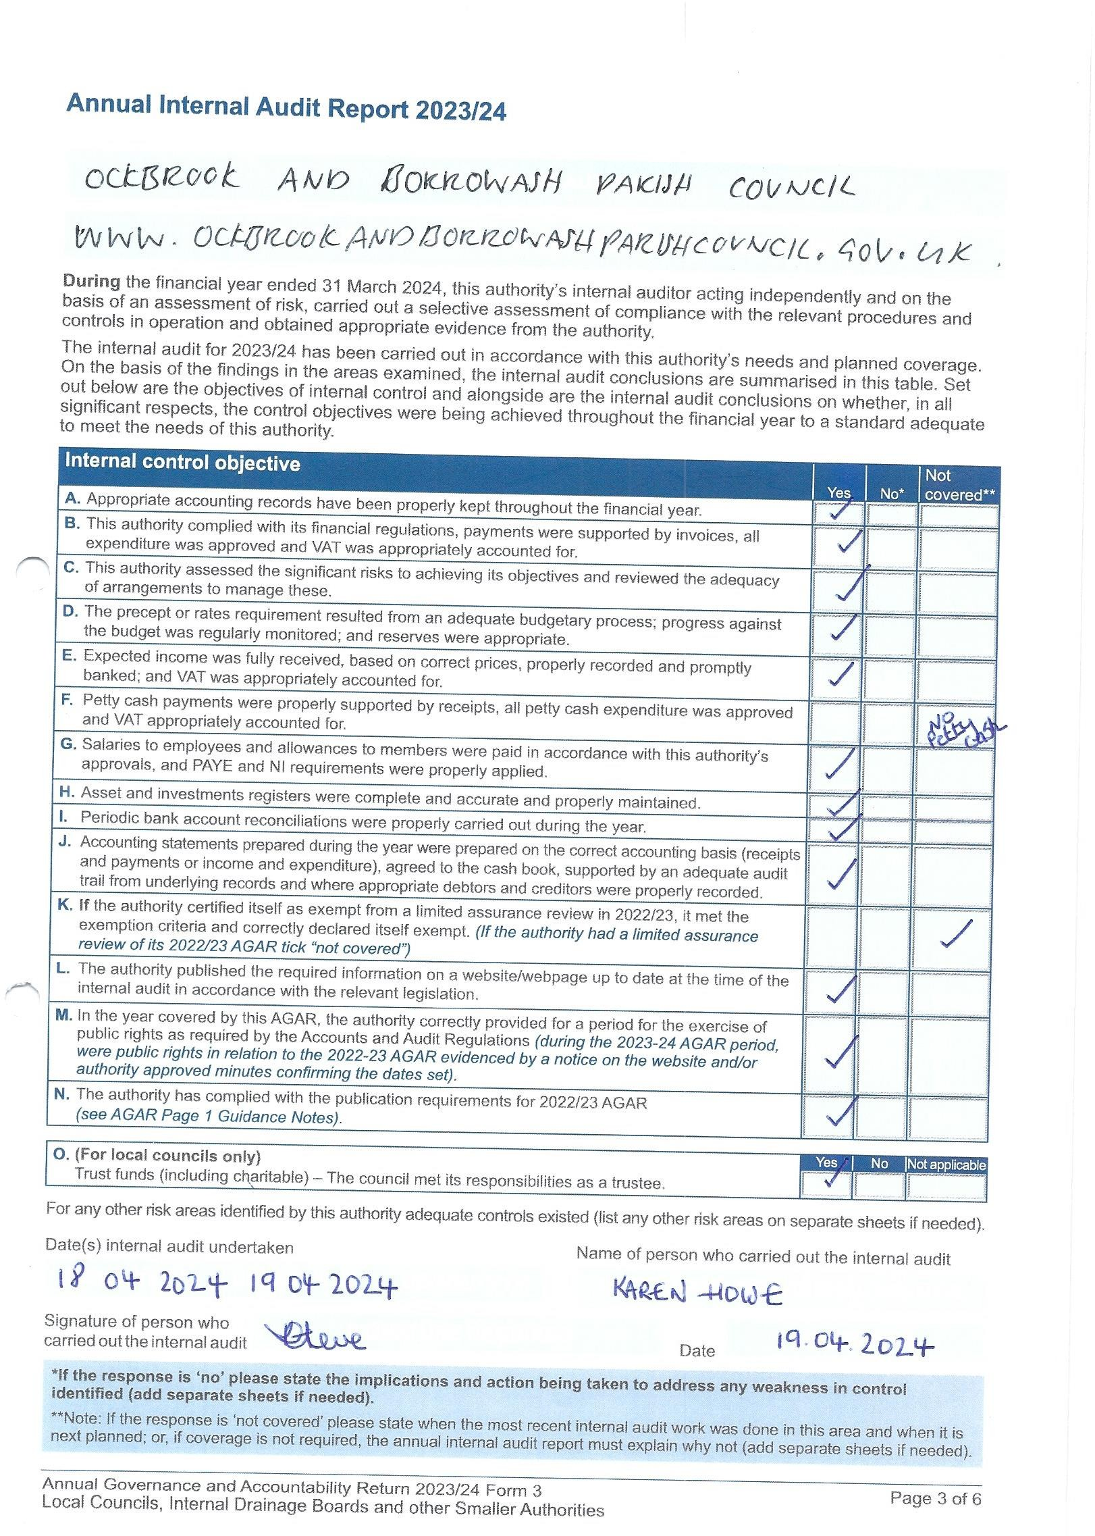

### **Appendix 6 –** Correspondence receivedUp To 21/04/24.

Emails/letters received from members of public:

* Request for information as to why the Parish Council have increased the precept – answered, mainly due to loss of concurrent functions and the Borrowash toilet and normal yearly increases. (1)
* Informed of two dangerous potholes – logged with DCC and informed resident how they can log them themselves. (2)
* Request for information on what the concurrent functions covers and how else the Parish Council receive income –concurrent functions covers a proportion of ground maintenance, wages, playground repairs, allotment water, hanging baskets, Christmas lights and cemetery running costs. Income comes via the precept, burials, allotments and hall hiring. (3)
* Thank you for organising the annual parish meeting and for the donation from the chair. (4)
* Thank you for the donation from the chair. (5)
* Request for information on what each house band pays for their council tax – suggested they contact EBC for the information. (6)
* FOI request for all information on the change of the green belt for two areas in Ockbrook – only information in the office to mention this was minutes from 2012-2019 which were forwarded. (7)
* Cc’d into emails between a resident and EBC regarding their land. (8)
* Request for further information held in the office regarding their land to be forwarded – no information could be forwarded as the information is not in the office. (9)
* Cc’d into emails between a resident and EBC regarding their concerns of their neighbours house being rennervated. (10)
* Request for information as to why the office isn’t holding certain information, why items were not minuted and what audits are done when a new set of Councillors come into power- unable to answer about the information and recording of information in the minutes as this was before my time and that when new Councillors start there are no audits done just the normal yearly ones. (11)
* Letters regarding the weight limit campaign – all forwarded to Councillor G Maskalick. (12)
* Thank you for the donation given to the group from the chair. (13)
* Query if permission is needed to install no dog fouling signs on the grass verges- would need to talk to DCC as the verges belong to them. (14)
* Will EBC reduce concurrent functions again? – none will be available 2025/26. (15)
* Hall hiring enquiries and updates. (16)
* Allotment enquiries, complaints and updates. (17)

Other emails received:

* Clerks and Councils direct – informed the Local Councils Update will no longer be issued. (18)
* Information from Over The Wall. (19)
* Connecting Erewash Week events – advertised on Facebook and the notice boards. (20)
* Request for information as to the requirements the council need to open an aesthetic clinic – informed them to contact EBC. (21)
* Yearly domain name confirmation - all correct. (22)
* Request for grounds work within the parish. (23)
* Community information and advice event – will be advertised after the election. (24)
* Email from the PCSO regarding setting up a speedwatch group – informed them one had been sent up by a community group. (25)
* Response from the Crime Commissioner regarding reducing the speed to 30mph between Borrowash and Spondon – would need to contact DCC. (26)
* Response from a Spondon ward Councillor regarding reducing the speed to 30mph between Borrowash and Spondon – they would also like to see this being reduced and have asked their traffic offices to contact me. (27)
* Response from a Spondon Ward Councillor regarding reducing the speed to 30mph between Borrowash and Spondon – They agree and will contact highways/traffic management and get back to me. (28)
* Enquiry as to if we would like a CWGC green sign installed at Balmoral Road Cemetery due to having a commonwealth war grave – Yes. (29)

Emails received from EBC:

* Tree preservation conformation order – 6 Cedar Drive, Ockbrook. (30)
* Notification of tree preservation order – Youth Community Centre, Borrowash. (31)
* Walking week information – on Facebook and Notice boards. (32)
* Core strategy new hearing date – forwarded to Councillors. (33)
* Cc’d into an email regarding the playpark gate – in the process of being fixed. (34)
* Response to the Clerks email regarding a residents concern about very large trees on someone else’s land at the bottom of their garden – they need to carry out a land registry search to find the owner, EBC can only help if the tree is in danger of failing, updated resident. (35)
* Planning meeting agenda and minutes. (36)

Emails received from DCC:

* Reminder of the Parish and Town Council Liaison forum on the 16th. April – forwarded to Councillors. (37)
* Free online safety event on the 29th. April – forwarded to Councillors. (38)
* Update on the Clerks and Councillor R Parkinsons request for information on the proposed pedestrian crossing in Borrowash – will chase up the final proposed drawing. (39)
* Proposed pedestrian crossing design – forwarded to Councillors to comment on by the 29th. April. (40)
* Parish and Town Council liaison forum slides – forwarded to Councillors. (41)
* Community news x 2 – on website and Facebook. (42)

DALC updates and April newsletter – Forwarded to Cllrs (43)

Numerous emails received from NALC - forwarded to Cllrs. (44)

SLCC updates and news bulletins. (45)

ICO updates. (46)

Rural action newsletters. (47)

The Countryside Charity Derbyshire newsletter. (48)

Local Councils Update. (49)