# OCKBROOK & BORROWASH PARISH COUNCIL

# The Parish Hall, Church Street, Ockbrook, Derby DE72 3SL

Tel: 01332 664100/ 07860 702904 Email: Clerk@ockbrookandborrowashparishcouncil.gov.uk

15th July 2024

To the Chair and Councillors of the Cemeteries Committee for Ockbrook and Borrowash Parish Council,

You are summoned to attend a Cemeteries Committee meeting of the Ockbrook and Borrowash Parish Council to be held in the Parish Hall, Ockbrook, immediately after the Planning and Environment Committee on Wednesday 24th July 2024.

Yours sincerely,

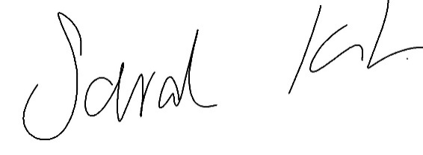

Sarah Kitchener

Clerk and RFO

Ockbrook and Borrowash Parish Council

## Agenda.

1. To receive apologies for absence.
2. To confirm the minutes of the previous meeting held on the 19th June 2024.
3. Variation of the order of business.
4. Declaration of members interests
5. Committee items for Discussion/Action/Update.

* Look into having the cemetery open for an extra hour during the summer period.
* Consider what to do with grave surrounds in the cemetery that were installed without permission.
* Consider what to do with memorabilia left on the cemetery benches.
* Discuss what to replace the poppy cross with.
* Discus the possibility of having a Christmas Choir at the cemetery.
* Consider installing a flagpole for Balmoral Road cemetery.
* Consider the Parish Council installing a bench within Balmoral Road cemetery.
* Consider allowing small Christmas trees onto the plots, to be removed by the 12th day and agree a maximum size.

1. Date of the next Cemeteries Committee meeting – 25th September if necessary.