# OCKBROOK & BORROWASH PARISH COUNCIL

# The Parish Hall, Church Street, Ockbrook, Derby DE72 3SL

Tel: 01332 664100/ 07860 702904 Email: Clerk@ockbrookandborrowashparishcouncil.gov.uk

16th September 2024

To the Chair and Councillors of the Cemeteries Committee for Ockbrook and Borrowash Parish Council,

You are summoned to attend a Cemeteries Committee meeting of the Ockbrook and Borrowash Parish Council to be held in the Parish Hall, Ockbrook, immediately after the Recreation Committee meeting on Wednesday 25th September 2024.

Yours sincerely,

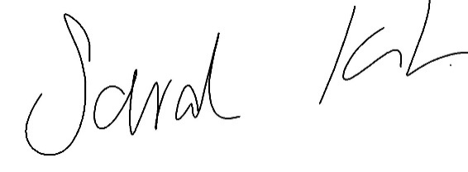

Sarah Kitchener

Clerk and RFO

Ockbrook and Borrowash Parish Council

## Agenda.

1. To receive apologies for absence.
2. To confirm the minutes of the previous meeting held on the 24th July 2024.
3. Variation of the order of business.
4. Declaration of members interests
5. Committee items for Discussion/Action/Update.

* Agree to the placement of the three CCTV cameras.
* Update members on the proposed Christmas Choir as discussed in Julys committee meeting.
* Consider closing the cemetery to non-residents.
* Discuss and agree the proposed budget for 2025/26 to go to the Finance committee meeting in November – see appendix 1.

1. Date of the next Cemeteries Committee meeting – 20th November 2024 if necessary

image showing the proposed budget