# OCKBROOK & BORROWASH PARISH COUNCIL

# The Parish Hall, Church Street, Ockbrook, Derby DE72 3SL

Tel: 01332 664100/ 07860 702904 Email: Clerk@ockbrookandborrowashparishcouncil.gov.uk

16th September 2024

To the Chair and Councillors of the Recreation Committee for Ockbrook and Borrowash Parish Council,

You are summoned to attend a Recreation Committee meeting of the Ockbrook and Borrowash Parish Council to be held in the Parish Hall, Ockbrook, immediately after the Hall Committee meeting, on Wednesday 25th September 2024.

Yours sincerely,

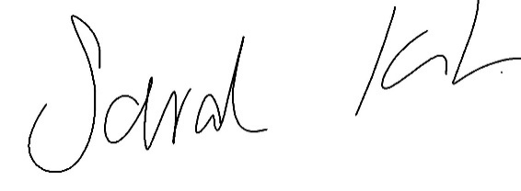

Sarah Kitchener

Clerk and RFO

Ockbrook and Borrowash Parish Council

## Agenda.

1. To receive apologies for absence.
2. To confirm the minutes of the previous meeting held on the 20th September 2023.
3. Variation of the order of business.
4. Declaration of members interests
5. Committee items for Discussion/Action/Update.

* Discuss and agree the proposed budget for 2025/26 to go to the Finance committee meeting in November – see appendix 1.

1. Date of the next Recreation Committee meeting – 20th November 2024 if necessary.

### image showing the budget breakdoiwn