# Minutes of the Ordinary Meeting of Ockbrook and Borrowash Parish Council.

# Held at the Ashbrook Centre, Borrowash on Wednesday 4th September 2024 at 19:00.

Councillor G Maskalick opened the meeting with a tribute to the late former Councillor Jayne Locke.

As chair it is with great sadness that I report the passing of former Councillor Jayne Locke this past August. Jayne was the loving wife of EBC Councillor Richard Locke, and they both served as Parish Councillors at the same time until May 2023, adding a real dynamic duo to the Parish Council.

To serve on the Parish Council is indeed an honour for anyone as it is strictly a voluntary role even though elected. In other words, one gives their time and passion to serve the parish and try to make it a better place. Jayne Locke became a Parish Councillor and more than fulfilled her role. She was someone the community looked to for help, guidance and support. She was a community leader who influenced decisions for the benefit of the people of Ockbrook and Borrowash and her contribution to the parish and Parish Council will be remembered with the greatest of respect.

Jayne held many posts during her time on the Parish Council. She was vice chair of the burials committee, vice chair of the halls committee, chair of the recreation committee and served on the finance and HR committee. Her highest office was that of vice chair of the Parish Council and she took on that role with great professionalism and confidence. All the committees she served on succeeded in doing good work and she was the driving force behind the bench by the war memorial in Ockbrook. It is an incredible bench placed in an incredible position in our parish. The project was done with great care and certainly adds dignity to the area.

Perhaps Jaynes biggest role was as vice chair when she stepped forward to chair the handover meeting in May 2023. She fulfilled a parish constitutional duty with style and grace. I can remember when she was performing this duty, her husband Richard sat in the front row with a smile and facial expressions that showed such pride in Jayne. I also remember when Jayne went back to sit next to Richard after the handover, she smiled back at him and both Richard and Jayne stayed for the rest of the meeting as observers.

I recall when I served on the Parish Council at the same time as Jayne that she brought much common sense to debate and was always willing to do her share of the work. I also remember fondly that when Jayne entered either the Parish Hall or Ashbrook Centre one knew she had arrived. Always a bubbly greeting for everyone and made it a point to ask everyone individually how they were doing. She was always willing to listen to what others had to say, but was not afraid to let you know when she disagreed in the kindest of ways. She supported everyone and what they wanted to attain on the Parish Council and everyone on the Parish Council certainly supported Jayne with her elevation to vice chair as testament to that.

Richard we can only imagine the grief and pain you feel. Everyone on the Parish Council and I am sure the whole of the parish extend our deepest condolences. I am sure you will be holding onto the memories of love and joy you shared with Jayne. Those who served with her on the Parish Council will hold onto those memories of how she worked to make our community stronger.

At this time I would ask everyone who can stand to rise and join us in a minutes silence of prayer and reflection to honour former Councillor Jayne Locke.

A minutes silence was then held.

## Public Speaking.

### Councillor Mark Alfrey – Update regarding EBC’s rewilding scheme for 2025.

* Councillor Mark Alfrey was elected to this role in May and engaged with the local Parish Councils regarding this new project.
* There will be future engagements to explain how this project will go forward by explaining the new policy that he will be producing.
* Tonight is to give residents the opportunity to ask questions regarding the scheme.

Councillor G Maskalick asked how flower seeding will work and is there anything the Parish Council can do to help? Councillor M Alfrey responded that rewilding and flower seeding are two separate entities. Wildflower seeding is a sustainable planting design, the wildflowers are put into place and the seeds are collected yearly which ensures no further money needs to be spent. Rewilding has caused issues this year and a policy is being produced to be implemented in March 2025. Councillor M Alfrey has been working with an individual who has produced an innovative project in Lincoln, they identified and planted species specific to Lincoln, having the one initial outlay, then the crops are used for future flowers, this was done with the help of local groups.

A member of public mentioned Harrington Green that has had one cut this year and asked if this is what we are to expect again next year? Councillor M Alfrey responded that this would not happen again. The idea was to allow all spaces to grow, the seed bank would then be looked at to decide if this is an area that can be rewilded or not, if it isn’t fit for purpose it will then get removed. There have been teething issues this year and there is a need to ensure this doesn’t happen again.

Councillor J Fraser-Burton asked if it was possible to adopt a piece of land to maintain it? Councillor M Alfrey responded that this is possible, you would have to contact Head of Service Tom Haddock who would assess if the land was disposable, this would then go to the full council to decide.

Councillor A Dunn commented that the main issue was the lack of communication from EBC. Councillor M Alfrey responded that he noted this when he started the role stating that engagement with the local communities should have happened prior to May, a programme will be put together over the next eight weeks then between January and March he will be going out to the community to explain the programme.

Councillor J White asked why all the children’s play areas have not had their grass cut, stopping the children from being able to use these areas. Councillor M Alfrey responded that this will not happen next year and the policy being developed will correct this.

### Members of Public

* A member of public had requested a meeting with the Parish Council to discuss their issues with Balmoral Cemetery which was refused. There are still may questions unanswered, they understand that the rules changed in July but this should have no impact on them as they bought the plot about three years ago. Looking at the minutes from July there will be no retrospective charge for already installed grave surrounds but they are going to be charged £2,500 for their graves headstones and surround. This has been escalated to Councillor James Dawson who will be talking to the monitoring officer. They are still to receive the deed for these plots and feel they are being unfairly treated. The Clerk thought that the deeds had been sent out but will look into this. Councillor G Maskalick commented that the 2014 rules stated no grave surrounds but this was never enforced, which was unfair for relatives and the Parish Council and asked for three Councillors to request an extraordinary meeting to discuss their issues.
* A member of public asked that due to Councillor G Maskalick changing from an Independent Councillor to a Labour Councillor why don’t you resign as a Parish and Borough Councillor and re-stand? Councillor G Maskalick commented that this didn’t happen to a previous Councillor who was removed from the Conservative party and he would not be resigning.
* A member of public asked if planning permission had been granted for the Harrington field, Councillor G Maskalick responded that the field had been sold but nothing had gone to planning yet.

At this point Councillor J Fazackerley handed in her resignation as a Parish Councillor to the chair and left the meeting.

* The member of public continued that when they build on Harrington Green the surface water will now have nowhere to go which will increase the flooding problems for the village. Neither Severn Trent nor the Environment Agency are taking responsibility for this. Councillor G Maskalick responded that his objections need to be sent to EBC, and he will forward his findings to the Clerk.
* A member of public mentioned that they were unaware of there being two proposed routes for the pylons. Councillor G Maskalick responded that the alternative route would go down the M1 corridor, Andy Cotton (a parish resident) produced a document showing how the alternative route is a better idea, this has been circulated online.

### Derbyshire County Council Report.

No report was submitted.

### Erewash Borough Council Report.

Councillor G Maskalick submitted a report – see appendix 1.

### Derbyshire Constabulary Report – see appendix 2.

Ashbrook Youth Group - see appendix 3.

## Present.

Councillors G Maskalick (Chair), S Cresswell, J Fraser-Burton, G Markwell, A Dunn, K Eaglesham-Atkins and T Stevenson

## Also, Present.

S Kitchener (Clerk and RFO), Mayoress K Fennelly, Councillors J White, W Major, M Alfrey and F Phillips and 14 members of public.

## 108/09/24 Noted Apologise for Absence.

Councillors S Fraser-Burton (prior commitment), K Thomas (family matter) and C Millward (illness).

## 109/09/24 Declarations of Members Interests.

None.

## 110/09/24 Dispensations.

None.

## 111/09/24 Variation of Order of Business.

The pylon motion will be discussed before the approval of the minutes.

## 112/09/24 Accept the Below Motion From the Parish Council to the National Grid regarding the Route of the Pylon Upgrade.

Ockbrook and Borrowash Parish Council and residents understand the need for the National Grid to upgrade infrastructure so we have energy security as a nation and that energy is to be green energy in the future. We also understand and have studied the two proposed routes: EDN1 and EDN2. Looking carefully at the two routes we have come to the conclusion that EDN1 is the preferred route we support for the following reasons:  
  
EDN2 seems to have several drawbacks to it. The route will cost £20 million more to complete than EDN1 and will have to cross marsh land and a river which will be enormous engineering work to complete. It will also affect more people starting in Amber Valley, Morley, West Hallam, Ockbrook, Borrowash, Elvaston, Thulston, Aston on Trent just to name some areas locally.  
  
EDN1 basically goes down the M1 corridor and would terminate at Radcliff Power Station instead of Willington. It is a shorter distance, cheaper to build and no marsh land to transverse and affects far fewer areas of natural beauty. It would also affect less wildlife as the M1 corridor is already built upon.    
  
Using EDN1 as the preferred route seems the logical choice and we look forward to your reply to our community request.

**RESOLVED** proposed by Councillor J Fraser-Burton, seconded by Councillor S Cresswell and all unanimously agreed to the above motion. **ACTION** Clerk to forward the above and the online petition to the National Grid and the planning department at EBC, also to write to Mr A Cotton thanking him for the report he produced.

## 113/09/24 Approve the Minutes of the Ordinary Parish Council Meeting, Held on the 3rd July 2024.

**RESOLVED** Proposed by Councillor S Cresswell, seconded by Councillor G Markwell and all unanimously agreed that the minutes be approved as a true record and were signed by the Chair at the meeting.

## 114/09/24 Items to be Taken into Private Session.

None.

## 115/09/24 Report of the Parish Clerk/RFO.

Updates since Junes meeting:

* The burial regulations and fees have been updated, placed on our website and forwarded to the Funeral Directors and stone masons.
* Emailed the friends of Balmoral group asking for their ideas on which flowers to plant in Balmoral Cemetery and where they would like them to go – they have not responded.
* Wrote to planning requesting a full environmental impact assessment for the proposed solar farm – EBC have confirmed that this is a requirement for the application.
* The Balmoral Road Cemetery notice board will be renovated w/c 9th September 2024.
* Remembrance Day update:
  + Started working on the road closure application with EBC, just need to forward the new public liability certificate when we get it.
  + Rev Tim Sumpter has confirmed he will do the service.
  + The Parish Council wreath has been booked.
  + Some readers have confirmed their attendance, will need to chase a few more up.
* The notice of unaudited accounts was removed from the notice board on the 18th July, this was up slightly longer than needed, with no interest in anyone looking at the accounts.
* The public notice for memorial testing was put up in Balmoral Cemetery on the 23rd July and taken down on the 30th August, giving residents longer than the required 30 days for any objections. All Saints were sent one to install themselves which I have seen in their notice board.
* Christmas light switch on update:
  + Long Eaton Silver Prize Band have confirmed their attendance for both venues.
  + The Deputy Mayor has been booked for both venues as the Mayor is unavailable on the dates – awaiting confirmation on this from EBC
* We have obtained the foundation award for NALCs local quality council award scheme. Only failed on one section otherwise and we would have received the quality award. This section needs a lot of work doing on it regarding consultations with the public and producing an action plan, I was able to work on all the other sections but this needs the Parish Council to do work on it. Wendy Amis the Chief Officer from DALC will present the award in our October meeting.
* Done a lot of work on the budgets, all cost centre information has been sent out to each committee for them to amend if necessary, these will be discussed in the committee meetings being held on the 25th September.
* A lovely resident has offered to litter pick in both villages when they walk their dog, so I have supplied them with bags and a litter picker.
* The external audit has come back with no comments on – the website will be updated and the conclusion of audit will go up in the notice boards of the three wards.
* Had to organise a new quarterly playground inspector. We were let down by the previous one with me having to chase for each inspection to be done and then chasing again for the reports. Their last inspection should have been done in May, which I chased for over 2 month and heard nothing back. The Streetscape rep recommended someone, who charges the same as the other inspector and can even fix the equipment for us. They have already done the first inspection and sent in their report and have informed me of when the inspections will be done for the full year.
* The William James Charity bank account is now up and running, the charity commission has been updated and the money will be transferred on the next payment run.
* All letters have been sent out regarding retrospective applications for the grave surrounds. There are some that I have no contact details for so signs will be placed on the headstone asking them to contact me.

## 116/09/24 Report of the Chair.

* Met with resident regarding Bare Lane Park, they were supportive of the rewilding but are looking forward to it improving next year and were happy to see the football pitch had been reinstated.
* Met with residents about noise and parking on Flood Street, there is a concern regarding noise from the businesses at night.
* Met with owners of the minority owned businesses in Borrowash during the two weeks of riots, they all reported there were no problems.
* Have been going to Balmoral Road Cemetery doing some gardening and waste bin emptying, spoke to some visitors down there and they were all happy with the work the Parish Council was doing in the cemetery.

## 117/09/24 Finance, HR, Contractors and General Purposes.

The minutes were noted from the committee meeting held on the 24th July 2024.

### Accept Accounts for Payment – see appendix 4.

**RESOLVED** Proposed by Councillor G Markwell, seconded by Councillor A Dunn and all unanimously agreed to accept the payment list.

### Accept the Bank Statement Reconciliations. – see appendix 5.

* June and July 2024 HSBC Account.
* June n2 and July 2024 Unity Trust Account.

**RESOLVED** Proposed by Councillor K Eaglesham-Atkins, seconded by Councillor T Stevenson and all unanimously agreed to accept the bank statement reconciliations.

### Accept the Income and Expenditure Breakdown for the First Quarter, April to June – see appendix 6.

**RESOLVED** Proposed by Councillor S Cresswell, seconded by Councillor G Markwell and all unanimously agreed to accept the income and expenditure breakdown.

### Agree to Accept the External Audit – see appendix 7.

**RESOLVED** proposed by Councillor A Dunn, seconded by Councillor G Markwell and all unanimously agreed to accept the external audit.

### Consider Holding Public Consultations in October Regarding the Proposed Budget.

There will be two proposed budgets to go onto the website for residents to vote on, this enables them to have an idea of where the money might get spent and they will have some input into the spends. There will also be appointment only surgeries for people that have no access to a computer.

**RESOLVED** proposed by Councillor K Eaglesham-Atkins, seconded by Councillor T Stevenson and all unanimously agreed to hold consultations regarding the budget. **ACTION** Clerk to organise.

### Agree to Accept the New Insurance Quote.

The new quote is for £3162.40 which is an increase of £36.64 from last year.

**RESOLVED** proposed by Councillor S Cresswell, seconded by Councillor G Markwell and all unanimously agreed to accept the new quote and to freeze it for the next three years. **ACTION** Clerk to accept the quote.

## 118/09/24 Recreation.

Councillor J Fraser-Burton updated members:

* The inflatable and climbing wall days were very successful, there was a slight change to the inflatables as they couldn’t fit it all on their van, so they provided extra bouncy castles at no extra cost, this worked very well and will be looked at for next year.
* There will be the option for a dedication to go next to the lamppost poppies costing £5.00, all monies received will go to the British Legion.
* Christmas stalls have started to get in contact, we might have to rethink the switch on in Ockbrook for 2025 due to The Royal Oak going up for sale.
* Looking at providing Easter and Halloween parties for 2025.

## 119/09/24 Cemeteries.

The minutes for the committee meeting held on the 24th July 2024 were noted.

### Agree to Purchase 3 Solar Powered CCTV Cameras at £59.99 Each For the Financial Year 2025/26, and to Decide Where to Place Them.

Councillor G Maskalick would like to purchase 4, so we have a spare and for this to come out of the Chairs allowance for this financial year, CCTV signs would also need to be purchased. The cemeteries committee would then need to agree as to the placements of the cameras and who will install them.

**RESOLVED** proposed by Councillor S Cresswell, seconded by Councillor K Eaglesham-Atkins, Councillor T Stevenson voted against this but the rest all agreed to the purchase of the CCTV cameras. **ACTION** Clerk to purchase the cameras and signs.

## 120/09/24 Halls.

There was nothing to discuss.

## 121/09/24 Allotment.

### Consider Adding the Below to the Allotment Tenancy Agreement for 2025.

Use of Weedkiller

The use of weedkiller, such as glycophosphate, on grass paths between or around plots is forbidden.

In certain cases, where other methods to control weeds have failed, eg under hedges or for persistent, nuisance weed such as ivy and bindweed, selective spraying may be justifiable providing care is taken and permission has been grated from the Parish Council. Please do not treat weeds during wet or windy conditions to prevent leakage onto neighbouring plots.

Although manufacturers may claim that their product is environmentally safe, there is mounting evidence that glycophosphate harms various animals and insects and harming one class of animal results in harm to other classes of animal who depend on them.

**RESOLVED** Proposed by Councillor S Cresswell, seconded by Councillor G Markwell and all unanimously agreed to add the above. **ACTION** Clerk to make the changes.

### Consider the Below Changes to the Allotment Tenancy Agreement for 2025.

The additional sentence would be added to 2 (c) after the second sentence.

 Once a tenant has had a plot for 12 months, at least 75% should be cultivated.

The Parish Council will carry out regular inspections.  Enforcement letters will be issued if a plot is overgrown and/or not being sufficiently cultivated or is being used as a storage facility for rubbish.

**RESOLVED** Proposed by Councillor G Markwell, seconded by Councillor T Stevenson and all unanimously agreed to add the above. **ACTION** Clerk to make the changes.

Councillor S Cresswell updated members:

* Three plots have changed hands over the summer, the new tenants are working very hard.
* Thank you to Councillor G Markwell for his help in removing rubbish from Shacklecross.
* Quotes are coming in for the security fencing at Elm Street and we can now apply for a grant from the National Lottery.

## 122/09/24 Planning and Environment.

The minutes for the committee meeting held on the 24th July 2024 were noted.

### Agree to the Clerk Getting the Defib Unit at the Ashbrook Centre Moved Due to EBC Fencing the Site Off, Discuss Possible Alternative Placements.

A discussion was held**,** theClerk is to obtain quotes from an electrician to remove and reinstall the unit and bring these to the next meeting to be agreed on. As the defib was installed at the Ashbrook Centre at the request of the youth group the Clerk will contact the Ashbrook Centre Trustees to see if it can be moved to their front gate, an alternative position would be by the Prior Way Shops.

**RESOLVED** proposed by Councillor A Dunn, seconded by Councillor G Markwell and all unanimously agreed to the above. **ACTION** Clerk to organise.

### Discuss and Highlight Our Concerns Regarding the Planning Application ERE/0724/0071.

**RESOLVED** proposed by Councillor G Markwell, seconded by Councillor T Stevenson and all unanimously agreed to object on the same grounds as before. **ACTION** Clerk to write to planning.

### Agree to Support the Below Motion.

Agree to support a 7.5 tonne weight limit through Ockbrook and that the findings of our PC survey are represented accurately in DCC Councillor Wayne Major's report. We feel that quality of life has been strongly affected negatively by HGV trends through the village of Ockbrook over the past several years in a physical and mental health manner for all residents and especially those living on Green Lane, Bare Lane, Flood Street and Victoria Ave. Introducing and enforcing a 7.5 tonne weight limit will bring back our village way of life and relieve the mental stress many are suffering from because of uncontrolled access and weight of HGV's at present.

**RESOLVED** proposed by Councillor A Dunn, seconded by Councillor G Markwell and all unanimously agreed to support the above. **ACTION** Clerk to write to planning.

## 123/09/24 Correspondence Received – see appendix 8.

The correspondence received and listed in the agenda were available at the meeting.

## 124/09/24 Date and Time of Next Meeting.

The next Parish Council meeting is scheduled to take place at the Parish Hall, Ockbrook on Wednesday 2nd October 2024 at 19:00.

## 125/09/24 Exclusion of Press and Public.

Nothing to report.

There being no further business the meeting concluded at 20:40.

### **Appendix 1-** EBC REPORT AUGUST 2024 – EBC Councillor Greg Maskalick

**18th JULY EBC Scrutiny Meeting**

There was a very important EBC Scrutiny meeting in July where we heard from the S151 Officer about EBC’s Statutory Responsibility for Housing. It was pointed out that providing housing for released prisoners will affect our finances greatly in the next few years and he even gave the dire warning that if not on our radars now, it could bankrupt us as a Council.

Instead of tackling this issue, the Conservative group was more concerned with promoting putting blue bin lids on brown bins for residents. I am going to continue to broadcast the crisis that’s around the corner that the S151 officer expressed.

More to come on this in future months.

**1st AUGUST Full Council Meeting**

This full council meeting was very interesting and took about 2.5 hours to complete. Much debate on rewilding and the Pylons coming through. There were many questions asked by the public on rewilding and Councillor Mark Alfrey (Environmental Portfolio) answered them all and talked about what has happened and what will happen in future. I felt all concerns were taken onboard and under Councillor Alfrey the whole project will take on better shape in years to come.

There was a motion about the pylons that was voted down even by the Green Party. It was a rather weak motion offering no solutions based on facts as no facts were sighted in the motion.

You can find all about these two items and more online at EBC website. The draft minutes are available.

**CONSULTATIONS:**

The public rightly so wants to be consulted with on many issues. Sometimes we miss these opportunities because no one bothered to tell us. Well, here are two very important consultations that you can participate in. Please do so. Your voice matters.

**Derbyshire Police and Crime Plan Consultation**

Police and Crime Commissioner Nicolle Ndiweni has launched a major survey giving residents an unprecedented role in the design of plans to build a safer and more inclusive Derbyshire.

The survey asks residents about the issues that cause them fear and concern and warrant extra resources and focus from the police to keep them safe.

These priorities will form the foundations of her Police and Crime Plan and will determine where and how she will invest critical public funding to improve their safety in the future.

**Derbyshire County Council**

Derbyshire County Council (DCC) is committed to listening and learning from local people and provide important services to residents, visitors, employers and employees in the county and are always looking for ways to improve them.

Finding out what people think of the services DCC provide is essential because it helps the council to work out how to improve them and their commitment to consult ensures this will happen. Consultation is the process of informed communication between DCC and the users of their services prior to the council making a policy decision or determining changes to service delivery.

Details about current DCC consultations carried out in the past and those planned for the future can be found at [Derbyshire County Council Have Your Say](https://www.derbyshire.gov.uk/council/have-your-say/consultation-search/consultations.aspx) where you can read about the purpose of each consultation, find out who is being consulted and how to get involved.

**Crossing The Floor**

‘I am pleased to announce that I have joined the Labour Party and am crossing the floor from my position as one lone Independent Councillor to Labour at Erewash Borough Council.

Over the last year and a half, I have taken soundings from very, very many residents of Ockbrook and Borrowash and have found that public opinion has shifted significantly, and people want change delivered with Labour.

This is not a decision taken lightly but it has led to my firm conviction that only Labour locally and nationally has the policies that will truly help our Parish and our families.

As the lone Independent Councillor, I did have some influence on matters initially, but as the voices of negativity grew louder, it became more difficult for my voice to be heard for the people of Ockbrook and Borrowash whom I am so very proud to represent.

The two other EBC Councillors for our Parish consistently chose to pursue the politics of division rather than uniting in the best interests of the people we jointly represent and consequently there was no voice at the table for positive change and progress to be made in our villages. Now that I have crossed the floor, I do so with the confidence that all parishioners will now be represented from a position of strength, equality and a real vision of what the future will be and can be for all of us.

Being in a position to give Ockbrook and Borrowash a stronger voice at Erewash Borough Council will enable me to help shape policies that will be of benefit to all residents of our Parish – and indeed, to everyone who lives in the wider Borough of Erewash. I have full confidence above all in the fairness, equality and sound leadership of Cllr Dawson at Erewash and Keir Starmer as Prime Minister nationally.

Nobody ever said that change happens overnight or that it’s easy! The process of making beneficial changes can be uncomfortable sometimes, welcome at others but the journey is worth it because the changes that Labor is making will bring us all a more positive, supportive and inclusive future.

I look forward with the greatest enthusiasm to delivering the very best for everyone living in Ockbrook and Borrowash as a Labour Councillor at Erewash Borough Council. I’ll be here for you now as always!’

**Helen Clark, Chair of Mid Derbyshire Constituency Labour Party added:**

‘We are absolutely delighted that Greg is now a member of Mid Derbyshire Labour Party. He has been well known to people in our villages as a tremendous local champion for many years; respected across the political divide because of his tremendous integrity, ‘can do’ attitude and the sheer positivity of his approach to everything.

On July 4th 2025, people in our country voted overwhelmingly for the change that only Labour can deliver. Greg will ensure that the people he represents in Ockbrook and Borrowash have their voices heard and their needs met every step of the way.’

### **Appendix 2 –** Derbyshire Constabulary Report.

|  |  |  |
| --- | --- | --- |
|  | May | June |
| Violence and sexual offences | 14 | 16 |
| Anti-social behaviour | 4 | 2 |
| Public Order | - | 4 |
| Other theft | 2 | - |
| All other crime | 5 | 5 |

### **Appendix 3 –** Ashbrook Youth Group Report.

**ASHBROOK YOUTH GROUP, OCKBROOK & BORROWASH PARISH COUNCIL REPORT, September 2024**

This month sees the relaunched Ashbrook Youth Group celebrate its 3rd birthday as we welcome our new Year 5 intake to our youth group family; we hope they will enjoy many years with us.

Over the last 6 months users have continued to enjoy games, arts & crafts, sports, the tuck shop & just chilling with their friends. Youth group runs over most weeks across the year, not just term time. Holidays can be quieter but we expect to soon be up to our regular 50 to 60 attendees!

As a part of our community we are aware that many families continue to face financial challenges. Over the school summer holiday we continued to provide something hot to eat, free of charge, for those who wanted it – this year's offers included pizzas, hot dogs, jacket spuds & the old favourite.... a chippy tea. All were enjoyed with sweet treats including ice lollies & muffins.

Youth group sessions are supervised by our fabulous leaders, Liz & Kerry who couldn't do it without our wonderful volunteers, Chris, Jono, Kay & Christine.

As always, youth group would like to thank the parish council for their continued financial support. 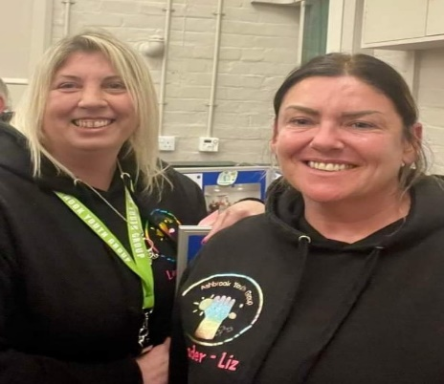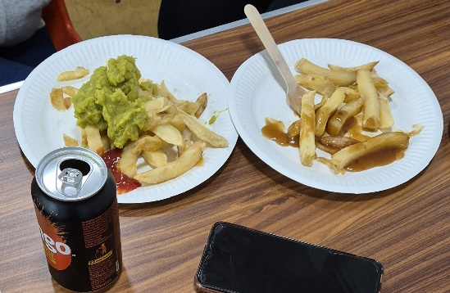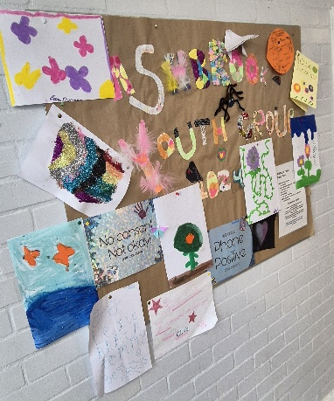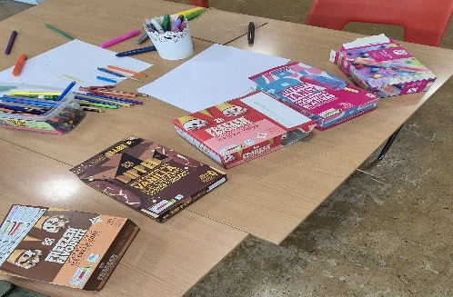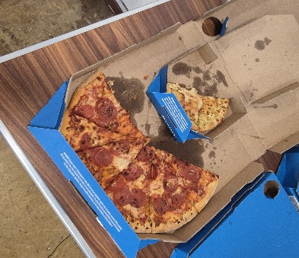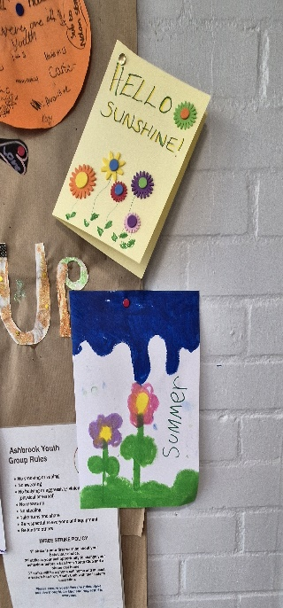s

### **Appendix 4 –** September 2024 payment list

|  |  |  |  |
| --- | --- | --- | --- |
| **Invoices to be paid** | - | - | minute agreed |
| Ashbrook Youth Group | £280.00 | Monthly donation –Sept | 229/12/23 |
| Simply Sparkle | £15.00 | Parish hall windows | - |
| EBC | £3429.90 | Aug payroll | - |
| Lisa’s | £275.50 | Aug hall clean | - |
| Fox Grounds Maintenance | £2263.80 | Aug works | - |
| Sarah Kitchener | £15.30 | Aug expenses | - |
| NALC | £60.00 | Local Council award scheme | - |
| William James Charity | £2281.09 | Transfer of charity funds | 264/03/24 |
| Pear Technology | £180.00 | Yearly fees | 24/05/24 |
| Acclimbatize | £940.00 | Climbing wall x2 | - |
| Pete Sadler | £80.00 | Sexton fee for Anderton | - |
| Hydro International | £591.00 | Maintenance visit and sim card | - |
| **Invoices already paid** | - | - | - |
| Signs Express | £414.00 | Parish hall sign | 60/06/24  81/07/24 |
| G Markwell | £9.00 | Balmoral gate key | 81/07/24 |
| Fox | £180.00 | Priorway park mow | 81/07/24 |
| Ashbrook Youth Group | £280.00 | Monthly donation – Aug | 229/12/23  81/07/24 |
| City Hygiene | £439.30 | Yearly fees | 81/07/24 |
| Roadkill Blues – J Gayton | £50.00 | Blues weekend grant | 57/06/24  81/07/24 |
| Roadkill Blues – J Calder | £50.00 | Blues weekend grant | 57/06/24  81/07/24 |
| Ding and John | £100.00 | Blues weekend grant | 57/06/24  81/07/24 |
| Gypsy Pop Music | £100.00 | Blues weekend grant | 57/06/24  81/07/24 |
| Simply Sparkle | £15.00 | Parish windows | 81/07/24 |
| Hydro International | £372.00 | Yearly charges | 81/07/24 |
| Streetscape | £450.00 | Playground repairs | 81/07/24 |
| EBC | £3411.53 | July wages | 81/07/24 |
| Lisa’s | £318.05 | July clean | 81/07/24 |
| Fox | £504.00 | Balmoral Cem extra mow | 81/07/24 |
| Fox | £2155.99 | July works | 81/07/24 |
| PKF | £504.00 | External audit | 81/07/24 |
| Sarah Kitchener | £18.90 | July expenses | 81/07/24 |
| Derby Diocesan | £327.40 | Faculty fee for memorial testing | 81/07/24 |
| Acclimbatize | £200.00 | Climbing wall x2 deposit | 81/07/24 |
| KCM inflatables | £580.00 | Inflatable balance 28/08 | 81/07/24 |
| KCM inflatables | £580.00 | Inflatable balance 17/08 | 81/07/24 |
| **Monthly direct debits** | - | - | - |
| British Gas | £74.19 | Elec 19/06-22/07 | 22/05/24 |
| British Gag | £29.46 | 22/07-23/08 | 22/05/24 |
| British Gas | £29.46 | Gas 26/07-30/07 | 22/05/24 |
| British gas | £22.42 | Gas 30/07-28/08 | 22/05/24 |
| Virgin | £64.80 | Broadband and phone July / Aug | 22/05/24 |
| Virgin | £64.80 | Broadband and phone Aug / Sept | 22/05/24 |
| O2 | £35.22 | Mobile | 22/05/24 |
| O2 | £35.22 | Mobile | 22/05/24 |
| Lloyds Bank | £296.21 | Stamps, sprayer, flags, paper, pens, tent pegs, cellotape | 22/05/24 |
| Lloyds Bank | £103.00 | Inflatable deposit x 2 | 22/05/24 |
| Everflow | £171.21 | Water 06/08/24-05/09/24 | 22/05/24 |
| Everflow | £123.58 | Water 06/09/24-05/10/24 | 22/05/24 |
| EBC | £23.00 | July cem rates | 22/05/24 |
| EBC | £23.00 | Aug cem rates | 22/05/24 |
| EBC | £325.00 | Cem trade waster | 22/05/24 |

All invoices listed have been examined, verified and certified by the Clerk/RFO.

### **Appendix 5 –** Bank Reconciliation

**June 2024 Bank Reconciliation - HSBC Account**

|  |  |  |  |
| --- | --- | --- | --- |
| **Bank Balance** | - | - | - |
| Bank s/m bal as at 01/04/24 | - | 24,778.50 | - |
| + total cash book receipts | - | 93,688.00 | - |
| - total Cashbook payments | - | 30,024.00 | - |
| **Cashbook Closing Balance** | - | **88,442.50** | - |
| - | - | - | - |
| **Bank Balance at 04/07/24** | - | **88,442.50** | - |
| - outstanding payments | - | 0.00 | - |
| + outstanding receipts | - | 0.00 | - |
| **Net Balance** | - | **88,442.50** | - |
| - | - | - | - |
| **-** | - | **-** | **Difference: 0.00** |

**July 2024 Bank Reconciliation - HSBC Account**

|  |  |  |  |
| --- | --- | --- | --- |
| **Bank Balance** | - | - | - |
| Bank s/m bal as at 01/04/24 | - | 24,778.50 | - |
| + total cash book receipts | - | 93,688.00 | - |
| - total Cashbook payments | - | 30,032.00 | - |
| **Cashbook Closing Balance** | - | **88,434.50** | - |
| - | - | - | - |
| **Bank Balance at 04/08/24** | - | **88,434.50** | - |
| - outstanding payments | - | 0.00 | - |
| + outstanding receipts | - | 0.00 | - |
| **Net Balance** | - | **88,434.50** | - |
| - | - | - | - |
| **-** | - | **-** | **Difference: 0.00** |

**June 2024 n2 Bank Reconciliation - Unity Trust Account**

|  |  |  |  |
| --- | --- | --- | --- |
| **Bank Balance** | - | - | - |
| Bank s/m bal as at 01/04/24 | - | 39,302.63 | - |
| Less items related to 23/24 | - | 8,334.33 | - |
| - | - | 30,968.30 | - |
| + total cash book receipts | - | 184,679.32 | - |
| - total Cashbook payments | - | 128,308.20 | - |
| **Cashbook Closing Balance** | - | **87,339.42** | - |
| - | - | - | - |
| **Bank Balance at 01/07/24** | - | **97,349.69** | - |
| - outstanding payments | - | 11,287.97 | - |
| + outstanding receipts | - | 1,277.70 | - |
| **Net Balance** | - | **87,339.42** | - |
| - | - | - | - |
| **Balance per Cashbook** | - | **87,339.42** | **Difference: 0.00** |
| - | - | - | - |
| Charity Accounts included in bank total: | - | - | - |
| William James | 2,281.09 | - | - |

**July 2024 Bank Reconciliation - Unity Trust Account**

|  |  |  |  |
| --- | --- | --- | --- |
| **Bank Balance** | - | - | - |
| Bank s/m bal as at 01/04/24 | - | 39,302.63 | - |
| Less items related to 23/24 | - | 8,334.33 | - |
| - | - | 30,968.30 | - |
| + total cash book receipts | - | 187,595.83 | - |
| - total Cashbook payments | - | 139,154.33 | - |
| **Cashbook Closing Balance** | - | **79,409.80** | - |
| - | - | - | - |
| **Bank Balance at 01/08/24** | - | **93,186.03** | - |
| - outstanding payments | - | 14,343.20 | - |
| + outstanding receipts | - | 566.97 | - |
| **Net Balance** | - | **79,409.80** | - |
| - | - | - | - |
| **Balance per Cashbook** | - | **79.409.80** | **Difference: 0.00** |
| - | - | - | - |
| Charity Accounts included in bank total: | - | - | - |
| William James | 2,281.09 | - | - |

### **Appendix 6 –** Income and expenditure breakdown for the 1st quarter.

|  |  |  |  |  |  |  |  |  |
| --- | --- | --- | --- | --- | --- | --- | --- | --- |
|  | ***Budget 2024/25*** | ***¼ 1***  ***Apr-June*** | ***Actual to date 2024/25*** | ***Forecast to year end 2024/25*** | ***Total forecast to year end***  ***2024/25*** | ***Variance to budget 2024/25*** | ***Variance to budget 2024/25*** | ***Notes*** |
| **Income** | £ | £ | £ | £ | £ | £ | % | - |
| Precept and Grant | 141,341 | 141,341 | 141,341 | 0 | 141,341 | 0 | 0 | - |
| Burials | 11,985 | 2,025 | 2,025 | 9,960 | 11,985 | 0 | 0 | - |
| Recreation | 2,605 | 266 | 266 | 2,339 | 2,605 | 0 | 0 | Most income from Nov onwards |
| Hall/lettings | 14,337 | 3,737 | 3,737 | 10,158 | 14,702 | 365 | 3 | Extra bookings, class time increases /decreases and cancelled bookings |
| Allotment | 4,088 | 6 | 6 | 4,082 | 4,088 | 0 | 0 | Rent comes in Dec onwards |
| Other | 575 | 381 | 381 | 194 | 575 | 0 | 0 | - |
| Environment/NP | 0 | 0 | 0 | 0 | 0 | 0 | 0 | - |
| VAT | 0 | 5,561 | 5,561 | 0 | 5,561 | 5,561 | 0 | - |
| **Total Income** | **174,931** | **153,317** | **153,317** | **26,734** | **180,051** | **5,120** | **-** | **-** |
| **Expenditure** | - | - | - | - | - | - | - | - |
| Parish Hall | 15,824 | 5,428 | 5,105 | 11,525 | 16,631 | 807 | 5 | - |
| Sal/miles/train/ chair allowance | 50,884 | 10,720 | 10,720 | 40,164 | 50,884 | 0 | 0 | - |
| Rec/ events | 11,117 | 898 | 898 | 10,219 | 11,117 | 0 | 0 | - |
| Environment | 12,321 | 1,854 | 1,854 | 10,617 | 12,471 | 150 | 1 | - |
| Grants | 8,000 | 2,660 | 2,660 | 5,340 | 8,000 | 0 | 0 | £679.52 refunded from grant given in 2021 |
| Gen/admin/bank charges/Subs/ ins/ utilities | 22,466 | 3,316 | 3,639 | 18,827 | 22,466 | 0 | 0 | - |
| Reserve build up | 20,000 | - | 0 | 20,000 | 20,000 | - | - | - |
| Burials | 21,048 | 5,180 | 5,180 | 16,228 | 21,406 | 360 | 2 | - |
| Allotments | 6,750 | 360 | 360 | 6,390 | 6,750 | 0 | 0 | - |
| VAT | 0 | 2,543 | 2,543 | - | 2,543 | 2,543 | - | - |
| **Total Expenditure** | **168,410** | **32,959** | **32,959** | **139,311** | **172,269** | **3,859** | **-** | - |
| - | - | - | - | - | - | - | - | - |
| **Total Income and Expenditure 2024/2025 (+surplus/-deficit)** | **6,521** | **120,359** | **120,359** | **-112,577** | **7,781** | **1,260** | **-** | **-** |
| **Balance carried forward from 2023/2024** | 30,968 | - | - | 2023/24 | 30,968 | - | - | - |
| **HSBC A/c 23/24** | 24,779 | - | - | - | 88,435 | - | - | - |
| **Forecast balances as at 31st March 2025** | **62,268** | - | - | 2024/25 outturn | **127,184** | **-** | - | - |

|  |  |
| --- | --- |
| **RESERVES** | £ |
| Reserve build up | 20,000 |
| Bi election | 6,000 |
| William James Charity | 2,281 |
| General reserves | 98,903 |
| - | **127,184** |

### **Appendix 7 –** External Audit.

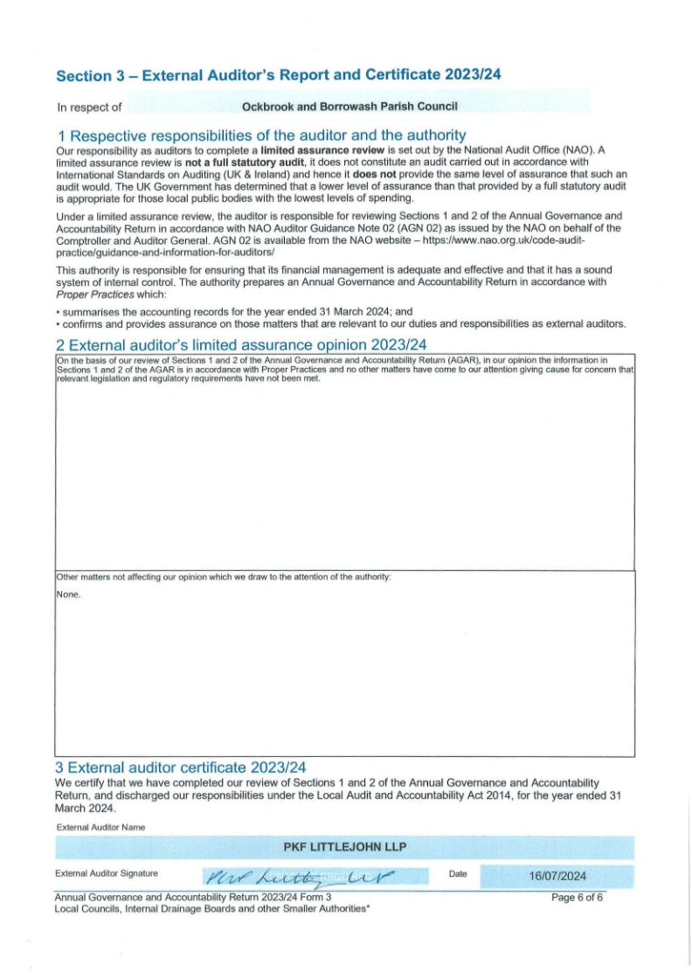

### **Appendix 8 –** Correspondence receivedUp 23rd August 2024

Emails/letters received from members of public:

* Request for a bus shelter to be installed opposite Quillings Way, Borrowash – this will be discussed during the budget meetings. (1)
* Complaint regarding graffiti on Prior Way bus shelter – forwarded to EBC. (2)
* Update on a meeting held at South Wigfield regarding the proposed pylons. (3)
* Complaint regarding the rewilding in the parish – requested for them to forward to EBC. (4)
* Thank you received from the scarecrow team for our support during this event. (5)
* Request for the date that the Blues festival donations will be paid – will be paid w/c 05/08/24. (6)
* Thank you for the donation from the chairs allowance for the rewilding done on plot 46 Elm Street, photos supplied. (7)
* Thank you received for agreeing to hold the Heritage Societies archives. (8)
* Copied into an email between a resident and Cllr G Maskalick regarding ownership of a strip of land in Borrowash. (9)
* Querry into if the Parish Council will be putting up bunting and flags for the Tour of Britain - forwarded to the recreation chair, this is not something that we will be doing. (10)
* Request for a BMX track to be installed at Deans Drive playpark – forwarded to the recreation chair, at this moment this is not something that we are looking into. (11)
* Complaint regarding access on the pavement from Collyers to Draycott House – logged with DCC. (12)
* Request for The Parish Council to hold their own in bloom competition as EBC aren’t doing it this year – forwarded to the Cllrs, due to time constraints and not being budgeted for the Parish Council will not be consider it for this year. (13)
* Copied into an email between a resident and Cllr R Parkinson regarding their concerns about the state of the roads that the Tour of Britain will be using. (14)
* Copied into emails between Cllr G Maskalick and a resident regarding the proposed pylons. (15)
* Copied into emails between Cllr G Maskalick, a resident and EBC regarding pollution in Ockbrook. (16)
* Copied into emails between a resident and Hydro International reading the flood gauges – have asked the resident to contact the Clerk and for me to liaise with Hydro International. (17)
* Request for the Parish Councils views on the proposed pylons – this will be discussed in Septembers meeting. (18)
* Copied into an email between a resident and the National Grid regarding the proposed pylons. (19)
* Copied not a complaint between a resident and EBC regarding rewilding on Bare Lane playpark. (20)
* Copied into an email between Cllr G Maskalic and a resident regarding the proposed Pylons. (21)
* Request for information on scattering ashes at Balmoral Road cemetery – information forwarded. (22)
* Copied into emails between a resident and DCC regarding dangerous trees on Victoria Avenue, Borrowash – forwarded to the Environment committee chair. (23)
* Hall hiring enquiries and updates – all responded to (24)
* Allotment enquiries and updates all responded to (25)
* Cemetery enquires / requests and complaints – all responded to. (26)

Other emails received:

* Stop the Pylons Derbyshire – information forwarded to the Cllrs. (27)
* MPLC license – not needed in the hall. (28)
* ABEI Energy Group – screening request for the proposed solar farm – forwarded to Cllrs. (29)
* Midland Net Zero Hub – finding available for local groups. (30)
* National Grid – stage 1 consultation events information – posted to Facebook. (31)
* Police and Crime Commissioner – consultation on the Police and Crime Plan for Derbyshire – forwarded to Cllrs and put on Facebook. (32)
* Royal British Legion – thank you for the donation regarding the DD signs. (33)
* Unity Bank – update on changes to the account. (34)
* National Allotment Society – update on their new website. (35)
* Update from Foundation Derbyshire on getting a grant for the Parish Council – they do not give them to Parish Councils. (36)
* Derbyshire Wildlife Trust and Derwent Living Forest – forwarded to the environment committee chair. (37)
* Flood warden training – too late to send out to Cllrs due to annual leave. (38)
* Simply Sparkle – increase in costs from £15.00 to £15.75. (39)
* HSBC – changes to interest rates for the account. (40)
* CPRE Derbyshire – pylons and planning training – forwarded to Cllrs. (41)

Emails received from EBC:

* Planning applications/amendments/appeal decisions:
  + ERE/0724/0071 Ridings Farm, The Ridings, Ockbrook – prior notification for change of use from agricultural barn to research and development use (Use Class E(g)ii) as a Technical Development Unit for the G4 Master “Modern Method of Construction” building system. (42)
  + ERE/07247/0068 5 Pares Way Ockbrook – proposed single storey rear extension. (43)
  + ERE/0724/0065 32 Harrington Green, Borrowash – erection of two storey side extension and single storey rear extension. (44)
  + ERE/0724/0058 16 Draycott Road, Borrowash – Construction of vehicular access via dropped kerb, retention of hard surfacing to front. (45)
  + ERE/0624/0064 Ockbrook School. Ockbrook – Single storey extension and alterations to former school and nursery buildings to facilitate use as childrens residential activity camp (including the change of use of The Mews from a nursery to a C2 use to align with the remainder of the site) and associated landscaping work. (46)
  + ERE/0624/0065 Ockbrook School, Ockbrook – single storey extension and internal alterations to facilitate re-use of former school buildings. (47)
  + ERE/0624/0060 66 Balmoral Road, Borrowash – two storey front extension and first floor side extension. (48)
  + ERE/0724/0010 8 Towle Close, Borrowash – proposed two storey side extension and single storey rear extension. (49)
  + ERE/0624/0055 32 Balmoral Road, Borrowash – proposed two storey extension to the side and rear of the existing property, to form kitchen space, dining space, family space, utility room, boot room, shower room and garage on the ground floor, together with the formation of 2 bedrooms, en-suite and a bathroom extension on the first floor. (50)
* Gym equipment on Deans drive needs foot plate changing due to a crack – all changed. (51)
* Summer holiday activity and food camp information – on Facebook. (52)
* Response to the Clerks request for an environmental impact assessment to be produced regarding the proposed solar panel farm – EBC have confirmed this will be required with their planning application. (53)
* What’s on guide for summer holiday ideas – on Facebook and the noticeboards. (54)
* Response to the Clerks enquiry regarding a grant – we do not fulfil the criteria. (55)
* Media release – Town deal projects for Long Eaton. (56)
* Planning / ordinary meeting agendas and minutes. (57)

Emails received from DCC:

* Temporary road closure notices – all on Facebook. (58)
* Response to the Clerks request to look into the failing bridge on the Coach Road footpath, Ockbrook – no safety issue so will not be pursuing this. (59)
* Response to the Clerks request to look into a proud manhole cover on Pares Way grass verge – this is not actionable. (60)
* Bus service improvement plan newsletter. (61)
* Community news x 8 – on website and Facebook. (62)

DALC July and August newsletter, information on the proposed pylons and confirmation of joining the October meeting to present the Local Council Award Scheme - foundation award. (63)

Numerous emails received from NALC - forwarded to Cllrs. (64)

SLCC updates and news bulletins. (65)

ICO updates. (66)

Mentall newsletters. (67)

East Midlands Airport Community Flyer – on Facebook. (68)

BRAMM News and updates. (69)

Rural Action Derbyshire updates. (70)

Magazines:

* Clerks and Councils Direct. (71)
* The Clerk. (72)
* Allotment and Leisure Gardener. (73)