# OCKBROOK & BORROWASH PARISH COUNCIL

# The Parish Hall, Church Street, Ockbrook, Derby DE72 3SL

Tel: 01332 664100/ 07860 702904 Email: [Clerk@ockbrookandborrowashparishcouncil.gov.uk](mailto:Clerk@ockbrookandborrowashparishcouncil.gov.uk)

14th January 2025

To the Chair and Councillors of the Planning and Environment Committee for Ockbrook and Borrowash Parish Council,

You are summoned to attend a Planning and Environment Committee meeting of the Ockbrook and Borrowash Parish Council to be held in the Parish Hall, Ockbrook, at 19:00 on Wednesday 22nd January 2025.

Yours sincerely,

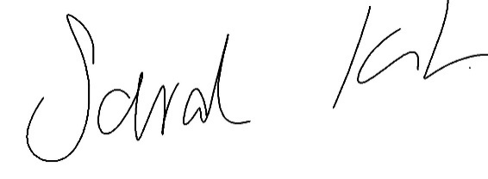

Sarah Kitchener, Clerk and RFO, Ockbrook and Borrowash Parish Council

## Agenda.

1. To receive apologies for absence.
2. To confirm the minutes of the previous meeting held on the 20th November 2024.
3. Variation of the order of business.
4. Declaration of members interests
5. Committee items for Discussion/Action/Update.

* To consider Launching an Ockbrook and Borrowash Parish Council Pylon Campaign: Initiate a campaign for OBPC, to respond to the second consultation in 2025, which will require the following skillsets from our Parish:
  + Engineers (Electrical, Structural, Civil)
  + Environmentalists
  + Ecologists
  + Historians
  + Volunteers for leaflet drops and canvassing (Foot Soldiers)
  + Volunteers to create and manage Social Media pages

1. Date of the next Planning and Environment Committee meeting – 19th March 2025 if necessary.