# OCKBROOK & BORROWASH PARISH COUNCIL

# The Parish Hall, Church Street, Ockbrook, Derby DE72 3SL

Tel: 01332 664100/ 07860 702904 Email: Clerk@ockbrookandborrowashparishcouncil.gov.uk

28th July 2021

To the Chairman and Councillors of the Burials Committee for Ockbrook and Borrowash Parish Council,

You are summoned to attend a Burials Committee meeting of the Ockbrook and Borrowash Parish Council to be held in the Parish Hall, Ockbrook, immediately after the Recreation Committee meeting, on Thursday the 5th. August 2021.

Yours sincerely,

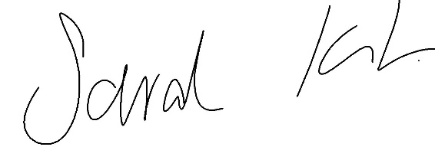

Sarah Kitchener

Clerk and RFO

Ockbrook and Borrowash Parish Council

## Agenda.

1. To receive apologies for absence.
2. To confirm the minutes of the previous meeting held on the 26th. January 2021.
3. Variation of the order of business.
4. Declaration of members interests
5. Committee items for Discussion/Action/Update.

* Agree a course of action regarding the dead tree in Balmoral Cemetery.
* Consider the quotes received for memorial inspections.
* Discuss changing the ruling on allowing kirbs in the cemetery.
* Decide who is responsible for dealing with collapsed graves.
* Discuss the collapsed wall at Belmont Drive.

1. Date of the next Burials Committee meeting.