# OCKBROOK & BORROWASH PARISH COUNCIL

# The Parish Hall, Church Street, Ockbrook, Derby DE72 3SL

Tel: 01332 664100/ 07860 702904 Email: Clerk@ockbrookandborrowashparishcouncil.gov.uk

10th September 2021

To the Chairman and Councillors of the Burials Committee for Ockbrook and Borrowash Parish Council,

You are summoned to attend a Burials Committee meeting of the Ockbrook and Borrowash Parish Council to be held in the Parish Hall, Ockbrook, on Wednesday 15th September 2021 at 19:00.

Yours sincerely,

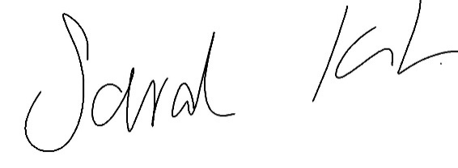

Sarah Kitchener

Clerk and RFO

Ockbrook and Borrowash Parish Council

## Agenda.

1. To receive apologies for absence.
2. To confirm the minutes of the previous meeting held on the 5th. August 2021.
3. Variation of the order of business.
4. Declaration of members interests
5. Committee items for Discussion/Action/Update.

* Kerbs in the cemetery – Do we keep the present ruling of no kerbs or amend the rules to allow them.
* Agree who will carry out memorial testing.
* Discuss if we should reintroduce yearly grave topping up and reseeding.

1. Date of the next Burials Committee meeting.