# OCKBROOK & BORROWASH PARISH COUNCIL

# The Parish Hall, Church Street, Ockbrook, Derby DE72 3SL

Tel: 01332 664100/ 07860 702904 Email: Clerk@ockbrookandborrowashparishcouncil.gov.uk

10th September 2021

To the Chairman and Councillors of the Allotment Committee for Ockbrook and Borrowash Parish Council,

You are summoned to attend an Allotment Committee meeting of the Ockbrook and Borrowash Parish Council to be held in the Parish Hall, Ockbrook, immediately after the Burials Committee meeting, on Wednesday 15th September 2021.

Yours sincerely,

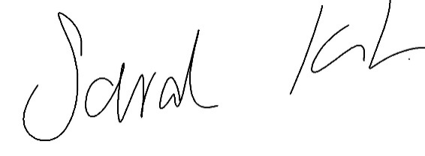

Sarah Kitchener

Clerk and RFO, Ockbrook and Borrowash Parish Council

## Agenda.

1. To receive apologies for absence.
2. To confirm the minutes of the previous meeting held on the 5th. August 2021.
3. Variation of the order of business.
4. Declaration of members interests
5. Committee items for Discussion/Action/Update.

* Agree a course of action for rabbit removal on Elm Street.
* Discuss possible plot terminations by the Parish Council
* Plot 6
* Plot 23 – if not worked on by the 13th. September 2021.
* Plot 22 – If not worked on by the 15th. September 2021.
* Plot 17 – Termination form sent to the tenant; they haven’t returned it.

1. Date of the next Allotment Committee meeting.