# OCKBROOK & BORROWASH PARISH COUNCIL

# The Parish Hall, Church Street, Ockbrook, Derby DE72 3SL

Tel: 01332 664100/ 07860 702904 Email: Clerk@ockbrookandborrowashparishcouncil.gov.uk

20th October 2021

To the Chairman and Councillors of the Contractors Committee for Ockbrook and Borrowash Parish Council,

You are summoned to attend a Contractors Committee Meeting of the Ockbrook and Borrowash Parish Council to be held in the Parish Hall, Ockbrook at 19.00 on Wednesday the 27th. October 2021.

Yours sincerely,

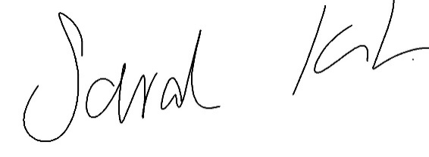

Sarah Kitchener

Clerk and RFO

Ockbrook and Borrowash Parish Council

## Agenda.

* To receive apologies for absence.
* To confirm the minutes of the previous meeting held on the 5th. August 2021.
* Variation of the order of business.
* Declaration of members interests.
* Report from Wayne Peapell.
* Consider the request from Borrowash in Bloom in using Wayne Peapell to mark out two wildflower beds on the Nottingham Road, Barrons Way grass verge.
* Date of the next contractors meeting.