# OCKBROOK & BORROWASH PARISH COUNCIL

# The Parish Hall, Church Street, Ockbrook, Derby DE72 3SL

Tel: 01332 664100/ 07860 702904 Email: Clerk@ockbrookandborrowashparishcouncil.gov.uk

11th November 2021

To the Chairman and Councillors of the Burials Committee for Ockbrook and Borrowash Parish Council,

You are summoned to attend a Burials Committee meeting of the Ockbrook and Borrowash Parish Council to be held in the Parish Hall, Ockbrook, on Wednesday 17th November 2021, immediately after the halls committee meeting.

Yours sincerely,

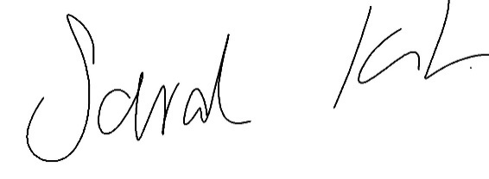

Sarah Kitchener

Clerk and RFO

Ockbrook and Borrowash Parish Council

## Agenda.

1. To receive apologies for absence.
2. To confirm the minutes of the previous meeting held on the 15th. September 2021.
3. Variation of the order of business.
4. Declaration of members interests
5. Committee items for Discussion/Action/Update.

* Agree on the budget to go to the finance committee meeting.

1. Date of the next Burials Committee meeting.