# OCKBROOK & BORROWASH PARISH COUNCIL

# The Parish Hall, Church Street, Ockbrook, Derby DE72 3SL

Tel: 01332 664100/ 07860 702904 Email: Clerk@ockbrookandborrowashparishcouncil.gov.uk

9th May 2022

To the Chairman and Councillors of the Contractors Committee for Ockbrook and Borrowash Parish Council,

You are summoned to attend a Contractors Committee Meeting of the Ockbrook and Borrowash Parish Council to be held in the Parish Hall, Ockbrook, immediately after the General Purposes Committee meeting on Thursday the 19th May 2022.

Yours sincerely,

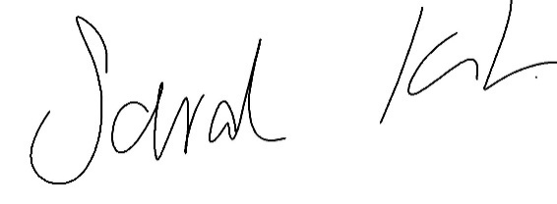

Sarah Kitchener

Clerk and RFO

Ockbrook and Borrowash Parish Council

## Agenda.

1. To receive apologies for absence.
2. To confirm the minutes of the previous meeting held on the 27th October 2021.
3. Variation of the order of business.
4. Declaration of members interests.
5. Committee Items for Discussion/Action/Update.

Agree on the new Grounds Contractor tender, which will be taken to full council in June.

1. Date of the next contractors meeting.