# OCKBROOK & BORROWASH PARISH COUNCIL

# The Parish Hall, Church Street, Ockbrook, Derby DE72 3SL

Tel: 01332 664100/ 07860 702904 Email: Clerk@ockbrookandborrowashparishcouncil.gov.uk

14th July 2022

To the Chairman and Councillors of the Recreation Committee for Ockbrook and Borrowash Parish Council,

You are summoned to attend a Recreation Committee meeting of the Ockbrook and Borrowash Parish Council to be held in the Parish Hall, Ockbrook, at 19:00, on Thursday 21st July 2022.

Yours sincerely,

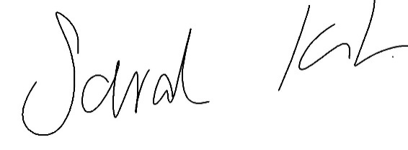

Sarah Kitchener

Clerk and RFO

Ockbrook and Borrowash Parish Council

## Agenda.

1. To receive apologies for absence.
2. To confirm the minutes of the previous meeting held on the 19th. May 2022.
3. Variation of the order of business.
4. Declaration of members interests
5. Committee items for Discussion/Action/Update.

* Agree on the proposed Christmas Light switch on.

1. Ockbrook – 26th November at the Royal Oak with the Deputy Mayor.
2. Borrowash – 2nd December, location to be agreed, with the Mayor.
3. Date of the next Recreation Committee meeting.