# OCKBROOK & BORROWASH PARISH COUNCIL

# The Parish Hall, Church Street, Ockbrook, Derby DE72 3SL

Tel: 01332 664100/ 07860 702904 Email: Clerk@ockbrookandborrowashparishcouncil.gov.uk

14th July 2022

To the Chairman and Councillors of the Burials Committee for Ockbrook and Borrowash Parish Council,

You are summoned to attend a Burials Committee meeting of the Ockbrook and Borrowash Parish Council to be held in the Parish Hall, Ockbrook, on Thursday 21st July 2022, immediately after the Recreation Committee meeting.

Yours sincerely,

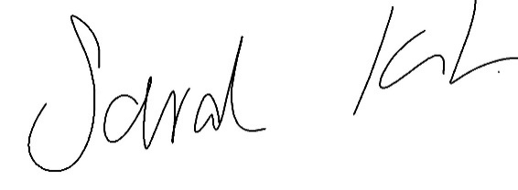

Sarah Kitchener

Clerk and RFO

Ockbrook and Borrowash Parish Council

## Agenda.

1. To receive apologies for absence.
2. To confirm the minutes of the previous meeting held on the 19th. May 2022.
3. Variation of the order of business.
4. Declaration of members interests
5. Committee items for Discussion/Action/Update.

* Agree on a course of action for dealing with the placement of stones and sub soil around All Saints Cemetery by their contractors.
* Belmont Drive.

1. Date of the next Burials Committee meeting.