# OCKBROOK & BORROWASH PARISH COUNCIL

# The Parish Hall, Church Street, Ockbrook, Derby DE72 3SL

Tel: 01332 664100/ 07860 702904 Email: Clerk@ockbrookandborrowashparishcouncil.gov.uk

14th July 2022

To the Chairman and Councillors of the Environment and Neighbourhood Plan Committee for Ockbrook and Borrowash Parish Council,

You are summoned to attend an Environment and Neighbourhood Plan Committee meeting of the Ockbrook and Borrowash Parish Council to be held in the Parish Hall, Ockbrook, immediately after the Burials Committee meeting, on Thursday 21st July 2022.

Yours sincerely,

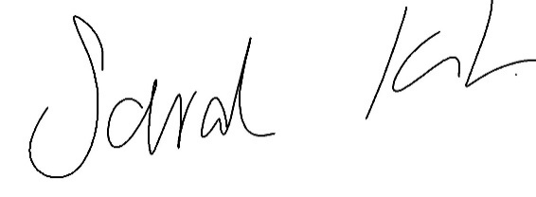

Sarah Kitchener

Clerk and RFO, Ockbrook and Borrowash Parish Council

## Agenda.

1. To receive apologies for absence.
2. To confirm the minutes of the previous meeting held on the 17th November 2021.
3. Variation of the order of business.
4. Declaration of members interests
5. Committee items for Discussion/Action/Update.

* Discuss the information received and processes from Urban Vision. Agree to engage with their NP consultant or approach others.
* Discuss how to apply for locality grant and technical support (available till 31st March 2023).
* Discuss creation of a NP working party.

1. Date of the next Environment and Neighbourhood Plan Committee meeting.