# OCKBROOK & BORROWASH PARISH COUNCIL

# The Parish Hall, Church Street, Ockbrook, Derby DE72 3SL

Tel: 01332 664100/ 07860 702904 Email: Clerk@ockbrookandborrowashparishcouncil.gov.uk

14th July 2022

To the Chairman and Councillors of the Allotment Committee for Ockbrook and Borrowash Parish Council,

You are summoned to attend an Allotment Committee meeting of the Ockbrook and Borrowash Parish Council to be held in the Parish Hall, Ockbrook, immediately after the Environment and Neighbourhood Plan committee meeting, on Thursday 21st July 2022.

Yours sincerely,

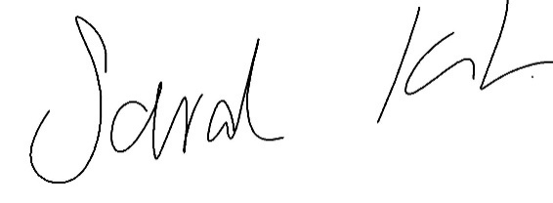

Sarah Kitchener

Clerk and RFO, Ockbrook and Borrowash Parish Council

## Agenda.

1. To receive apologies for absence.
2. To confirm the minutes of the previous meeting held on the 19th. May 2022.
3. Variation of the order of business.
4. Declaration of members interests
5. Committee items for Discussion/Action/Update.

* Discuss the quotes received regarding fencing on Elm Street, see appendix 1

1. Date of the next Allotment Committee meeting.

### **Appendix 1**

Quote received from Ilkeston fencing

Quote 1.

To Supply and erect 57m of 2m high ppc green single weld mesh panel fencing system.

To supply and fit 1nr 3m wide double leaf gate to suit.

To supply and fit 1nr 1200 wide single leaf gate to suit.

Lump sum price £4649.43.

Quote 2.

To take down and cart away existing timber gate and railings.

To supply and erect 9m of 2m high ppc green single weld mesh panel fencing system.

To supply and fit 1nr 1200 wide single leaf gate to suit.

Lump sum price £1464.06.

Quote 3.

To Supply and erect 6m of 2m high ppc green single weld mesh panel fencing system in front of existing fence.

Lump sum price £323.71.

All prices subject to vat at current rates.

Due to fluctuation in steel and timber prices the quoted figures can only be held firm for **Seven days** **from time of quotation**. All prices need to be confirmed prior to order.

Payment TBC.

All sales of goods and/or services are subject to our terms and conditions supplied herewith.

We have not quoted for anything not listed.

2nd Company quote still to receive.