# OCKBROOK & BORROWASH PARISH COUNCIL

# The Parish Hall, Church Street, Ockbrook, Derby DE72 3SL

Tel: 01332 664100/ 07860 702904 Email: Clerk@ockbrookandborrowashparishcouncil.gov.uk

28th September 2022

To the Chairman and Councillors of the Recreation Committee for Ockbrook and Borrowash Parish Council,

You are summoned to attend a Recreation Committee meeting of the Ockbrook and Borrowash Parish Council to be held in the Parish Hall, Ockbrook, immediately after the allotment committee meeting, on Thursday 6th October 2022.

Yours sincerely,

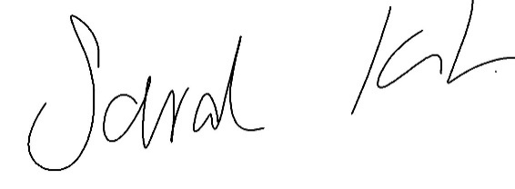

Sarah Kitchener

Clerk and RFO

Ockbrook and Borrowash Parish Council

## Agenda.

1. To receive apologies for absence.
2. To confirm the minutes of the previous meeting held on the 21st July 2022.
3. Variation of the order of business.
4. Declaration of members interests
5. Committee items for Discussion/Action/Update.

* Discuss and agree what to do with the Platinum Jubilee lamp post signs.
* Update from the Christmas meeting with Chloe.
* Discuss the possibility of holding wreath or table decoration workshops for this year.
* Agree to purchase a PA System for the Parish Council.
* Discuss and agree the proposed budget for 2023/2024. To go to the finance committee meeting in November.

1. Date of the next Recreation Committee meeting.