# OCKBROOK & BORROWASH PARISH COUNCIL

# The Parish Hall, Church Street, Ockbrook, Derby DE72 3SL

Tel: 01332 664100/ 07860 702904 Email: Clerk@ockbrookandborrowashparishcouncil.gov.uk

28th September 2022

To the Chairman and Councillors of the Burials Committee for Ockbrook and Borrowash Parish Council,

You are summoned to attend a Burials Committee meeting of the Ockbrook and Borrowash Parish Council to be held in the Parish Hall, Ockbrook, immediately after the Hall Committee meeting, on Thursday 6th October 2022.

Yours sincerely,

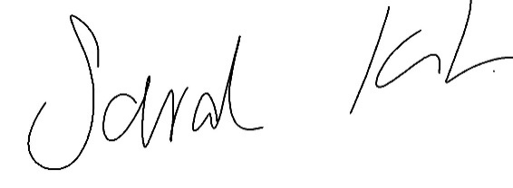

Sarah Kitchener

Clerk and RFO

Ockbrook and Borrowash Parish Council

## Agenda.

1. To receive apologies for absence.
2. To confirm the minutes of the previous meeting held on the 21st July 2022.
3. Variation of the order of business.
4. Declaration of members interests
5. Committee items for Discussion/Action/Update.

* Discuss a course of action for Belmont Drive, considering Broomfield are unable to work on the site if they are not supervised.
* Consider increasing all fees by 10%.
* Discuss and agree on the proposed budget for 2023/2024, to go to the finance committee meeting in November.

1. Date of the next Burials Committee meeting.