# OCKBROOK & BORROWASH PARISH COUNCIL

# The Parish Hall, Church Street, Ockbrook, Derby DE72 3SL

Tel: 01332 664100/ 07860 702904 Email: Clerk@ockbrookandborrowashparishcouncil.gov.uk

15th November 2022

To the Chairman and Councillors of the Environment and Neighbourhood Plan Committee for Ockbrook and Borrowash Parish Council,

You are summoned to attend an Environment and Neighbourhood Plan Committee meeting of the Ockbrook and Borrowash Parish Council to be held in the Parish Hall, Ockbrook, on Wednesday 23rd November 2022 at 19:00.

Yours sincerely,

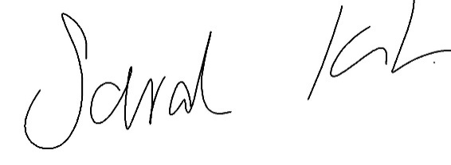

Sarah Kitchener

Clerk and RFO, Ockbrook and Borrowash Parish Council

## Agenda.

1. To receive apologies for absence.
2. To confirm the minutes of the previous meeting held on the 6th October2022.
3. Variation of the order of business.
4. Declaration of members interests
5. Committee items for Discussion/Action/Update.

* Discuss and agree to use Planning Design as our Neighbourhood Planning consultant, to be taken as a recommendation to Decembers full council meeting.

1. Date of the next Environment and Neighbourhood Plan Committee meeting.