# OCKBROOK & BORROWASH PARISH COUNCIL

# The Parish Hall, Church Street, Ockbrook, Derby DE72 3SL

Tel: 01332 664100/ 07860 702904 Email: Clerk@ockbrookandborrowashparishcouncil.gov.uk

18th May 2023

To the Chairman and Councillors of the Recreation Committee for Ockbrook and Borrowash Parish Council,

You are summoned to attend a Recreation Committee meeting of the Ockbrook and Borrowash Parish Council to be held in the Parish Hall, Ockbrook, immediately after the Finance, HR, Contractors and General Purposes Committee meeting, on Wednesday 24th May 2023.

Yours sincerely,

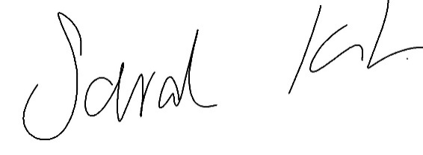

Sarah Kitchener

Clerk and RFO

Ockbrook and Borrowash Parish Council

## Agenda.

1. To receive apologies for absence.
2. To confirm the minutes of the previous meeting held on the 22nd March 2023.
3. Variation of the order of business.
4. Declaration of members interests
5. Committee items for Discussion/Action/Update.

* Discuss and agree on future events for the parish.

1. Date of the next Recreation Committee meeting.