# OCKBROOK & BORROWASH PARISH COUNCIL

# The Parish Hall, Church Street, Ockbrook, Derby DE72 3SL

Tel: 01332 664100/ 07860 702904 Email: Clerk@ockbrookandborrowashparishcouncil.gov.uk

18th May 2023

To the Chairman and Councillors of the Allotment Committee for Ockbrook and Borrowash Parish Council,

You are summoned to attend an Allotment Committee meeting of the Ockbrook and Borrowash Parish Council to be held in the Parish Hall, Ockbrook, immediately after the Recreation Committee meeting, on Wednesday the 24th May 2023.

Yours sincerely,

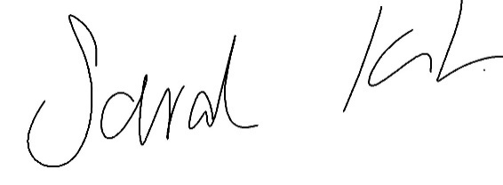

Sarah Kitchener

Clerk and RFO, Ockbrook and Borrowash Parish Council

## Agenda.

1. To receive apologies for absence.
2. To confirm the minutes of the previous meeting held on the 22nd March 2023.
3. Variation of the order of business.
4. Declaration of members interests
5. Committee items for Discussion/Action/Update.

* Consider the allotment associations request to supply them with a skip to remove the rubble at the end Elm Street.
* Consider whether the tenancy agreement should include a probationary period for new tenants.
* Discuss the Elm Street access track.

1. Date of the next Allotment Committee meeting.