# OCKBROOK & BORROWASH PARISH COUNCIL

# The Parish Hall, Church Street, Ockbrook, Derby DE72 3SL

Tel: 01332 664100/ 07860 702904 Email: Clerk@ockbrookandborrowashparishcouncil.gov.uk

18th May 2023

To the Chairman and Councillors of the Planning and Environment Committee for Ockbrook and Borrowash Parish Council,

You are summoned to attend a Planning and Environment Committee meeting of the Ockbrook and Borrowash Parish Council to be held in the Parish Hall, Ockbrook, immediately after the Allotment Committee meeting, on Wednesday 24th May 2023.

Yours sincerely,

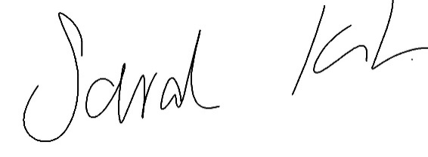

Sarah Kitchener

Clerk and RFO, Ockbrook and Borrowash Parish Council

## Agenda.

1. To receive apologies for absence.
2. To confirm the minutes of the previous meeting held on the 23rd November 2022.
3. Variation of the order of business.
4. Declaration of members interests
5. Committee items for Discussion/Action/Update.

* Overgrowth of public footways around the Parish
* Cycle survey second phase
* Accessibility in the Parish - update on parishioner visit and strategy moving forwards.
* Neighbourhood Plan update
* Planning applications to discuss:
  + 40 Green Lane (two new dwellings) - ERE/0123/0050
  + 15 Flood Street (one new dwelling) - ERE/0043/0029

1. Date of the next Environment and Neighbourhood Plan Committee meeting.