# OCKBROOK & BORROWASH PARISH COUNCIL

# The Parish Hall, Church Street, Ockbrook, Derby DE72 3SL

Tel: 01332 664100/ 07860 702904 Email: Clerk@ockbrookandborrowashparishcouncil.gov.uk

14th September 2023

To the Chair and Councillors of the Allotment Committee for Ockbrook and Borrowash Parish Council,

You are summoned to attend an Allotment Committee meeting of the Ockbrook and Borrowash Parish Council to be held in the Parish Hall, Ockbrook, at 19.00 on Wednesday 20th September 2023.

Yours sincerely,

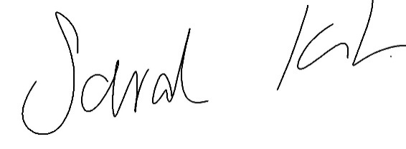

Sarah Kitchener

Clerk and RFO, Ockbrook and Borrowash Parish Council

## Agenda.

* To receive apologies for absence.
* To confirm the minutes of the previous meeting held on the 24th May 2023.
* Variation of the order of business.
* Declaration of members interests
* Committee items for Discussion/Action/Update.
* Agree to adopt the structure application form – see appendix 1.
* Discuss and agree on the proposed budget for 2024/25, to go to the finance committee meeting in November – see appendix 2.
* Date of the next Allotment Committee meeting.

### **Appendix 1**

OCKBROOK & BORROWASH PARISH COUNCIL

ALLOTMENT STRUCTURE APPLICATION FORM

Site: Plot number:

Name:

Address:

Email:

Structure Description

Please put circle the structure you require: Shed Greenhouse Polytunnel

The materials it is made from:

Walls:

Roof:

Floor:

Sketch of Proposed Structure (you may wish to attach photos to your application)

Dimensions:

Length:

Width:

Overall height:

Position of Proposed Structure

Please show the proposed position of the structure within your plot and in relation to the adjacent plots. Please add plot numbers.

|  |  |  |
| --- | --- | --- |
|  |  |  |

Plot My plot Plot

Rainwater collection

All sheds and greenhouses will need to make provision for the collection of rainwater.

I wish to apply for permission to erect the structure detailed above on my plot and agree to abide by all terms and conditions and to keep it well maintained.

I understand that I must wait for the outcome of my application before starting to erect the structure.

Signed: Date:

Please hand deliver or post your completed application to:

The Clerk

Ockbrook & Borrowash Parish Council

Parish Hall

Church Street

Ockbrook DE72 3SL

Email: clerk@ockbrookandborrowashparishcouncil.gov.uk

### **Appendix 2**

budget breakdown
