Ockbrook and Borrowash Parish Council

Car Usage Policy

Any employee or Parish Councillor will be eligible to claim mileage expenses for use of their private vehicle whilst on Parish Council business (subject to holding valid Car Insurance, and a full driving licence)
Private Car Usage Suitability Any vehicle used should be fit for the purpose it is being used for, for example, towing or delivering items.
Mileage rates will be subject to change in accordance with the government guidelines.
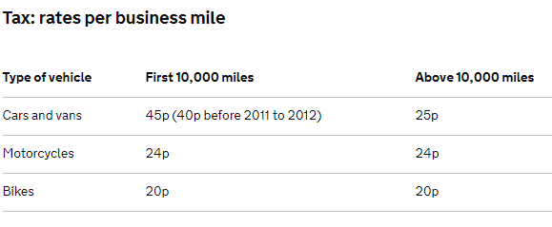
During the period when a car is off the road for repairs, reimbursement in respect of travel by other forms of transport should be made by the Council.
Maintenance: please ensure that the car is kept in good condition. This includes keeping it clean and ensuring that the tyre pressure, lights, oil, water etc are up to the required standard. Employees should not use their cars on Council business in an un-roadworthy condition and should undertake to service their car on a regular basis in accordance with the car’s servicing requirements.
Insurance: Employees must ensure that any vehicle which is used on Council business is adequately insured for personal business usage. Employees will be required to produce evidence of insurance every year, so that the council can double check they are still adequately insured, along with a copy of their driving licence.
Offences: If an employee is prosecuted or convicted for a driving offence which results in a period of disqualification, they must inform the Council immediately. The Council will consider the impact on the employee’s job role to determine if this affects their employment status.
Driving with a Mobile telephone: It is an offence to use hand-held mobile telephones whilst driving. A driver will be liable for prosecution if they are holding a mobile telephone and any other type of hand-held device to send or receive any sort of data, be it voice, text or pictorial image. An employee is regarded as driving if they are in charge of a vehicle with its engine running on a public road, even if the vehicle is stationary. Therefore the Council strictly forbids employees using hand-held mobile telephones whilst driving. A mobile telephone may only be used with a hands-free device, in which case the call should be kept to the shortest possible time and only to effect essential communications. Where employees need to operate the mobile phone or need to deal with a call through a caller’s hands-free device for longer than receiving or giving a short communication, before doing so the Council expect the employee to stop and park the car where it is safe and lawful to do so and with the engine switched off. Whilst driving, employees should not use the message facility on the mobile phone, or if available through such a phone, an image facility or internet access.
A breach of the Council’s rule on the use of a mobile phone whilst driving will render the employee liable to action under the Disciplinary and Dismissal Procedure up to and including dismissal dependent on the circumstances.
Inspection of Documents: Employees and Parish Councillors who claim Mileage Rates are to produce the following original documents at the request of the Council, on an annual basis, or at the specific demand of the Clerk if applicable:
- Current MOT certificate,
- Current car insurance, showing the employee / Councillor is covered for personal business use;
- Current driving licence.

