# OCKBROOK & BORROWASH PARISH COUNCIL

# The Parish Hall, Church Street, Ockbrook, Derby DE72 3SL

Tel: 01332 664100/ 07860 702904 Email: Clerk@ockbrookandborrowashparishcouncil.gov.uk

12th March 2024

To the Chair and Councillors of the Allotment Committee for Ockbrook and Borrowash Parish Council,

You are summoned to attend an Allotment Committee meeting of the Ockbrook and Borrowash Parish Council to be held in the Parish Hall, Ockbrook, at 19.00 on Wednesday 20th March 2024.

Yours sincerely,

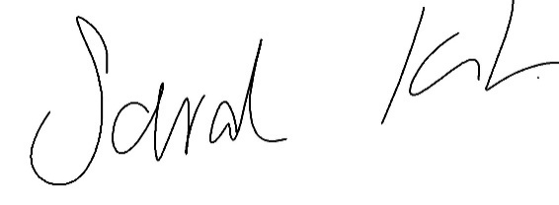

Sarah Kitchener

Clerk and RFO, Ockbrook and Borrowash Parish Council

## Agenda.

* To receive apologies for absence.
* To confirm the minutes of the previous meeting held on the 20th September 2023.
* Variation of the order of business.
* Declaration of members interests
* Committee items for Discussion/Action/Update.
* Discuss and agree on which quote to accept for the replacement of the Elm Street allotment gate – see appendix 1.
* Consider stopping the rent discount from 2026 onwards.
* Agree to reimburse an allotment holder for their work on the community orchard, plot 46 - see appendix 2.
* Date of the next Allotment Committee meeting.

### **Appendix 1**

**Quote 1.**

As promised, please find below the quotation for the replacement of two gate posts, reinstallation and re-alignment of existing gate to the Elm Street allotments.

The quotation includes the following works;

1. Removal of existing fence posts and concrete.

2. Supply and installation of two new fence posts and concrete.

3. Re-installation and re-alignment of existing gate.

4. Disposal of old posts and concrete from site.

The quotation for the above works is **£640.00,** which is to be paid upon completion of the works.

As materials are constantly changing the quotation is valid for 30 days from the date above. Please do not hesitate to contact us should you have any.

**Quote 2.**

Please find enclosed your estimate for works to your property on Elm Street in Borrowash.

* Take out the 2 Rotten / loose timber gate posts.
* Install 2 steel box section posts.
* Fix treated timber to the steel posts.
* Rehang the gates on the new posts.
* Install a new gate latch.
* Site to be left clean and tidy.
* Total for materials and labour **£1380.**

**Quote 3**

Quote as requested, part 1.

* Option one

Gate posts replacement

To replace broken wooden gate post at the entrance of the allotments at Ladysmith Road with the same wooden posts and concreate into the ground, and refit old gate.

Labour and materials **£650.00**.

* Option two.

To replace the above broken wooden gate posts with two 100mm x100mm steel Galv posts sunk in the ground and concreate, then refit gates.

Labour and materials **£850.00**.

Part 2.

To supply and install gate.

To fabricate new 1.800 m steel gate one leaf constructed from 50mmx50mm box section drawing will be supplied to confirm.

This includes fitting.

Labour and materials £**1,890.00** plus vat

### **Appendix 2**

8 boards @ £7.65 = £61.20

40 pegs @ £1.15 = £46.0

Vat £21.44

Total = **£128.64**