# OCKBROOK & BORROWASH PARISH COUNCIL

# The Parish Hall, Church Street, Ockbrook, Derby DE72 3SL

Tel: 01332 664100/ 07860 702904 Email: Clerk@ockbrookandborrowashparishcouncil.gov.uk

11th June 2024

To the Chair and Councillors of the Cemeteries Committee for Ockbrook and Borrowash Parish Council,

You are summoned to attend a Cemeteries Committee meeting of the Ockbrook and Borrowash Parish Council to be held in the Parish Hall, Ockbrook, at 19:00 on Wednesday 19th June 2024.

Yours sincerely,

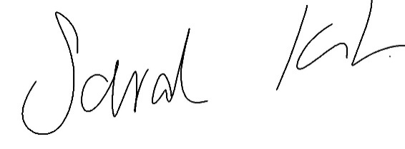

Sarah Kitchener

Clerk and RFO

Ockbrook and Borrowash Parish Council

## Agenda.

1. To receive apologies for absence.
2. To confirm the minutes of the previous meeting held on the 8th May 2024.
3. Variation of the order of business.
4. Declaration of members interests
5. Committee items for Discussion/Action/Update.

* Look at the cemetery rules and regulations, making any amendments deemed necessary, paying particular attention to the ornament and grave surround rules.

1. Date of the next Cemeteries Committee meeting.