# Minutes of the Ordinary Meeting of Ockbrook and Borrowash Parish Council.

# Held at the Parish Hall, Ockbrook on Wednesday 3rd July 2024 at 19:00.

## Public Speaking.

### Members of Public

* A member of public gave an update on the Briar Close meeting held on the 1st July. They mentioned no provision was made for residents with hearing difficulties. The meeting began with the statement that there is no requirement for the council to provide care homes only that they need to provide care. The meeting closed very quickly although members of public still had points to make. The overall impression was that the consultation was more of a tick box exercise and the decision had already been made. The point was made that of the three care homes within Erewash all three are going through this consultation, the question was asked as to what the criteria was for deciding to put Briar Close through this process, this was not answered. It was also pointed out that there had been no transparent auditable journey to come to the two options for Briar Close. At the same time there was a protest outside with about 100 people attending, this support was appreciated by both the staff and residents of the home.
* A member of public mentioned that they are in the position of needing this care home in the near future, but they need their relative to be close by not somewhere else within the county.

### Derbyshire County Council Report.

No report was submitted.

### Erewash Borough Council Report.

Councillor G Maskalick submitted a report – see appendix 1.

### Derbyshire Constabulary Report – See appendix 2.

Ashbrook Youth Group

No report was submitted.

## Present.

Councillors G Maskalick (Chair), S Fraser-Burton (Vice Chair), S Cresswell, J Fraser-Burton, G Markwell, C Millward and A Dunn.

## Also, Present.

S Kitchener (Clerk and RFO) and 11 members of public.

## 72/07/24 Noted Apologise for Absence.

Councillors K Eaglesham-Atkins, J Fazackerley (health matter) and K Thomas (family matter).

## 73/07/24 Absent.

Councillor T Stevenson.

## 74/07/24 Declarations of Members Interests.

None.

## 75/05/24 Dispensations.

None.

## 76/07/24 Variation of Order of Business.

None.

## 77/07/24 Approve the Minutes of the Ordinary Parish Council Meeting, Held on the 5th June 2024.

**RESOLVED** Proposed by Councillor S Fraser-Burton, seconded by Councillor G Markwell and all unanimously agreed that the minutes be approved as a true record and were signed by the Chair at the meeting.

## 78/07/24 Items to be Taken into Private Session.

None.

## 79/07/24 Report of the Parish Clerk/RFO.

Updates since Junes meeting:

* Informed the solicitor that the public toilet lease has been accepted once the date has changed, in the process of sorting out the hand over date.
* Informed the individual that the grants for the blues weekend have been accepted, but we require the individual bank accounts to pay each group, still awaiting the bank accounts.
* Looked into the school crossing patrol for Borrowash this is being advertised on the DCC website.
* I have taken over the responsibility of water the parish hall hanging baskets during the absence of Councillor J Fazackerley, this is only being done Monday to Friday.
* The new “old schoolhouse” sign has been installed.
* The carpark repairs are completed, they have even filled in the hole near the hedge at no extra cost.
* Started applying for the faculty to be able to do memorial testing in Balmoral Road cemetery and All Saints churchyard, should hear back by September.
* Started to work on the bank account for the William James charity.
* Started working on the Remembrance day service:

1) Contacted the Ambassadors band – they have confirmed attendance

2) Contacted DCC regarding the lamp post poppies from Flood Street, Ockbrook through to Victoria Avenue, Borrowash – they have been accepted.

3) Contacted parade members, readers and the bagpiper.

4) GTM have conformed they will manage the road closure again this year.

5) The Coop Funeral Directors have confirmed they will produce the order of services again this year.

6) started working on the road closure for EBC, this will get sent out after the risk assessment has been agreed in the committee meeting in July.

## 80/07/24 Report of the Chair.

This mind map shows all the issues hitting the Parish all at once. It shows the progress being made and progress that needs to be made. We will continue to add to this issue map and update progress or lack of progress, so we all stay on-track and know what is going on.

a mind map showing the issues in the parish


**REWILDING**

The next pictures show the areas where there has been a real problem with the rewilding programme. We are in constant touch with the officers in charge of the Programme and will continue to press them on sorting our Parish out as soon as possible.

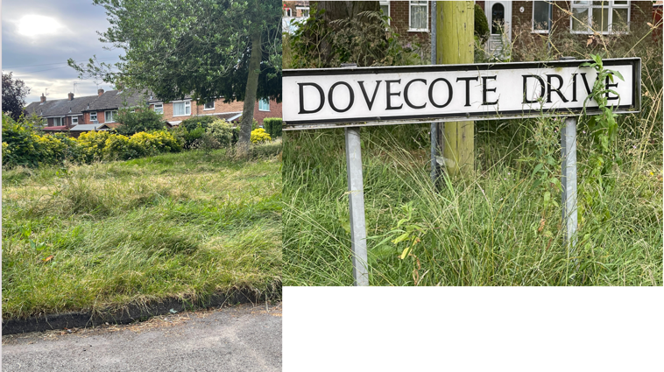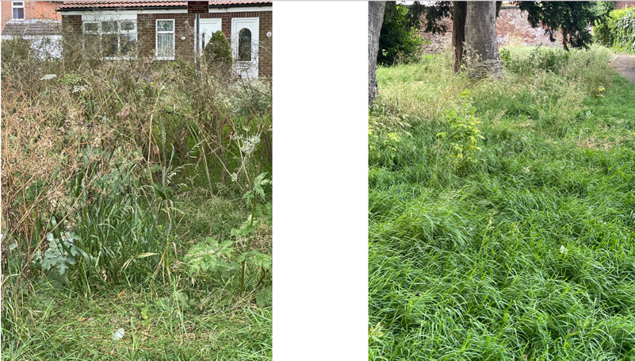

**BALMORAL CEMETERY**

Excellent progress has been made at Balmoral Cemetery and we are pleased that we now are receiving letters of praise. May it long continue.

A screenshot of a email

A grave has been recently recognised as a war memorial grave and therefor has been recognised with a plaque on the front gate.

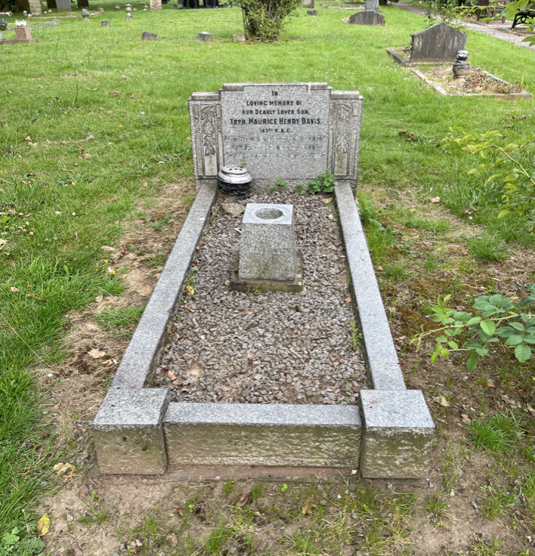

**BRIAR CLOSE CARE HOME**

We had a very successful meeting of the Save Briar Close group at the Coop where four candidates for Mid-Derbyshire MP came and spoke to the group which is supported by several Parish Council councillors.

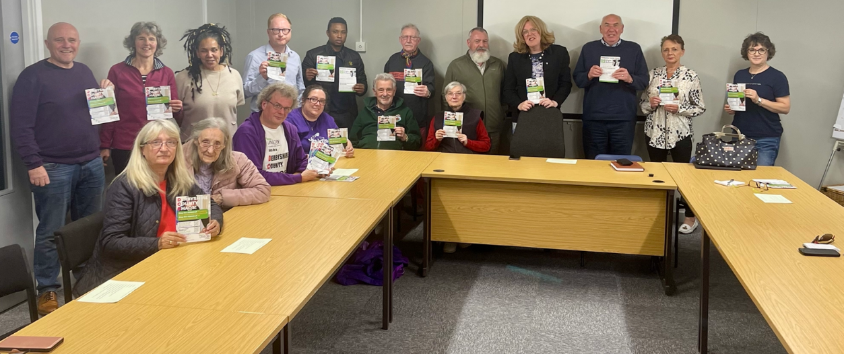

**BORROWASH BLUES FESTIVAL**

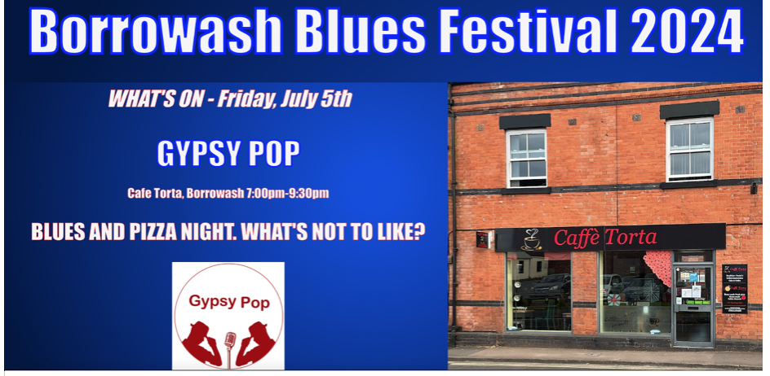

Borrowash Blues Festival is happening from 4th - 7th July and all venues seem to be ready. The Parish Council is very pleased to sponsor this event for its inaugural year and wish it all the best. Here’s to a successful blues festival.

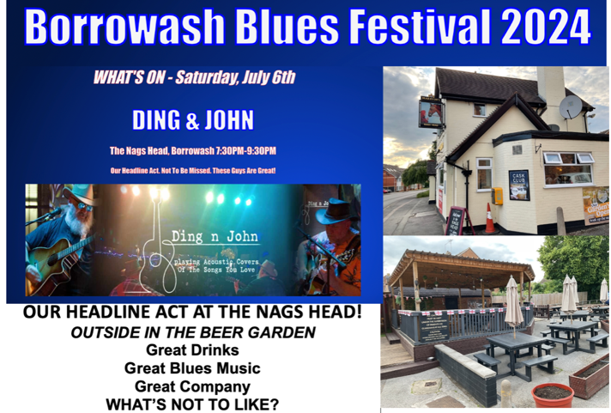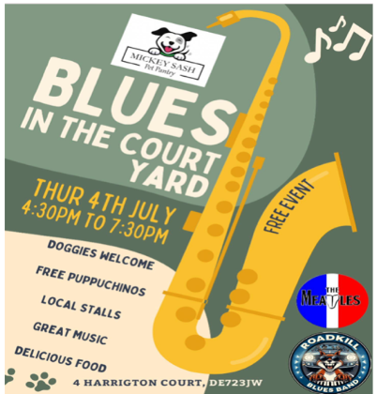

## 81/07/24 Finance, HR, Contractors and General Purposes.

### Accept Accounts for Payment – see appendix 3.

**RESOLVED** Proposed by Councillor J Fraser-Burton, seconded by Councillor C Millward and all unanimously agreed to accept the payment list.

### Accept the Bank Statement Reconciliations. – see appendix 4.

* May 2024 HSBC Account.
* May and June 2024 Unity Trust Account.

**RESOLVED** Proposed by Councillor A Dunn, seconded by Councillor J Fraser-Burton and all unanimously agreed to accept the bank statement reconciliations.

### Consider the need to employ a litter picker.

**RESOLVED** All unanimously agreed that this will get discussed again in the future if necessary.

### Agree to allow the Clerk to make Julys invoice payments in the month of August, to be Ratified in Septembers Parish Council meeting.

**RESOLVED** proposed by Councillor S Cresswell, seconded by Councillor C Millward and all unanimously agreed to allow the Clerk to make the payments.

## 82/07/24 Recreation.

Councillor J Fraser-Burton updated members:

* The inflatables and climbing wall for Deans Drive have been booked in for the 17th and the 28th August, the inflatables have been extended.
* The Remembrance Day Service is to be held on the 10th November, thank you to the Clerk for the work done on this so far. We will be providing lamppost poppy dedications of £5.00 to go to the Royal British Legion.
* Ockbrook Christmas light switch on will be held on the 22nd November 2024 at the Royal Oak
* Borrowash Christmas light switch on will be held on the 29th November 2024 in the Coop carpark.

## 83/07/24 Cemeteries.

The minutes for the committee meeting held on the 19th June 2024 were noted.

### Agree to the Recommendations from the Cemetery Committee Meeting Regarding the Changes to the Burial Rules and Regulations – see appendix 5.

A discussion was held regarding two items

**RESOLVED** proposed by Councillor S Fraser-Burton, seconded by Councillor S Cresswell and all unanimously agreed to accept the changes to the rules and regulations once the Clerk has made the two amendments.

### Agree for the Notice Board to be Refurbished and to Have a New Lock Installed.

**RESOLVED** proposed by Councillor C Milward, seconded by Councillor G Markwell and all unanimously agreed to have the notice board refurbished **ACTION** Clerk to organise.

### Consider the Request From the Friends of Balmoral Group for the Planting of Flowers – Areas for Consideration Include the Bed with the Poppy Cross and the Flower Bed by the Waste Bins.

A brief discussion was held:

* Councillor G Maskalick commented on the poppy cross needing to be replaced so would be a good idea to leave this area at the moment.
* Councillor C Millward suggested flowering shrubs rather than bedding plants.
* Councillor G Markwell suggested getting ideas from Borrowash in Bloom and to go back to the group to see what they had in mind. A proper planting scheme should be put in place for next year which would then be budgeted for.
* The Clerk queried who would maintain the beds.
* Councillor S Fraser-Burton suggested not to plant bedding plants due to the large amount of maintenance needed and that they would need to be perennial plants.

**ACTION** the clerk to contact the group and Borrowash in Bloom for their ideas, then this will be discussed in a future meeting.

### Consider Allowing Headstone of no Higher than 21 Inches (Including the Plinth) onto the Cremated Remains Plots.

The Clerk explained that after talking to a stone mason this would be the highest that could be accepted as anything higher would need a ground anchor which could affect the cremated remains and would impact on the plots around them. A brief discussion was held.

**RESOLVED** proposed by Councillor A Dunn, seconded by Councillor S Fraser-Burton, two abstained with the rest unanimously agreeing to allow headstone of no higher than 21 inches in the cremation area.

### Consider Allowing Small Christmas Trees onto the Plots, to be Removed by the 12th Day.

Councillor G Maskalick suggested that the Parish Council could provide the Christmas trees through Mr Christmas Tree, stating that a height limit would need to be agreed on and suggested the idea of a choir doing a service one night in December. These ideas will be discussed in Julys committee meeting.

### Consider Inviting all Ministers of the Parish to Future Committee Meetings to Give Advice to the Committee if it is Required.

**RESOLVED** proposed by Councillor S Fraser-Burton, seconded by Councillor S Cresswell and all unanimously agreed to invite all of the Parish Ministers to a specific committee meeting if required.

### Discuss and Agree to a Fee for Grave Surrounds.

A discussion was held.

**RESOLVED** Proposed by Councillor A Dunn and seconded by Councillor C Millward to accept the fee that EBC use of £682.00 this will be the same for residents and non-residents. Five voted to agree this, one abstained and one was against so the fee was accepted.

## 84/07/24 Halls.

### On the Advice of Clear Utility Solutions Consider Changing the Electricity Supply from British Gas Lite to Valda for a Fixed Three-Year Contract – see appendix 6.

**RESOLVED** proposed by Councillor S Fraser-Burton, seconded by Councillor G Markwell and all unanimously agreed to change the electricity supply from British Gas Lite to Valda but for 24 months only. **ACTION** The Clerk to organise the change.

## 85/07/24 Allotment.

### Consider the Request From a resident to get the Elm Street Allotment Hedge Cut – This Can be Done on Health and Safety Grounds due to it Causing Problems for People to Pass.

**RESOLVED** Proposed by Councillor S Cresswell, seconded by Councillor A Dunn and all unanimously agreed to get the hedge side cut. **ACTION** Councillor G Markwell to talk to the grounds team.

Councillor S Cresswell updated members that she is in talks with the Ashbrook School to arrange another visit to the allotments before they break up for the summer.

## 86/07/24 Planning and Environment.

### To Consider ABEI Energy’s “Screening Request” to Establish with the Council Whether They Consider That the Proposed Solar Development Would Request a Full Environmental Impact Assessment to Accompany and Planning Applications.

**RESOLVED** proposed by Councillor A Dunn, seconded by Councillor G Markwell and all unanimously agreed that the Parish Council do want a full environmental impact assessment. **ACTION** Clerk to write to EBC

## 87/07/24 Correspondence Received – see appendix 7.

The correspondence received and listed in the agenda were available at the meeting.

## 88/07/24 Date and Time of Next Meeting.

The next Parish Council meeting is scheduled to take place at the Ashbrook Centre, Borrowash on Wednesday 4th September 2024 at 19:00.

## 89/07/24 Exclusion of Press and Public.

Nothing to report.

There being no further business the meeting concluded at 20:50.

### **Appendix 1 -** EBC reports.

EREWASH BOROUGH COUNCIL REPORT – JUNE 2024, Greg Maskalick

Not too much has been going on politically as the National Election is taking place and laws pertaining to it don’t allow quite a few things from being discussed or have meetings about. However, there have been various committee meetings, and those minutes are online for you to look at if you so wish.

**ELECTION OF NEW MAYOR**

Councillor Kate Fennelly was elected Mayoress of Erewash, following on from her Deputy Mayor role last year. She has already got stuck into her role with an amazing number of engagements. She will be opening up the Borrowash Blues Festival on July 4th. Kate has also been in discussions with the Parish Council to plan a Mayors Walk through Ockbrook and Borrowash for charitable purposes. She hopes to complete a walk through every Parish and town in the Borough. Much more to report later as Kate is very busy in promoting Erewash through her role as Mayoress.

**ELECTION OF DEPUTY MAYOR**

Councillor Harry Atkinson has been elected Deputy Mayor and at just 24 years of age becomes the youngest Deputy Mayor ever. Harry has already started quickly with events and there is more to come. He has been very supportive of the Mayoress, helping wherever possible.

**EREWASH MUSEUM**

We all need to remember that the museum is everyone’s museum. I would encourage you to follow the Museum on all the socials and also on EBC’s website. So many new and great ideas are on offer from children’s educational projects to live music from some rather well-known names. There is something for everyone at the Museum and I would encourage you to go!

**EBC ADVERTISING EREWASH TOURISM**

Erewash Borough Council is now advertising tourism to the area nationally. There is so much local heritage to see and be proud of as well as history and of course incredible beauty spots. This is an incredibly important initiative as it will also help businesses as well. If you’re stuck for something to do on a weekend, perhaps don’t look any further than your own back yard – BOROUGH OF EREWASH. Visit the website and EBC socials for more details.

**CYCLE FOR HEALTH**

Regain cycling confidence, gently improve fitness & enjoy a free, sociable 10-mile ride. All abilities welcome. All rides start and end at the Straw’s Bridge Local Nature Reserve in West Hallam, Ilkeston, DE7 5FG . Everybody can join in for some gentle exercise every Monday from approximately 6.45pm to 8.30pm.  
  
Each ride is led by volunteers and supported by Erewash Borough Council’s Community Health and Wellbeing Development Team. The bike rides are free - you need only take your bike, a cycling helmet and a bottle of water. There is some parking at Straw’s Bridge if you wish to drive to the beginning of the route.  
  
Please contact Ilkeston Cycle for Health’s Facebook page Facebook or email [ebc.healthride@gmail.com](mailto:ebc.healthride@gmail.com) or call 0785 893 7004.

**Balanceability**

Balanceability is the UK's first and only accredited 'learn to cycle' scheme for children aged 2 and 1/2 to 6 years and specifically aimed to help develop confidence, spatial awareness and dynamic balance.

Balanceability benefits children by:

Physical improvement through the development of gross motor skills such as balance, co-ordination, agility, core strength and flexibility.

Gets children cycling much easier without the use of stabilisers which can be hindering and confusing to a child.

Improving children's confidence, self-esteem and resilience.

**Contact us**

For more information on these activities or to register your interest for a course in your area email [jordan.hedges@erewash.gov.uk](mailto:jordan.hedges@erewash.gov.uk) or call 0115 907 2244.

### **Appendix 2 –** Derbyshire Constabulary Report.

|  |  |
| --- | --- |
| - | April |
| Violence and sexual offences | 9 |
| Anti-social behaviour | 4 |
| Public Order | 3 |
| Shoplifting | 1 |

### **Appendix 3–** July 2024 payment list.

|  |  |  |  |
| --- | --- | --- | --- |
| **Invoices to be paid** | - | - | minute agreed |
| Ashbrook Youth Group | £280.00 | Monthly donation –July | 229/12/23 |
| Royal British Legion | £50.00 | Donation from DD signs | 34/05/24 |
| EBC | £3044.89 | June payroll | - |
| Lisa’s | £332.90 | June hall clean | - |
| Fox Grounds Maintenance | £2155.99 | June works | - |
| Sarah Kitchener | £39.25 | June expenses | - |
| **Invoices already paid** | - | - | - |
| Borrowash Burial Ground | £48.61 | Their money transferred to their new bank account | 264/03/24 |
| Dale Abbey Plants | £170.00 | Hall hanging baskets | 12/04/24 |
| R. Hoult LTD | £3654.00 | Carpark repairs | 60/06/24 |
| **Monthly direct debits** | - | - | - |
| British Gas | £50.91 | Elec 21/05-19/06 | 22/05/24 |
| British Gas | £83.30 | Gas 29/05-26/06 | 22/05/24 |
| Virgin | £65.10 | Broadband and phone June / July | 22/05/24 |
| O2 | £35.22 | Mobile | 22/05/24 |
| Lloyds Bank | £782.54 | Stamps, flags, subs, DD signs, toner, keys | 22/05/24  24/05/24  34/05/24 |
| Everflow | £121.15 | Water 06/07/24-05/08/24 | 22/05/24 |
| EBC | £23.00 | June cem rates | 22/05/24 |
| Unity Trust Bank | £34.65 | Transactions 05/03-03/06 | 22/05/24 |
| Unity Trust Bank | £0.90 | Cash/chq charges 05/03-03/06 | 22/05/24 |

All invoices listed have been examined, verified and certified by the Clerk/RFO.

### **Appendix 4 –** Bank Reconciliation

**May 2024 Bank Reconciliation - HSBC Account**

|  |  |  |  |
| --- | --- | --- | --- |
| **Bank Balance** | - | - | - |
| Bank s/m bal as at 01/04/24 | - | 24,778.50 | - |
| + total cash book receipts | - | 93,688.00 | - |
| - total Cashbook payments | - | 16.00 | - |
| **Cashbook Closing Balance** | - | **118,450.50** | - |
| - | - | - | - |
| **Bank Balance at 04/06/24** | - | **118,450.50** | - |
| - outstanding payments | - | 0.00 | - |
| + outstanding receipts | - | 0.00 | - |
| **Net Balance** | - | **118,450.50** | - |
| - | - | - | - |
| **-** | - | **-** | **Difference: 0.00** |

**May 2024 Bank Reconciliation - Unity Trust Account**

|  |  |  |  |
| --- | --- | --- | --- |
| **Bank Balance** | - | - | - |
| Bank s/m bal as at 01/04/24 | - | 39,302.63 | - |
| Less items related to 23/24 | - | 8,334.33 | - |
| - | - | 30,968.30 | - |
| + total cash book receipts | - | 152,333.25 | - |
| - total Cashbook payments | - | 116,848.43 | - |
| **Cashbook Closing Balance** | - | **66,453.12** | - |
| - | - | - | - |
| **Bank Balance at 31/05/24** | - | **74,931.56** | - |
| - outstanding payments | - | 10,018.86 | - |
| + outstanding receipts | - | 1,540.42 | - |
| **Net Balance** | - | **66,453.12** | - |
| - | - | - | - |
| **Balance per Cashbook** | - | **66,453.12** | **Difference: 0.00** |
| - | - | - | - |
| Charity Accounts included in bank total: | - | - | - |
| William James | 2,281.09 | - | - |
| B/W Burial Ground | 48.61 | - | - |

**June 2024 Bank Reconciliation - Unity Trust Account**

|  |  |  |  |
| --- | --- | --- | --- |
| **Bank Balance** | - | - | - |
| Bank s/m bal as at 01/04/24 | - | 39,302.63 | - |
| Less items related to 23/24 | - | 8,334.33 | - |
| - | - | 30,968.30 | - |
| + total cash book receipts | - | 152,333.25 | - |
| - total Cashbook payments | - | 116,848.43 | - |
| **Cashbook Closing Balance** | - | **66,453.12** | - |
| - | - | - | - |
| **Bank Balance at 03/06/24** | - | **75,865.35** | - |
| - outstanding payments | - | 9,983.64 | - |
| + outstanding receipts | - | 571.42 | - |
| **Net Balance** | - | **66,453.12** | - |
| - | - | - | - |
| **Balance per Cashbook** | - | **66,453.12** | **Difference: 0.00** |
| - | - | - | - |
| Charity Accounts included in bank total: | - | - | - |
| William James | 2,281.09 | - | - |
| B/W Burial Ground | 48.61 | - | - |

### **Appendix 5 -** BALMORAL ROAD CEMETERY REGULATIONS

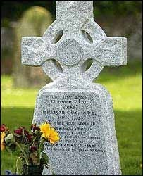

**Adopted by Ockbrook and Borrowash Parish Council March 2014.**

**Last amendments and adoption: June 2024**

**Contact details for Balmoral Road Cemetery**

**The Clerk, Ockbrook and Borrowash Parish Council, The Parish Hall, Church Street, Ockbrook, Derby DE72 3SL**

**Email:**[clerk@ockbrookandborrowashparishcouncil.gov.uk](mailto:clerk@ockbrookandborrowashparishcouncil.gov.uk%20)

**Tel: 01332 664100 / 07860 702904**

Table of Contents

* Introduction 3
* Terms of Reference and Definitions 3
* General Rules and Guidance 4
* Burial Rules and Guidance 6
* Grave Selection & Purchase of Exclusive Rights of Burial 7
* Transfer of Exclusive Right of Burial 8
* Plan of Cemetery 9
* Register of Burials 9
* Burial Procedure 9
* Grave Preparation and Backfilling……………………………………………………………………………….. 11
* Infectious Diseases 12
* Grave Aftercare 12
* Graves 12
* Cremated Remains interment 12
* Application of the Rules to certain graves in existence prior to the coming into force of the Policy Document……………………………………………………………………………………………………. 13
* Memorial Rules and Guidance 14
* Memorial Types 15
* Memorial Materials 16
* Operational Times for Memorial Works 16
* Stability Guarantee Period 16
* Memorial Safety Testing 16
* Memorial Inspections 17
* Memorial Liabilities and Insurance 19
* Unauthorised Items……………………………………………………………………………………………………..20
* Unauthorised Memorials 20
* Floral Tributes 21
* Exhumation ……………………………………………………………………………………………………………….. 21
* Memorial Benches ……………………………………………………………………………………………………… 21
* Alteration to Regulations ……………………………………………………………………………………………. 22
* Agreement of the Owner of Exclusive Rights of Burial for burial plots and memorial regulations 22

Appendix 1 – Application to Erect a Memorial 23

Appendix 2 – Notice of Interment Form …………………………………………………………………………………. 24

* 1. **Introduction**

The purpose of this Policy Document is to set out the Ockbrook and Borrowash Parish Council “in-house” rules which apply to the provision of the bereavement services and to provide a useful guide to members of the public who require the said services.

Please note, the explanatory notes set out in this policy document do not form part of the Rules but have been inserted into the Policy Document in italics so as to explain the provisions and reasons for the Rules.

All graves and ashes plots will be sold subject to the Rules set out in this Policy Document (which may be amended from time to time by the Parish Council), together with any statutory legislation relating to 1) the provision of the services and 2) the management, regulation and control of Parish Councils owned cemetery, and issued by central government, and any other competent authority under which the Parish Council is bound to comply.

Should anyone have any queries in connection with the Rules and guidance set out in this Policy Document, in the first instance they should contact the Clerk of Ockbrook and Borrowash Parish Council. Any complaints will be dealt with in accordance with the Council’s Complaints Policy.

* 1. **Terms of Reference and Definitions**

In this Policy Document, unless the context otherwise requires the following terms shall have the meanings given to them below:

“The Parish Council” means Ockbrook and Borrowash Parish Council.

“Cemetery, or Site” means Balmoral Road Cemetery on Balmoral Road, Borrowash, Derby.

“Cremation Regulations 2008” means the cremation (England and Wales) Regulations 2008.

“Exclusive Right of Burial” means an exclusive right of burial granted in accordance with the rules in these regulations.

“Traditional Grave” - means a grave which is mainly laid to lawn and which complies with rules in these regulations.

“Memorial” means an object serving as a remembrance and for the purposes of these rules include a headstone, cross, vase, flat memorial tablet and temporary grave markers.

“Register of Burials” means a register of all burials in a Cemetery kept and maintained by the Parish Council.

“Rules” means the Ockbrook and Borrowash Parish Council “in house” rules set out in this policy document.

“Table of Fees” means the list of fees and charges for goods and services

provided by Ockbrook and Borrowash Parish Council.

“The Parish Office” means Ockbrook and Borrowash Parish Council Office, The Parish Hall, Church Street, Ockbrook, Derby DE72 3SL.

“Working Day” means between 9.00am and 15.00 Monday to Friday inclusive but does not include any days which are bank holidays or public holidays,

* 1. **General Rules and Guidance**
     1. Other than as set out to the contrary in this Policy Document or in exceptional circumstances, the opening and closing times of the cemetery is displayed at the entrance to the site and are as follows:

1st May – 30th September 8:30-19:00

1st October – 30th April 8:30-16:00

* + 1. No person shall trade any goods or services within the Cemetery except with the prior written permission of the Parish Office

*To help protect visitors’ consumer rights and to ensure that the bereaved can visit the Cemetery without fear of being disturbed.*

* + 1. Animals are not permitted in the Cemetery other than dogs which must be kept on a lead at all times and be under proper control, owners must pick up any waste from their dogs.

*A review of Parks and Open Spaces (PSPO Order) in 2020 identified that cemeteries are suitable areas for exercising dogs provided they are kept under control and on a lead.*

* + 1. Vehicles (other than funeral cars and contractors’ vehicles) are not allowed in the cemetery except by permission of the Clerk.

*This is due to the limited parking spaces that we have.*

* + 1. Bicycles or any other recreational equipment must not be ridden in the cemetery grounds.

*This helps protect the safety of visitors and our staff.*

* + 1. All funeral corteges must be at the main entrance gates of the site by the agreed booking time. Burials may take place between 9:30 and 14:30 Monday to Friday, excluding Saturdays, Sundays, public holidays and other Local Government statutory holidays.

*It is essential that funerals arrive on time to ensure the efficient operation of the service.*

* + 1. The Parish Council reserves the right to exclude from the cemetery any persons not being mourners or persons directly connected with a funeral at the Cemetery. Such a right may be exercised by the Clerk on behalf of the Parish Council.

*In some cases, it may be necessary to close the Sites to visitors due to an extremely large funeral or on the request of the police or another authority.*

* + 1. If any damage is caused to Cemetery land, walls or premises by any cause whatsoever, the person or persons committing such damage will be held responsible by the Parish Council.

*The Parish Council will always attempt to recover full costs for any damage caused by visitors in order to protect the available budgets for the upkeep, maintenance and improvement of the Cemetery.*

* + 1. No photography or filming shall be allowed within the Cemetery during funerals except with the consent of the Clerk. Families or a representative of a family however may photograph an individual Memorial.

*Some visitors may be offended by being filmed or photographed within the Cemetery or whilst attending funerals.*

* + 1. No music (whether live or recorded) shall be played within the Cemetery by any person except with the permission of the Clerk.

*Music can disturb other visitors to the Cemetery. Permission will generally be granted for music to accompany a funeral service.*

* + 1. Dead flowers, spent wreaths or other articles of waste or litter must be placed in the appropriate receptacles provided at the Cemetery. Any

floral items found ‘past their best’ may be removed without notice by

the Parish Council.

*This allows our staff to keep the Cemetery areas tidy for our visitors.*

3.12 The use of any power tool is not permitted within the grounds without the Clerks consent.

*This ensures safety within the cemetery.*

3.13 All persons in the Cemetery must take all reasonable care in order to protect their own safety.

3.14 Visitors must conduct themselves in a quiet and orderly manner and must keep to the pathways, except when visiting graves.

*This ensures that the Cemetery grounds are used in the manner to which is expected from our visitors.*

3.15 No games or sport shall be played within the cemetery.

*This ensures that the Cemetery grounds are used in the manner to which is expected from our visitors.*

3.16 All persons admitted to the Cemetery will be subject to the Rules set out in this Policy Document. Any person infringing the Regulations may be removed from the Cemetery by a member of staff / Councillor of Ockbrook and Borrowash Parish Council.

3.17 The Parish Council reserves the right to make any alterations to the Rules as and when required.

*As the service changes and improves it may be necessary to amend the current regulations accordingly or at short notice. Wherever possible when this happens the Parish Council will take all reasonable steps to inform those affected by any changes.*

* 1. **Burial Rules and Guidance**
     1. All initial bookings for a burial (including the burial of cremated remains) must first be made to the Parish Office either by telephone or in person and confirmed in writing as soon as possible thereafter using the Councils specified form.

*This ensures all of our relative processes and procedures can be followed to minimise any problems that may arise.*

* + 1. For all burials a notice of an interment using the Council’s specified form must be delivered to the Parish Office on a Working Day with the associated fees at least four (4) Working Days prior to the interment.

*This ensures that the staff of Ockbrook and Borrowash Parish Council have enough notification to review and approve the application form in preparation for the internment.*

.

* + 1. A notice of interment shall be given only on the form provided by the Council and such form shall be duly completed in all respects and be signed by the person applying for the interment.

*It is a statutory requirement that a burial cannot take place without the consent of the burial authority.*

* + 1. No alteration to a notice of interment is permitted unless;
* a written request for any such alteration has been submitted to the Parish Office and
* such alteration has been agreed by the Clerk.

*Only alterations to arrangements can be accepted in writing prior to the burial date, this ensures there can be no misunderstandings if verbal alterations only are given.*

* + 1. The person responsible for the interment shall make all the necessary arrangements with the minister or other person intended to officiate at the interment, including the payment of the minister’s fee.

*Ockbrook and Borrowash Parish Council do not provide a minister or officiate as part of its service.*

* + 1. The person responsible for the interment shall make all the necessary arrangements with the Funeral Director for the grave / ashes plot to be dug including the payment of the sexton’s fee.

*Ockbrook and Borrowash Council do not provide a Sexton but will specify which sexton can dig graves / ashes plots at the cemetery.*

* + 1. Burial and ashes plots, the general rule is that only 1 set of remains is allowed to be interred per plot purchased, families can pre-purchase an unused plot next to the existing plot if they so wish.

*This is to comply with the legislation that interred remains cannot be disturbed without an exhumation order.*

* + 1. Fees for all cemetery services will be determined by the Parish Council, these are available from the Clerk. The Parish Council reserves the right to revise these fees and charges at any time. All fees and charges are to be paid to the Clerk before any interment takes place.
    2. Scattering of ashes is permitted upon application to the Clerk. A registrar’s certificate of disposal and the appropriate payment must accompany all applications for scattering of ashes.

*It is unlawful to scatter any remains within the cemetery without first gaining permission from the Parish Council who manage and own the land.*

* 1. **Grave Selection & Purchase of Exclusive Rights of Burial**
     1. An Exclusive Right of Burial allows the purchaser of such a right to burial in an agreed grave or ashes space. A grave or ashes plot which is subject to an Exclusive Right of Burial may not be opened and no one may be buried there without the owner’s permission.

*The person purchasing the grave has the right to select a grave / ashes space in advance of the burial subject to making an appointment with the Parish Office.*

* + 1. Once the appropriate fee has been paid an Exclusive right of Burial will be granted for a period of no more than 100 years beginning with the date upon which the grant is made, and upon such terms and conditions as the Parish Council deems appropriate. Upon expiry of the Exclusive Right of Burial the ownership of the grave / ashes plot will revert to the Parish Council if the family or owner has expressed no desire to extend the grant period. The Parish Council may extend the period of such a grant for up to a further 100 years from the date upon which the extension is granted. The fee for an Exclusive Right of Burial is set out in the Table of Fees.

*Under the current legislation, an Exclusive Right of Burial may only be granted for a certain length of time.*

* + 1. An Exclusive Right of Burial does not constitute any ownership of land. It is purely the right to have a burial in a selected grave / ashes plot.

*The rights are granted on the understanding that the owner of those rights complies with the rules set out in this Policy Document, in particular any such rules which are applicable to the particular type of grave / ashes plot to which the Exclusive Right of Burial relates. For example, if an Exclusive Right of Burial is granted in respect of a Grave, then the grant holder will be required to comply with the Rules relating specifically to Graves.*

* + 1. The purchase of burial rights is not in any way the purchase of the land in which the grave / ashes plot lies, it is essential that the public are aware that the grave is sold on a lease basis and that the only rights with that lease are the rights to a burial in the grave and to place a subsequent memorial.
    2. On the granting of the Exclusive Right of Burial a Deed of Grant shall be issued to the person by whom or on whose behalf the said exclusive Right of Burial is granted.
    3. The purchase of the Exclusive Right of Burial in any grave / ashes plot includes the right to erect and maintain a memorial on that space subject to the regulations concerning memorials.

*This allows for a memorial to be placed on a grave / ashes plot without need for additional rights to be granted.*

* + 1. The holder of the Exclusive Right of Burial may surrender his/her/their right at any time in respect of the grave space / ashes plot where the said right has not been exercised (i.e. where no burial has taken place). In all cases the fee repayable will be that of the original fee paid to acquire the Exclusive Right of Burial.

*Some people reserve a grave in advance but then later decide it is no longer required. As the grave is unused it is permissible for the Parish Council to sell the right of burial to another person.*

* 1. **Transfer of Exclusive Right of Burial**
     1. An Exclusive Right of Burial to a grave / ashes plot may be transferred by deed or bequeathed by will.
     2. In cases where the owner of the Exclusive Right or Burial (“the grant holder”) is still alive the transfer may be done by completion of a Deed of Assignment. A Deed of Assignment is available from the Parish Office. This form should be completed and signed by the grant holder and the person taking ownership of the said right and submitted to the Parish Office together with the original Deed of Grant. An amended Deed of Grant will be then issued to the new holder of the said right. This service is free of charge.

*This is the recognised legal way of transfer of grave rights where the grant holder is alive.*

* + 1. Where the grant holder is deceased, and provided that the Exclusive Right of Burial has not been specifically left to another person, then upon production of a will or letters of administration the Exclusive Right of Burial may be legally transferred to the person in possession of the Letters of Administration or the beneficiary of the residue of the estate under the terms of the grant holder’s will.

*The grave rights form part of the estate of the deceased and can thereby be transferred to the appropriate person upon proof being submitted to the Parish Office.*

* + 1. In cases where the grant holder is deceased and there is no will or Letters of Administration available then the Exclusive Right of Burial may not be transferred to another person until a Statutory Declaration has been completed and ensuring that any other person equally entitled counter signs the Statutory Declaration. A statutory declaration must be witnessed by a Solicitor or a Commissioner for Oaths.

*This is a legally recognised way of dealing with this issue.*

* 1. **Plan of Cemetery**
     1. In accordance with current legislation the Council keeps and maintains plans showing all used grave spaces and those graves or grave spaces to which special rights appertain (i.e. an Exclusive Right of Burial). Such plans are kept at the Parish Office and are available for inspection, free of charge on any day that the Parish office is open.

*This is a legal requirement as well as an operational requirement of the service.*

* 1. **Register of Burials**
     1. All burials carried out in the Cemetery are recorded in a Register of Burials. The Registers of Burials are kept in the Parish Office and are available for inspection by appointment on any one working day at the Parish Office by any person free of charge.
     2. If requested, searches of the Register of Burials can be made by the Clerk and a certified copy of an entry or entries relating to any grave space or interment in the Register of Burials will be provided, free of charge.

*This is a legal obligation of the Burial Authority to keep and maintain records of burials in the Cemetery and the current legislation permits the Parish Council to charge a fee for a search of the Register of Burials and to provide certified copies of entries of the said register.*

* 1. **Burial Procedure**
     1. Before a grave space / ashes plot which is subject to and Exclusive Right of Burial can be opened, the written consent of the owner of the Exclusive Right of Burial, or their legal representative, must be submitted to the Parish Council together with the original Deed of Grant. If the Deed of Grant has been mislaid/ lost a sworn statutory declaration relating to the loss of the original Deed of Grant will be required.

*The Parish Council must be satisfied that the person requesting the burial is the person legally entitled to the Exclusive Right of Burial.*

* + 1. In cases where the person intended to be interred was the owner of the Exclusive Right of Burial immediately before his death, the Parish Council if requested by the person giving notice of the interment, has the power to order that the grave space be re-opened for the interment of the deceased owner without obtaining the consent of his or her executor or other representative.

*The registered grave owner has a legal right to be buried in any grave space they own the rights to.*

* + 1. All bodies brought to the Cemetery for burial shall be contained in a suitable coffin. All cremated remains must also be held in a suitable container. The coffin or suitable container must be clearly marked for identification purposes and include the full name and age of the deceased.

*To properly respect the deceased and also prevent distress that may be caused to other visitors or staff it is essential that the body of the deceased person is properly covered. Cremated remains will only be accepted in a suitable container prior to burial or scattering within the grounds.*

* + 1. The date and time of an Interment shall be approved by the Clerk.

*It is essential that times for burials are approved in order to ensure the smooth operation of the service.*

* + 1. Prior to the burial being undertaken, the Registrar’s Certificate for Disposal or Coroner’s Order for Burial must be handed to the clerk with the application for interment at least 4 working days prior to the interment.

*These are legal documents that must be submitted prior to the burial being allowed to take place.*

* + 1. All funerals will be met by the Clerk of the Parish Council. No interment will be allowed to proceed unless accompanied by the Clerk. A check of the name plate will be made against the statutory paperwork prior to any interment being permitted.

*This ensures that the correct coffin is buried in the correct grave.*

* + 1. The person arranging the funeral or his/her/their representative shall ensure that they have sufficient persons to transfer the coffin from the vehicle to the grave side and lower the coffin into the grave. In all cases this should be a minimum of 4 persons for the burial of an adult.

*It is the responsibility of the funeral director or the person making the funeral arrangements to ensure enough people are present to transfer the coffin from the hearse/vehicle to the grave side and lower the coffin to the base of the grave.*

* 1. **Grave Preparation and Backfilling**
     1. The responsibility for organising grave digging at the cemetery will rest with the Funeral Director.
     2. All excavation works and backfilling of graves will only be undertaken by the Parish Council’s approved sexton, who is trained to a recognised and accredited standard and is the Parish Council’s appointed contractor. *Ockbrook and Borrowash Parish Council will only allow competent and qualified sextons to excavate graves / ashes plots. As a Health and Safety issue it is not possible to allow any other person to excavate any grave space within the Cemetery.*
     3. Grave spaces in the Cemetery shall be in accordance with the following measurements:-

Full Adult grave space - Maximum of 8ft / 2.44m long by 4ft / 1.22m wide.

*In order to effectively lay out and plan the Cemetery it is necessary to provide a maximum dimension to each grave space. Should a larger grave space than this be required a request to the Clerk should be submitted.*

* + 1. Graves shall be excavated to a maximum depth of 7ft / 2.13m and a minimum depth of 5ft / 1.52m.

*This is so that the Parish Council can comply with the current legislation in this regard.*

* + 1. The positions of the head and the feet of a grave space in the Cemetery shall be as designated by the Parish Council.

*In order to manage the layout of the cemetery, the Parish Council will decide on the location of sections and graves within those sections.*

* + 1. A grave shall be of sufficient width and length to admit a coffin to the size specified on the notice of interment.

*It is the responsibility of the person making the funeral arrangements to provide accurate measurements of the coffin size to ensure the correct size grave is prepared.*

* + 1. A grave / ashes plot shall be suitably matted and dressed prior to an interment taking place.

*In order to provide an aesthetically pleasing environment.*

* + 1. The sexton will attend each interment to ensure that the grave / ashes plot is safe and will fill in the grave / ashes plot immediately after the interment has taken place.

*This ensures the safety of visitors to the cemetery.*

* + 1. At the discretion of the Clerk and where safe and possible to do so the Parish Council will allow family backfilling to take place under the supervision of the Sexton. In the event of a family wishing to backfill the grave after the service, details must be included on the original notice of interment.

*Some families find this an appropriate way to pay their final respects to the deceased. In all cases the Sexton will be present to oversee and supervise the backfilling and provide assistance where necessary.*

* 1. **Infectious Diseases**
     1. The body of a person who has died of a dangerous infectious disease shall require a certificate which sets out details such as confirmation that the coffin containing the body has been thoroughly sprayed with disinfectant after having been screwed down and that adequate precautions have been taken to his satisfaction against the spread of the disease.

*This is to protect the Health and Safety of visitors and staff.*

* + 1. For the purpose of this Rule the term “dangerous infectious disease” includes plague, cholera, smallpox, typhus fever, enteric fever (including typhoid and paratyphoid fevers), scarlet fever and diphtheria, and such other infectious diseases as the Area Health Officer may determine from time to time to require such precautions.

*These are the current list of dangerous infectious diseases; this may be added to by the Chief Medical Officer at any point.*

* 1. **Grave Aftercare**
     1. The Parish Council will manage the aftercare and maintenance of the Cemetery grounds as they see fit. This includes levelling, turfing or seeding areas within the Cemetery as required.

*Under Article 4 of the Local Authorities’ Cemeteries Order 1977 the*

*burial authority has a duty to keep a cemetery in good order and repair.*

* 1. **Graves**
     1. Any Memorial placed on a lawn Grave is subject to the Memorial Rules.
  2. **Cremated Remains Interment.**
     1. Plots for the provision of cremated remains are available at Balmoral Road Cemetery.

*There is a dedicated cremated remains section.*

* + 1. Cremated remains may also be interred in any other full-size grave where an Exclusive Rights of Burial has been granted provided that the owner of the Exclusive Right of Burial has given the necessary permission to inter in that grave.

*Burials of cremated remains are available in any grave or a full-size adult grave if required.*

* + 1. Cremated remains must be held in a container suitable for burial. The container must have the full name of the deceased clearly visible.

*Suitable identification of the deceased person is essential to ensure the correct remains are interred in the correct grave.*

* + 1. No burial of cremated remains will be permitted unless a copy of the Certificate of Cremation from the crematorium where the cremation took place, is delivered to the Parish Council Office, together with the necessary completed notice of interment and the prescribed fee.

*This is to comply with current legislation.*

* + 1. Cremated remains will be interred in their containers no bigger than 30 inches / 0.76m by 30 inches / 0.76m. Double cremation plots are available next to each other, please contact the Parish office for more details.
  1. **Application of the Rules to certain graves in existence prior to the coming into force of the Policy Document.**
     1. Ockbrook and Borrowash Parish Council acknowledge that there may be some graves within the sites which were already in existence prior to the coming into force of this policy document and which will not comply with the rules set out in this policy document. In some circumstances the Parish Council reserves the right to use its discretion to waive some or all of these rules with respect to such graves on the condition that such graves are well kept and maintained by the owners of the graves and / or their families / heirs.
     2. The following rules will also apply to any such graves:-

Any such grave will be regularly inspected by the Parish Council;

Should any grave become untidy or neglected in the view of the staff of the Parish Council, where possible, we will notify the registered grave owner that the grave has become untidy or neglected and / or contains any unauthorised memorials, and if following a month after the notification the grave has not been properly maintained / repaired or made tidy or within the said one month timescale the grave owner, family or next of kin have not notified the Parish Council that they will maintain / repair and / or make tidy the grave within the next 5 days, then the necessary works will be carried out by the Parish Council.

*This ensures that neglected graves are restored to a neat and tidy appearance for the benefit of all of our visitors and the grounds staff who maintain the areas.*

* + 1. Once any items are removed and any works carried out on the grave the future management / maintenance of the grave space will fall under the rules set out in this policy document and no further discretion on the part of the Parish Council as to waiving such rules will be applied.

*This ensures that the problems of unauthorised memorials do not recur in the future and ensures the grounds are kept in a neat and tidy condition.*

* + 1. The Rules extend to cremated remains where any unauthorised memorialisation becomes neglected.

*This allows for the Authority to deal with any grave space regardless of its type should it become neglected.*

* 1. **Memorial Rules and Guidance**
     1. It is important to allow a new grave to settle before placing a memorial headstone.

*Due to the high-water table in Balmoral Road Cemetery a headstone will not be allowed to be installed within the first year after the burial.*

* + 1. No Memorial is to be installed in the Cemetery unless authorised by the Parish Council.

*It is essential for the Parish Council to manage Memorials placed within the Cemetery.*

* + 1. An application for a permit to carry out memorial works may be made by the owner of the Exclusive Right of Burial in respect of a grave or ashes plot; if the owner of the Exclusive Right of Burial is deceased, the transfer of rights must occur prior to the memorial being permitted.

*This ensures the correct person is applying for memorial works.*

* + 1. The permit application form must be completed fully and include:
* a detailed plan of the proposed Memorial
* the dimensions of the memorial
* A drawing of the proposed memorial
* A copy of the proposed inscription
* details of the proposed fixing method.

An application will only be processed upon receipt of the correct fee.

*This ensures our staff can ensure the proposed memorial is within the regulations and will be fixed to an approved industry standard.*

* + 1. The permit application must clearly state the section of the cemetery in which the grave is situated together with the grave number.

*This ensures the memorial is going on the correct grave and the proper person is authorised to instruct the work.*

* + 1. All such permit applications are to be submitted to the Parish Council Office. Once checked, and, if authorised, confirmation will be forwarded to the stone mason allowing the work to commence. The clerk should be notified when the works are complete.
    2. The upkeep and maintenance of any memorial within the Cemetery remains the responsibility of the person to whom a permit to place the Memorial was given.

*All Memorials remain in the ownership and are the responsibility of the grave owner.*

* 1. **Memorial Types**
     1. The following types of memorials are permitted in the Cemetery subject to compliance with any associated rules, as a minimum must show the name of the deceased, the date of death and on the back the plot number and the stonemason’s name;
        + Headstone or Cross
        + Memorial vase
        + Flat Memorial Tablet
        + Cremated Remains Plaque
        + Baby Memorials
        + Wooden grave marker, with approval
        + Grave surrounds
        + Temporary Grave Marker – for 18 months only.
     2. Memorials for graves shall be restricted to:
* the placing of a monumental vase or
* the erection of a headstone not exceeding a height of 4 foot / 1.22m (including the base). The base must not exceed a height of 9 inches / 0.23m with a width of 30 inches / 0.76m and a depth of 12 inches / 0.31m.
* The erection of a grave surround not exceeding 7 foot / 2.13m by 3 foot / 0.92m with a height of 6 inches / 0.15m

*To ensure safety within the cemetery and ensure they do not encroach onto other graves it is essential to prescribe a maximum size for new memorials.*

* + 1. Any memorials covering multiple grave spaces may be to a maximum width of 7 foot / 2.13m per double grave. Wider memorials may be considered in consultation with the Parish Council.

*This allows for families wishing to have a larger Memorial over a number of family-owned graves to do so.*

* + 1. Memorial vases shall not exceed 10-inch / 0.25m square by 10 inch / 0.25m in height and will be placed at the head of the grave only.

*To ensure safety within the cemetery and ensure they do not encroach onto other graves it is essential to prescribe a maximum size for new memorials.*

* + 1. Ashes plaques / tablets are permissible on any ashes plot and shall not exceed 18 inches / 0.46m square by 6 inches / 0.15m in height.

Ashes headstones are permissible on any ashes plot and shall not exceed 18 inches / 0.46m width and 21 inches / 0.53m in height.

* + 1. Temporary grave markers / wooden cross markers are permissible on any grave space for a period of no more than 18 months.
  1. **Memorial Materials**
     1. Memorials made of any type of natural material are permissible in the Cemetery provided that it complies with the approved NAMM standard and is fixed to the grave by a registered BRAMM fixer.
     2. Wooden crosses must be fitted securely into the ground but do not have to be secured, this is a national approved method.

*Wooden Crosses do not pose the same sort of danger as other traditional memorials.*

* 1. **Operational Times for Memorial Works**
     1. The erection of, cutting of inscriptions on, or professional cleaning of, memorials shall be carried out between the opening hours of the cemetery, Monday to Friday.

*Works can only be undertaken during normal operational hours to ensure safety within the site.*

* 1. **Stability Guarantee Period**
     1. All memorials from the date of installation must be subject to a ‘Guarantee of Conformity’ granted by the mason who installed the memorial. Such a guarantee is given to confirm that the memorial has been fixed to the best standard set by NAMM at the date of fixing and should last for a minimum of 6 years. If at any point during the life of the memorial it becomes loose or unstable and this cannot be attributed to ground conditions or disturbance, the mason should, under the terms of the said guarantee, refix the memorial to the original standard at no cost to the grave owner or the Parish Council.

*This is a standard guarantee that must be given to any person arranging a Memorial in any site.*

* 1. **Memorial Safety Testing**
     1. Any memorial purchased and erected on a grave space is owned by the registered grave owner and it is that person or persons who are ultimately responsible for its upkeep and maintenance.

*Historically there have been a number of accidents in cemeteries around the UK, some of which have resulted in fatalities, due to memorials being unsafe. Whilst the memorials are the responsibility of the registered grave owner Ockbrook and Borrowash Parish Council have a responsibility for ensuring that its cemetery is safe for both staff to work in and for the public to visit.*

* + 1. Memorial Fixing

All memorials over 24.5 inches / 0.62m in height must be fixed to, and fully compliant, with the current British Standard (BS8415). This also extends to ANY memorial over 24.5 inches / 0.62m that is being re-fixed following an interment or removal for any other reason.

* + 1. The key requirements are that memorials must be fixed to an approved and suitable foundation and must be further secured using an approved locking or anchoring system.
    2. Note that any refixing or repair works to memorials must be completed by a BRAMM (or other equivalent scheme) registered memorial mason. Temporary works to make memorials safe and remove the risk of danger will be undertaken by trained Ockbrook and Borrowash Parish Council staff.
  1. **Memorial Inspections**
     1. All memorials over 24inches / 0.61m in height in all cemeteries will be inspected by trained staff at least once during a rolling 5-year period to assess their safety. This will be done through both a visual assessment and a basic hand test to determine if there is movement in the memorial and to what extent. The individual undertaking the assessment will make the decision on the memorials’ overall safety based on a dynamic risk assessment for which they have been trained.
     2. Once inspected each memorial will fall into one of three categories, detailed as follows:
* Category 1 – Memorial is unsafe and poses a risk and will require immediate attention to make safe and/or protect from the public.
* Category 2 – Memorial is safe but there are minor concerns, and it should be reassessed in 12 months’ time to ensure it has not deteriorated further.
* Category 3 – Memorial is Safe and should be re-inspected in 5 years as part of the next round of inspections or as part of any other check that may occur, for example when checking memorials around a planned burial ahead of excavation of the grave.

*The Parish Council has a legal obligation to ensure that the Cemetery is safe to both visit and work in. To be satisfied that this is the case it is essential that Ockbrook and Borrowash Parish Council carry out regular inspections of memorials in the Sites in a bid to avoid injury or death to any of its staff or visitors.*

* + 1. Staff undertaking the inspections will record the details of every memorial and an assessment of its safety using the categories above. These details will be recorded onto the Bereavement Services administration system. The details will include:
* Date of Inspection
* Name of Inspector
* Grave Identification (Section and Number)
* Category of Memorial (1, 2 or 3)
* Details of any Actions Taken
  + 1. Actions Post Inspection

Should a Memorial be identified as a Category 1 and fail the inspection staff will need to take immediate action to make that memorial temporarily safe or cordon it off until permanent repairs can be made by the grave owner. These actions will be based on a number of factors and the best solution will be administered by the Clerk based on their assessment of the memorial and the surrounding area. These actions may include:

* Laying the memorial flat – In most cases this will invariably be where a memorial can be laid down on or within an existing kerb set so as not to cause a new trip hazard. A warning sign will be placed near to the memorial.
* Staked and Banded – The memorial will be fastened tight to a wooden post which will act as a temporary support. The banding will also hold a warning notice. The stake and band will be re-inspected every 12 months to ensure neither have deteriorated.
* Monolith Conversion – This involves digging out a depth roughly one third of the overall height of the memorial from the last joint in order that it can be sunk into the ground and made safe. The memorial will have a suitable material wrapped around the part under the ground and a memorial warning notice will be added to the grave. Due to foundations, it may be necessary for the memorial to be moved slightly forward into the grave space to avoid existing foundations.
* Cordoned Off – In some cases it may be necessary to cordon off a particular memorial or an area containing a number of memorials due to their safety. Warning signs will be attached to any cordon placed around a memorial or group of memorials.
* Removal – In extreme cases it may be necessary to remove a memorial from the grave and place it into storage if none of the above options are suitable.

*All of the above are regarded as ‘Temporary Fixes’ and should not be seen as a permanent solution to deal with an unsafe memorial and are intended to reduce or remove the risk of a memorial causing harm or damage to someone. Prior to taking any of the actions above the memorial will be photographed and details recorded of any existing damage or issues.*

* + 1. Very large memorials, those over 8 foot / 2.44m will be visually assessed and if any concerns are recorded the memorial will be cordoned off and if it is safe and possible to do so Ockbrook and Borrowash Parish Council staff will carry out works to ensure the memorials are safe. If we are not able to make the memorial safe arrangements will be made for a specialist contractor to undertake an inspection and provide a detailed report including costs and options to make safe.
    2. Informing Grave Owners.

We will endeavour to contact the grave owner where any action has been taken due to a memorial failing a safety inspection. Correspondence will only be sent providing that the grave owner is not recorded as being in the grave or if it is apparent that the registered address no longer exists. For any memorials over 50 years of age no correspondence will be sent but a notice will be left on the grave space for a period of not less than 12 months.

*Ockbrook and Borrowash Parish Council will make every effort to contact grave owners, however if the grave owner is deceased or the burial was over 50 years ago in our experience it is unlikely that any response will be received therefore no correspondence will be sent out.*

* + 1. For any memorial that fails an inspection that has been installed within the previous 6 years we will contact the memorial mason directly to request repairs be made to ensure the memorial is fully compliant with BS8415.

*The stability guarantee of a memorial is the responsibility of the memorial mason and they may provide a longer guarantee period, 6 years is the standard legal period that must be covered by the installation.*

* + 1. Grave Owners Responsibilities

The registered grave owner has a responsibility to ensure the memorial is made safe through being properly re-fixed to the current BS8415 standard and works must be undertaken by a qualified and BRAMM (British Register of Accredited Memorial Masons) registered Memorial Mason.

*Do it yourself repairs by families will not be permitted, memorials must be fixed to the current best standard of the day by a licensed memorial fixer. All costs associated with organising a memorial to be repaired, including the reversal of any works undertaken by Ockbrook and Borrowash Parish Council staff, remain the responsibility of the grave owner.*

* + 1. Should grave owners fail to take any action within a reasonable time then we will look to apply a semipermanent solution to the memorial, this will involve either laying the memorial flat or sinking the memorial into the ground (monolith conversion) or other suitable action.

*We need to maintain the Cemetery to a high standard and will always try to avoid taking any action that may impact on the general ground’s maintenance of site.*

* 1. **Memorial Liabilities and Insurance**
     1. Any memorial placed on a grave space remains the property of the owner(s) of the Exclusive Right of Burial. The owner is therefore responsible for ensuring the memorial remains in a safe condition.
     2. The Parish Council can take no responsibility for any damage, accidental or otherwise, to any memorial within its cemeteries. Therefore, any person arranging for the installation of a memorial must consider appropriate insurance that will cover repair or replacement of a memorial should it become damaged in the future.

*It has to be understood that memorials are exposed to all types of weather and maintenance in the site. Memorial Masons will fix to the best standards of the day however future occurrences such as bad weather may result in memorials becoming damaged or destroyed beyond repair. Your memorial mason will be able to advise of insurance options available to you.*

* 1. **Unauthorised Items**
     1. Unauthorised items placed on or around any grave will be removed by the Parish Council and disposed of.These include:
* alcohol,
* food stuffs,
* glass,
* sharp instrument and tools
* broken / damaged items.
  1. **Unauthorised Memorials**

**25.1** The Parish Council will allow the placement of ornaments on the headstone / plinth and within a grave surround.Should any unauthorised items be placed on a plot or if any memorial contravene the rules the grave will be photographed, and the Parish Council will make every reasonable effort to contact the holder of the Exclusive Rights. If the items are still in place after the designated time frame or the owner is uncontactable then the unauthorised items shall be removed and placed into storage by the Parish Council for a period of up to 6 months, after which they may be destroyed.

25.2 Articles such as windchimes, cards, pictures, flags etc. are not permitted to be placed on any tree, bench or other similar feature within the cemetery.

*Pursuant to the Local Authorities’ Cemeteries Order 1977 no tombstone or other memorial may be placed in a cemetery without the permission of the officer appointed for that purpose by the burial authority. If permission has not been granted the burial authority is permitted to remove the memorialisation from the site.*

*It is essential that the burial sections are maintained to the agreed standard for the benefit of all of our visitors. It is unfair for one or two families to furnish their graves with articles outside of the Rules which can cause distress to others when alternative options are available. It is not always possible to notify the grave owner of the need to remove unauthorised memorialisation, particularly if the grave owner has moved and has not informed the Council. It is for this reason; we hold any items that are removed and destroy them after 6 months without necessarily giving notice.*

25.3 The Parish Council, in its capacity as a burial authority, is legally entitled to recover the cost it may incur in removing any unauthorised tombstone or other Memorial from the person to whose order the tombstone or Memorial was placed or within two years from the placing of the tombstone or memorial, from the personal representative of such a person.

*All memorials installed within the Cemetery must be approved by the Council by the granting of a permit. If any memorials are erected outside of the Rules or without proper permission, they may be removed and destroyed.*

* 1. **Floral Tributes.**
     1. It is common for floral tributes to be left within the cemetery. The Parish Council are not responsible for the type or condition of any floral tributes left by visitors. These will be removed when they have ‘past their best’.
     2. Floral tributes are expected to be removed from graves where a burial has taken place between 14 and 21 days after the burial date by the family. Should any families wish to remove and keep the floral tributes themselves they are advised to do this within 14 days of the burial date.

* 1. **Exhumation**
     1. The removal of buried / cremated remains after interment requires a faculty from the Diocese.
  2. **Memorial Benches**
     1. Memorial benches are allowed in the cemetery, and the appropriate forms can be obtained from the Parish Council office.
     2. Once the form has been completed and the fee paid the Clerk will determine if the bench is acceptable. If it is acceptable the Clerk and applicant will agree to the placement of the bench.
     3. It is the responsibility of the owner to get the bench to the cemetery.
     4. On payment of the fee the Parish Council will provide the plinth for the bench to be attached to. Plinths are only allowed to be installed by the Parish Council.
     5. The bench must be maintained whilst it is in the cemetery. Bench checks will be done twice a year, if the Clerk deems the bench to be dangerous on health and safety grounds contact will be made with the owner, if the bench has not been improved it will be removed and held for a year then it will be disposed of.
     6. No memorial benches are to be installed at the cemetery without the permission of the Clerk.
     7. The memorial bench must be clear of floral / tributes or further personalization.
  3. **Alterations to Regulations.**
     1. The Parish Council reserves for itself the power to make alterations from time to time to these regulations and the schedule of fees and payments.
     2. Any amendments made to the regulations / fees shall have the effect of cancelling all previous regulations and fees agreed by the Parish Council.
  4. **Agreement of the Owner of Exclusive Rights of Burial for burial plots and memorial regulations**

Each funeral director will be responsible for providing the applicant with a copy of these regulations, these must be returned signed with the application fees and relevant certificates.

I agree to abide by the above regulations and have received, read and agreed to abide to the Balmoral Road Cemetery Regulations

Grave/Plot number ………………………………………………………………………….

Name …………………………………………………………………………………………

Address ………………………………………………………………………………………

…………………………………………………………………………………………………….

Signed

(Can only be signed by the owner of the Exclusive Rights of Burial)

Date………………………………………………………..

Document to be signed in duplicate – 1 for retention of owner of the plot and 1 to be returned to Ockbrook and Borrowash Parish Council

**Appendix 1**

Ockbrook and Borrowash Parish Council, The Parish Hall, Church Street, Ockbrook, Derby DE72 3SL

**Application to Erect a Memorial**

Name of Deceased ……………………………………………………………………………………………………………

Name of current OWNER of the grave space………………………………………………………………………

Signature of applicant …………………………………………………………………………………………………….­­­­­­...

Dated …………………………………………………………………………………………………………………………………

Address of Current owner....................................…………………………………………………………………..

……………………………..………………………………………………………………………………………………………………

Grave/plot number ……………………………………………………………………………………………

Name of Stone Mason ………………………………………………………………………………………………………..

Stone Mason address ………………………………………………………………………………………………………….

……………………………………………………………………………………………………………………………………………

**Memorial**

Ockbrook and Borrowash Parish Council are now registered with BRAMM, all memorials are required to be erected to British Standard 8415. Any memorial fixers working under the BRAMM scheme must have a current fixer license.

Type: Headstone / Cremation Tablet / Vase.

Material: ……………………………………………………………………………………………………………………………

Dimensions: Headstone: …………………………………. Base………………………… Vase………………………..

Grave surround: …………………………………………………………………………………………………………………..

Installation/fixing Details …………………………………………………………………………………………………….

Please indicate if: Initial inscription / Additional inscription.

Design of Memorial Inscription

**Signature of stone mason ………………………………………………………………**

**Dated ……………………………………**

**Appendix 2**

Ockbrook and Borrowash Parish Council

The Parish Hall, Church Street, Ockbrook, Derby DE72 3SL

**Notice of Interment Form.**

Please complete **CAREFULLY** and **ACCURATELY** using **BLOCK CAPITAL.**

|  |
| --- |
| **New Grave/Plot** (purchasers’ name) |
| **Address** |
|  |
| **Pre-Purchased** (name of owner) |
| **Address** |
|  |
| Is the deceased the owner of the Exclusive Right of Burial YES/NO |
| Deed Number |
| Following the interment, the grave must be legally transferred to a **new owner**. The Clerk to the Council can help with this process. However, it is necessary to know who the legal owner is likely to be. Please compete the name and address below. For Further information contact the Clerk on 01332 664100/07860 702904 |
| Name |
| Address |
| Phone |
| **BURIAL DETAILS** |
| Full name of deceased Mr/Mrs/Miss/Ms Male/Female |
| Occupation Marital Status |
| Date of Death Age |
| Grave Number/interment Plot |
| Name of Grave Digger(s) arranged  Grave digging is organised by the Funeral Director for this Cemetery. |
| Date of burial/interment Arrival time at cemetery |
| Last permanent address of deceased |
| Address where death occurred |
| If a minor, please provide name and residence of parents |
| Name of Minister Contact number |
| As owner of the above-mentioned burial plot, I confirm that the details I have given are correct. |
| **CONTACT DETAILS OF GRAVE/ PLOT OWNER/ APPLICANT** |
| Name |
| Address |
| Telephone email address |
| Signature Date |
| **CONTACT DETAILS OF FUNERAL DIRECTOR** |
| Name |
| Address |
| Telephone email address |
| Signature Date |

Please make cheques payable to Ockbrook and Borrowash Parish Council.

Please show the name of the deceased and grave/plot number on the reverse of the cheque.

### **Appendix 6 –** new electricity quotes

Our partnership with DALC requires us to search for the best deals and update you when the market has stabilised. My director Chris has promised Wendy Aimis (CEO of DALC) we will always strive to save public money as well as preventing carbon emissions. So far, we have saved over £100,000 of public money as well as prevented 495kg of carbon emissions. Not to mention countless hours of clerk and RFOs time by handling everything for them.

I have attached the quote for the Electricity meter, with Valda working out the best with price and service. Valda are one of our most trusted suppliers and are keen to take on council supplies, we have placed a large number of councils with them and have always come up trumps. Their tech driven approach to the industry gives them the competitive edge over other suppliers, meaning you will more than likely get the cheapest quote from them.

If acceptable we will handle the process for you and offer full post contract support as standard with our DALC partnership.

Fixing for 3 years with Valda moving forward is a good bet, we are likely to see further increases in the coming months and not predicted to settle until mid 2027.

As the market is all over the place at the moment the above prices are held day by day (won’t move by much).

|  |  |  |  |  |  |  |
| --- | --- | --- | --- | --- | --- | --- |
| FUEL | START DATE | FIXED TERM | UNIT RATE (P/KWH) | STANDING CHARGE (P/DAY) | DAY CONSUMPTION | ESTIMATED ANNUAL COST |
| **Valda** | - | - | - | - | - | - |
| Electricity | 02/10/24 | 24 mths | 24.840 | 49.000 | 3424 | £1029.37 |
| Electricity | 02/10/24 | 36 mths | 25.710 | 49.000 | 3424 | £1059.16 |
| **British Gas Lite** | - | - | - | - | - | - |
| Electricity | 02/10/24 | 24 mths | 23.090 | 78.700 | 3424 | £1077.86 |
| Electricity | 02/10/24 | 36 mths | 23.850 | 79.036 | 3424 | £1105.11 |
| **EDF** | - | - | - | - | - | - |
| Electricity | 02/10/24 | 24 mths | 25.500 | 60.000 | 3424 | £1092.12 |
| Electricity | 02/10/24 | 36 mths | 26.200 | 60.000 | 3424 | £1116.09 |

### **Appendix 7 –** Correspondence receivedUp 21/06/24.

Emails/letters received from members of public:

* Complaint regarding the lack of mowing at Priorway Play Park – informed them they need to contact EBC. (1)
* Copy of a letter from the Ashbrook infants thanking the Parish Council for organising their trip to the allotment. (2)
* Request for information as to where Fox’s costs are allocated – informed them they are split between the environment, cemeteries and allotments. (3)
* Complaint regarding overflowing bins and the lack of a bin at Priorway Play Park - informed them they will need to contact EBC. (4)
* Request for the old cremation plots to be levelled and gravelled – this is going to be looked at when we do the budget for 2025/26. (5)
* Request for a new bus shelter to be installed on Nottingham Road, opposite Brook Road – informed them this will have to be looked at when we do the budget for 2025/26. (6)
* Complaint regarding a Parish Councils private Facebook page – forwarded to the relevant Councillor. (7)
* Objection to the pride flag being flown in the Parish. (8)
* Request for information on any consultations held by EBC regarding their rewilding scheme – informed them that there was not a consultation. (9)
* Questioned as to if members of public can attend our committee meetings – informed them they can attend but there is no public speaking in our committee meetings. (10)
* Request to purchase a flagpole from the Parish Council. (11)
* Request for a date as to when the verges are going to be cut – informed them they need to contact EBC as they cut the verges. (12)
* Copied into emails between a resident and the Environment Agency regarding the removal of a tree on the brook banks. (13)
* Copied into an email between a resident and the Derbyshire Flood Team regarding their back garden being flooded again. (14)
* Copied into a letter to EBC regarding the dangerous grass verges on the A52 slip roads. (15)
* Asked if the Parish Council still supply and install flagpole brackets – no due to how expensive they became. (16)
* Hall hiring enquiries and updates. (17)
* Allotment enquiries and updates. (18)
* Cemetery enquires / requests and complaints. (19)

Other emails received:

* Treetops Charity walk – information put onto our Facebook page. (20)
* ICO informing the Council of a possible complaint coming into the office – updated them that the complainant is asking for information that we do not hold in the office but I look forward to receiving their complaint if necessary. (21)
* Apology from Fox regarding the state of Balmoral Road Cemetery – sent to Councillors and put onto our Facebook page. (22)
* Proposal for a new development of a solar farm - forwarded to the Councillors. (23)
* Hydro logic, informing the Parish Council that we need a new sim card – this will be installed during their next visit in August. (24)
* Christmas stilt walkers - forwarded to Councillor J Fraser-Burton. (25)
* Request from the Ashbrook Trustees to remove the Parish Council road sweeper from their site by the end of June and to update their details on our website– Contacted Councillor G Markwell regarding this and website updated. (26)
* National grid Chesterfield to Willington consultation updates. (27)
* Cuttlefish – information on the new updates to the website. (28)

Emails received from EBC:

* Planning applications/amendments/appeal decisions:
  + ERE/0624/0020 54 Derby Road, Borrowash – Proposed 2 storey rear extension to create improved open plan living space at ground level and additional master bedroom suite at first floor and associated external alterations. (29)
* Media release: Long Eaton cinema purchase. (30)
* General election information. (31)
* Walk leader training – in notice boards and on Facebook. (32)
* Core strategy review information – forwarded to Councillors. (33)
* Planning meeting agenda. (34)

Emails received from DCC:

* Parish and town council liaison forum follow up meeting – forwarded to Councillors. (35)
* Response to the Clerks letter regarding reducing the speed limit between Borrowash and Spondon – unactionable. (36)
* Response to the Clerks request to fix a pothole near the Dale Road junction – this has now been repaired. (37)
* Response to the Clerks request to get the foliage cut back in the jitty on Derby Road, Borrowash – the jitty is still passable so DCC will not do anything at the moment but will keep an eye on it, resident who contacted the Clerk regarding this matter has been updated. (38)
* Community news x 4 – on website and Facebook. (39)

DALC June newsletter and information on the pre-election period – Forwarded to Cllrs (40)

Numerous emails received from NALC - forwarded to Cllrs. (41)

SLCC updates and news bulletins. (42)

ICO updates. (43)

ICCM updates. (44)

Mentall newsletters. (45)

National Allotment Society news – forwarded to Councillor S Cresswell. (46)

Magazines:

* ICCM journal. (47)