Ockbrook and Borrowash Parish Council November Newsletter.

**From The Chair - Councillor Greg Maskalick**

**A VERY ACTIVE AUTUMN AND WINTER**

It has been an amazing Autumn with many Parish events put on by volunteer groups and the Parish Council. It is incredible how involved volunteerism has taken hold in the Parish after COVID. Many communities have suffered a downturn in volunteers helping with community projects. Not so in Ockbrook & Borrowash!

We at the Parish Council congratulate whole heartedly all those organisations and the volunteers who help run them in all their efforts. It certainly adds much to our community, and it seems like there are more activities for young and old to be a part of than ever before. A new generation is coming forward and that is so exciting and needed.

As a Parish Council we are here to offer support in the way of help where appropriate and through grant funding. Please remember that if your community group needs some funding for a project that we (the Parish Council) may be able to assist. Just contact the Parish Clerk and she will advise you on what to do.

**PARISH HISTORY DAY**

We celebrated a part of our Parish history with the whole of Erewash this past October by having a tour of The Settlement and its buildings, the Moravian Church and the whole 250+ years of its history. There 33 people from all over Erewash in attendance and they enjoyed a superb historical tour, and we thank Ockbrook Moravian Church for hosting the whole event. We also thank the Friends of Erewash Museum (FOAM) and Erewash Museum as well for their support.

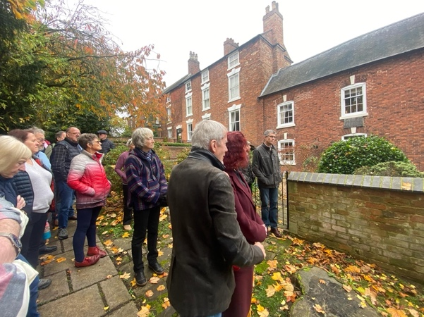A group of people wh attended the Settlement tour

We are hoping to do the same with other historical areas of our Parish. There are many and it is a great calling card to the rest of Erewash to show how steeped in history we are and our importance to the borough’s overall history.

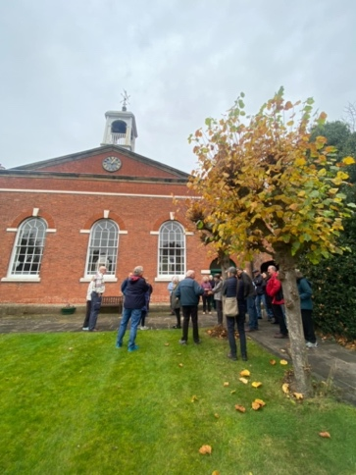

**TWO VERY IMPORTANT THINGS TO WATCH FOR**

We have the following items coming up where we will need your help. To communicate to you we will be using our social media channels more regularly. So, please always check in. Here are the items to watch for and help with:

* **Pylons Campaigning & Parliamentary Consultation in 2025**
* **Neighbourhood Plan (Working on the Plan and Consultations)**

**REMEMBRANCE SUNDAY**

This is a huge event in our Parish year. This year saw a very large crowd in attendance and a ceremony that was flawless. A very big thanks to all who made this possible and helped in the ceremony itself, especially the name readers. We must also remember that our incredible Parish Clerk (Sarah Kitchener) organised the whole event aided by Councillor Steve Fraser-Burton. The bagpiper and bugler were exceptional.

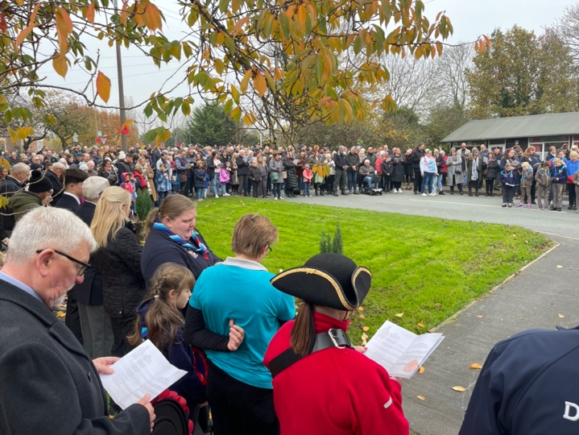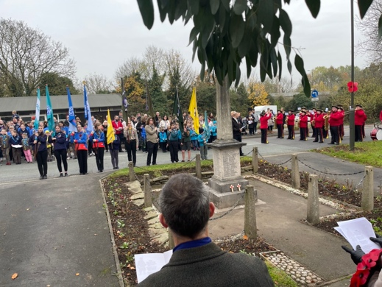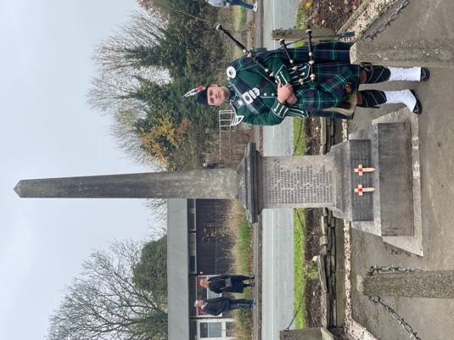

**OCKBROOK & BORROWASH CHRISTMAS LIGHT SWITCH-ON’S**

These two events are massive for our Parish villages. Both have an entirely different flavour to the other and are equally as nice and exciting to attend. We had Deputy Mayor Harry Atkinson open both events and we thank him very much for doing so.

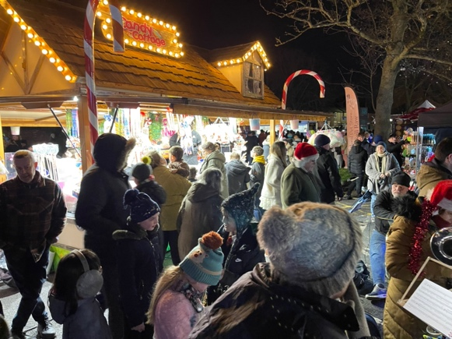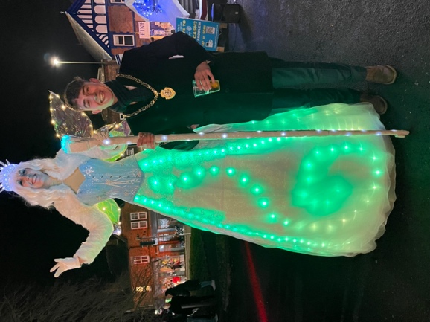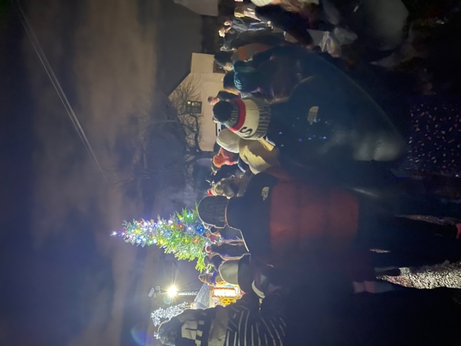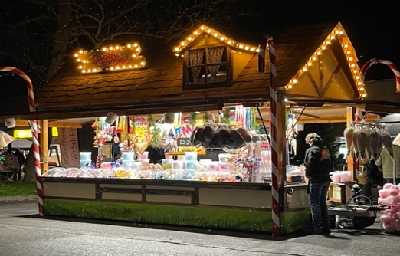Both Christmas Light Switch-On’s were well attended, and the weather cooperated fully. There were record crowds at both events and it was pleasing to see so many youngsters really enjoying the frosty evenings.

A BIG shoutout must go to two organisations which without their help, none of this would have been possible. The Rotary Club of Church Wilne helped marshal both events and provided the grotto for the Ockbrook Light Switch-On. The Long Eaton Silver Prize Band performed magnificently at both events and their music really made the atmosphere come to life. One last (but not least) shout-out to **THE ROYAL OAK PUB** who host year on year this wonderful event. The pub started the event many, many years ago and may it stay there for many more years to come.

**FINAL THOUGHTS**

As always it is an honour and a privilege to serve the Parish as a Parish Councillor and as Chair. On behalf of the Parish Council, I would like to wish everyone a very merry Christmas and a super New Year. May 2025 bring everything you want.

What we have delivered for the community

* **Provided our summer playscheme events of the inflatable obstacle course and climbing wall at Deans Drive.**
* **Organised a successful Remembrance service and parade led by the Ambassador Show band, thank you to all who attended especially the groups in the parade and the readers.**
* **Planned and ran the Christmas light switch on in both Ockbrook and Borrowash, with children’s entertainers, Santa, rides, stalls and Christmas songs being played by the Long Eaton Silver Prize band.**

A flower bed in a park

soldier silhouette surrounded by poppies
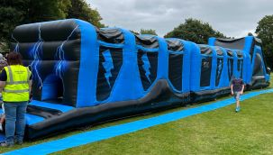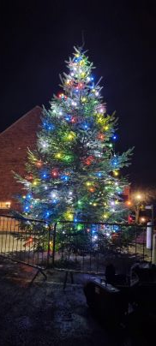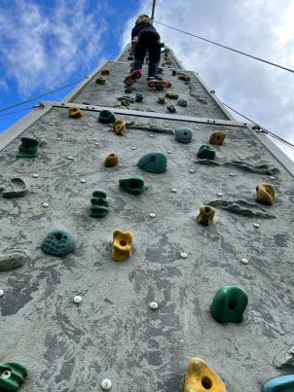

**Parish Council Meeting Dates.**

The first 30 minutes of these meetings are set aside for public speaking.

**WE WELCOME PARTICIPATION AND PUBLIC ATTENDANCE.**

4th December 2024 Parish Hall 5th February 2025 Ashbrook Centre

5th March 2025 Parish Hall

**Committee Meeting Dates – if required.**

22nd January 2025 19th March 2024

All Parish Council meetings will commence at 19.00, these dates might change, see website for all updates.

**Parish Council Contact Details:**

Councillor Greg Maskalick (Chair) - 07834 728540 [cllr.gregmaskalick@ockbrookandborrowashparishcouncil.gov.uk](mailto:cllr.gregmaskalick@ockbrookandborrowashparishcouncil.gov.uk)

Councillor Stephen Fraser-Burton (Vice Chair) - 07977 067252 [cllr.stephenfraser-burton@ockbrookandborrowashparishcouncil.gov.uk](mailto:cllr.stephenfraser-burton@ockbrookandborrowashparishcouncil.gov.uk)

Councillor Ashley Dunn - 07939 965493 [cllr.ashleydunn@ocbrokknandborrowshparishcouncil.gov.uk](mailto:cllr.ashleydunn@ocbrokknandborrowshparishcouncil.gov.uk)

Councillor Katie Eaglesham-Atkins [cllr.katieeaglesham-atkins@ockbrookandborrowashprishcouncil.gov.uk](mailto:cllr.katieeaglesham-atkins@ockbrookandborrowashprishcouncil.gov.uk)

Councillor Christine Millward - 07731 753469 [cllr.christinemillward@ockbrookandborrowashparishcouncil.gov.uk](mailto:cllr.christinemillward@ockbrookandborrowashparishcouncil.gov.uk)

Councillor Tania Stevenson [cllr.taniastevenson@ockbrookandborrowashparishcouncil.gov.uk](mailto:cllr.taniastevenson@ockbrookandborrowashparishcouncil.gov.uk)

Councillor Sarah Cresswell [cllr.sarahcresswell@ockbrookandborrowashparishcouncil.gov.uk](mailto:cllr.sarahcresswell@ockbrookandborrowashparishcouncil.gov.uk)

Councillor Graham Markwell [cllr.grahammarkwell@ockbrookandborrowashparishcouncil.gov.uk](mailto:cllr.grahammarkwell@ockbrookandborrowashparishcouncil.gov.uk)

Councillor Kay Thomas - 01332 726713 [cllr.kaythomas@ockbrookandborrowashparishcouncil.gov.uk](mailto:cllr.kaythomas@ockbrookandborrowashparishcouncil.gov.uk)

Councillor Mike Warrener

[cllr.michaelwarrener@ockbrookandborrowashparishcouncil.gov.uk](mailto:cllr.michaelwarrener@ockbrookandborrowashparishcouncil.gov.uk)

Councillor Tim Sumpter

[cllr.timsumpter@ockbrookandborrowashparishcouncil.gov.uk](mailto:cllr.timsumpter@ockbrookandborrowashparishcouncil.gov.uk)

Sarah Kitchener Clerk and RFO - 07860 702904/ 01332 664100 [clerk@ockbrookandborrowashparishcouncil.gov.uk](mailto:clerk@ockbrookandborrowashparishcouncil.gov.uk)

**Other areas of Responsibility.**

**Erewash Borough Council are responsible for:**

* Building regulations/planning
* Council tax
* Dog wardens
* Bus shelters
* Refuse collection
* Street cleaning

Erewash Borough Council contact details:

Switch board: 0115 9072244

Councillor Greg Maskalick: [greg.maskalick@erewash.gov.uk](mailto:greg.maskalick@erewash.gov.uk)

Councillor Jane White: [jane.white@erewash.gov.uk](mailto:jane.white@erewash.gov.uk)

Councillor R Locke: 07977 637 799 [richard.locke@erewash.gov.uk](mailto:richard.locke@erewash.gov.uk)

Derbyshire County Council are responsible for:

* Education
* Libraries
* Social Services
* Street lighting
* Trading standards
* Highways

Derbyshire County Council contact details:

Switchboard: 01629 533190

Councillor Wayne Major – Ockbrook ward: 01629 535650 / 07780 222575 [Wayne.Major@derbyshire.gov.uk](mailto:Wayne.Major@derbyshire.gov.uk)

Councillor Robert Parkinson – Borrowash ward: 01332 872793 / 07715 012459 [Robert.Parkinson@derbyshire.gov.uk](mailto:Robert.Parkinson@derbyshire.gov.uk)