Ockbrook and Borrowash Parish Council June Newsletter.

**FROM THE CHAIR**

**BELMONT CEMETERY FUNDING**

I am very pleased to announce that the Board of Trustees (through the efforts of Councillor Markwell) were able to gain a **grant of £10,000.00 from East Midlands Airport**. This will enable us to start clearing out the cemetery of 10+ years of overgrowth and once again making it into a space that is respectful to the 500+ souls buried there.

We will be holding several Parish consultations in the next 6 months to come up with a plan that will celebrate the cemetery and its cultural heritage of our Parish as well as being a respectful place once again for the parishioners buried there. Date and details for consultations will be announced shortly.

In the meantime, you may want to look at our website for the project: [www.friendsofbc.uk](http://www.friendsofbc.uk). The website is in its infancy, but more will be added as time goes on.

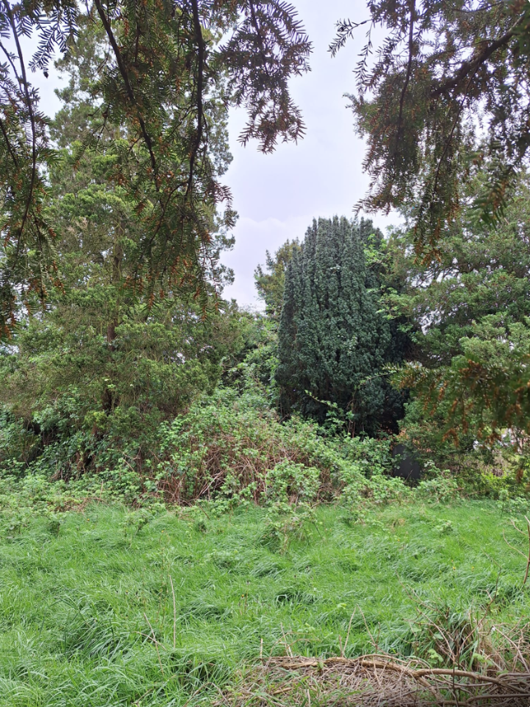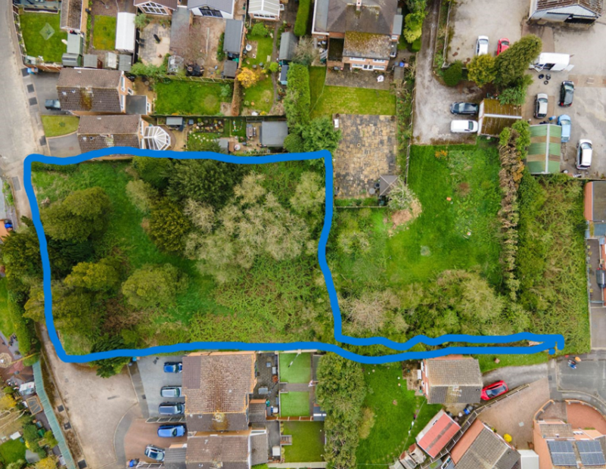

**REWILDING IN OUR PARISH**

As you are most likely aware, Derbyshire County Council and Erewash Borough Council have been implementing rewilding schemes. Whilst as a Parish Council we feel this is a good idea, we recognise that public safety needs to be first and foremost when implementing the rewilding strategy and this concerns mainly (but not exclusively) lines of site at junctions… when driving.

We have been and continue to be in touch with the officer in charge of rewilding at Erewash Borough Council to sort out these lines of site matters and other safety concerns. Basically, it’s a new initiative that is going through teething problems, but I am sure it will all be worked out as EBC does listen and respond to these sorts of concerns.

If you notice an issue somewhere within the Parish on this or any Parish matter, I urge you to contact the Parish Clerk by email or phone. Contact details are on our website.

**BRIAR CLOSE CARE HOME**

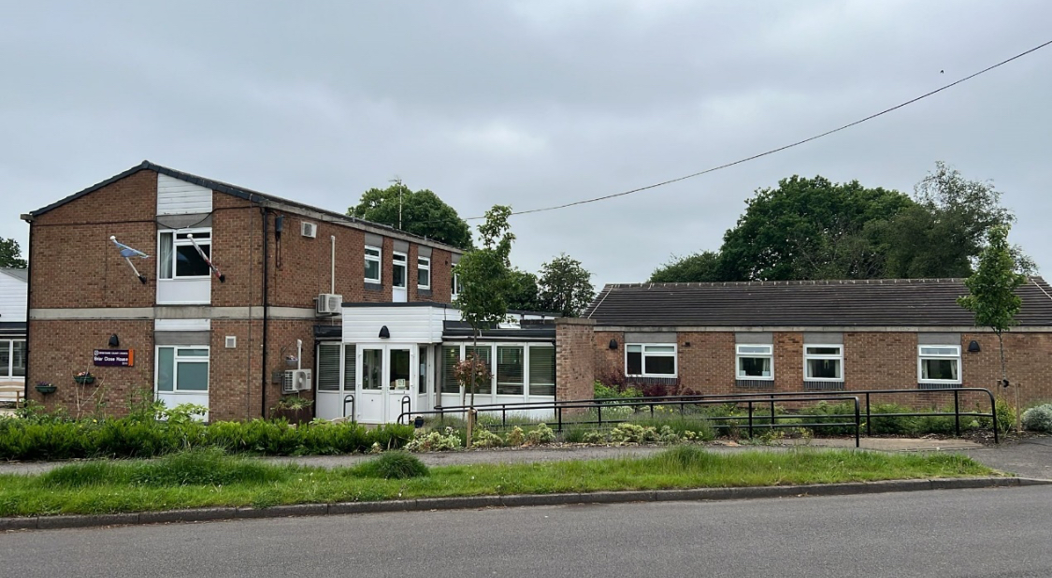Derbyshire County Council has proposed to sell or close Briar Close Care Home in Borrowash. We are very much against this and would ask you to go on to the DCC website and read all the information on the proposed sale/closure and public consultation. There are petitions circulating at all the pubs to sign and let DCC know that you object to the sale/closure of Briar Close.

Briar Close Care Home has many residents with dementia and the care BC gives to these vulnerable residents is amazing. The amazing staff that work there and the residents deserve our support.

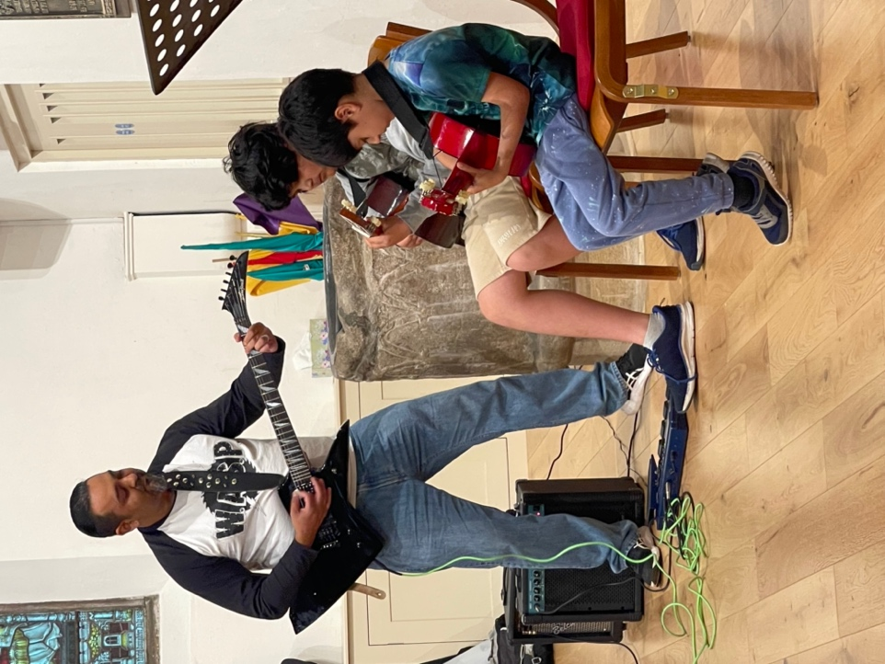

**YOUTH CONCERT 2.0**

We had our second Youth and Youth at Heart concert on Friday 24th May 2024. It was the second Youth concert in less than a year, the last concert being in October 2023. It was amazing and we had more performers than the first concert and a great mix of music. Everything from AC/DC to Telemann and everything in-between.

Congratulations to all who participated Thank you to the audience members for supporting it. A major thank you to All Saints Church for hosting the concert. Next concert will be October 2024. More anon.

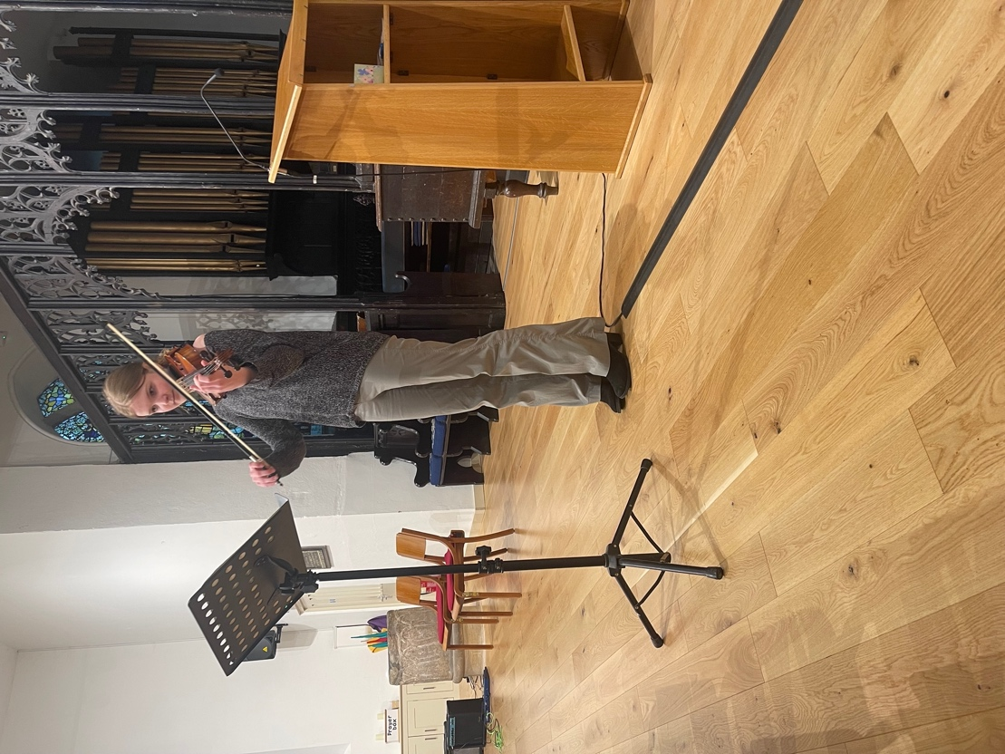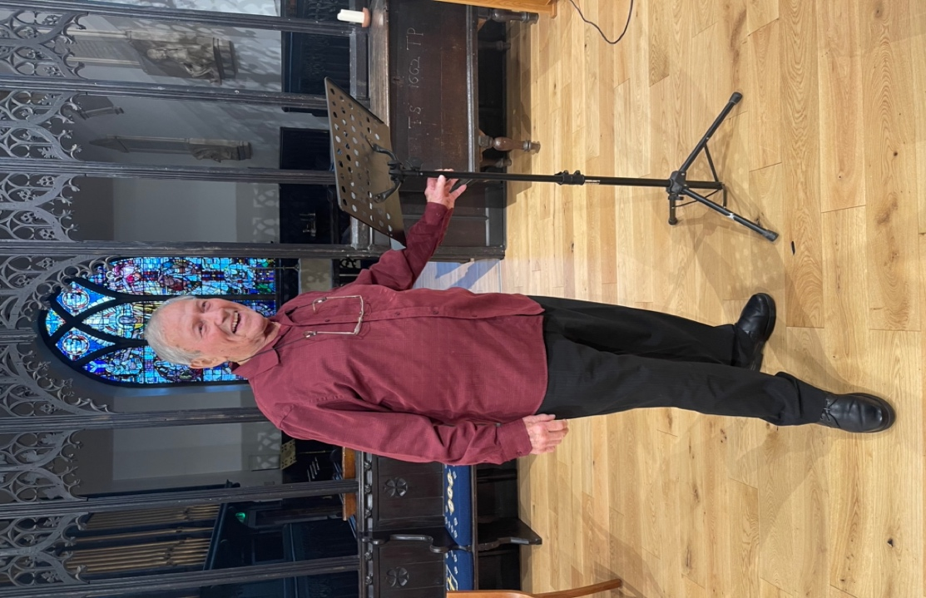

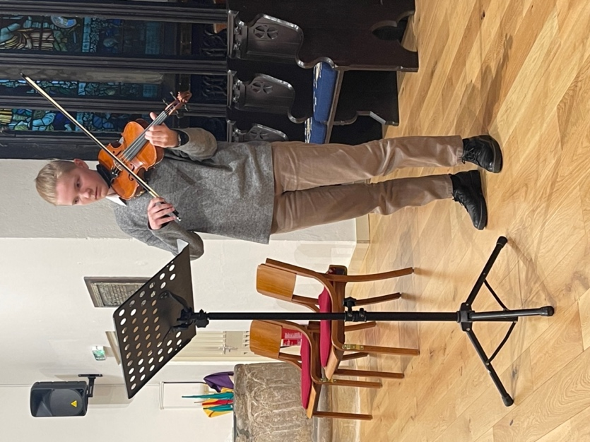

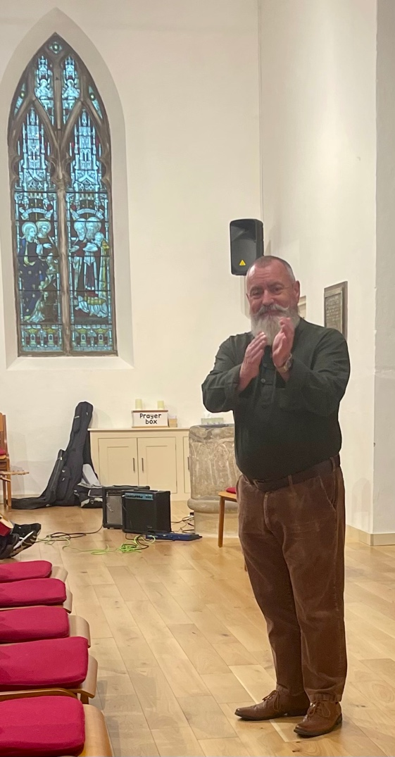

Councillor Greg Maskalick

Chair Ockbrook & Borrowash Parish Council

Erewash Borough Councillor for Ockbrook & Borrowash

Parish Council Meeting Dates.

The first 30 minutes of these meetings are set aside for public speaking.

**WE WELCOME PARTICIPATION AND PUBLIC ATTENDANCE.**

5th June 2024 Ashbrook Centre 4th December 2024 Parish Hall

3rd July 2024 Parish Hall 5th February 2025 Ashbrook Centre

4th September 2024 Ashbrook Centre 5th March 2025 Parish Hall

2nd October 2024 Parish Hall 2nd April 2025 Ashbrook Centre

6th November 2024 Ashbrook Centre

Committee Meeting Dates – if required.

All committee meetings are held in the Parish Hall Ockbrook.

24th July 2024 22nd January 2024

25th September 2024 19th March 2025

20th November 2024

All Parish Council meetings will commence at 19:00, the agendas for our meetings are displayed on the 5 village noticeboards and can be found on the Parish Council website.

Parish Council Contact Details:

Councillor Greg Maskalick (Chair) - 07834 728540

[cllr.gregmaskalick@ockbrookandborrowashparishcouncil.gov.uk](mailto:cllr.gregmaskalick@ockbrookandborrowashparishcouncil.gov.uk)

Councillor Stephen Fraser-Burton (Vice Chair) - 07977 067252

[cllr.stephenfraser-burton@ockbrookandborrowashparishcouncil.gov.uk](mailto:cllr.stephenfraser-burton@ockbrookandborrowashparishcouncil.gov.uk)

Councillor Ashley Dunn - 07939 965493

[cllr.ashleydunn@ockbrookandborrowashparishcouncil.gov.uk](mailto:cllr.ashleydunn@ockbrookandborrowashparishcouncil.gov.uk)

Councillor Katie Eaglesham-Atkins

[cllr.katieeaglesham-atkins@ockbrookandborrowashprishcouncil.gov.uk](mailto:cllr.katieeaglesham-atkins@ockbrookandborrowashprishcouncil.gov.uk)

Councillor Christine Millward - 07731 753469

[cllr.christinemillward@ockbrookandborrowashparishcouncil.gov.uk](mailto:cllr.christinemillward@ockbrookandborrowashparishcouncil.gov.uk)

Councillor Tania Stevenson [cllr.taniastevenson@ockbrookandborrowashparishcouncil.gov.uk](mailto:cllr.taniastevenson@ockbrookandborrowashparishcouncil.gov.uk)

Councillor Sarah Cresswell [cllr.sarahcresswell@ockbrookandborrowashparishcouncil.gov.uk](mailto:cllr.sarahcresswell@ockbrookandborrowashparishcouncil.gov.uk)

Councillor Graham Markwell [cllr.grahammarkwell@ockbrookandborrowashparishcouncil.gov.uk](mailto:cllr.grahammarkwell@ockbrookandborrowashparishcouncil.gov.uk)

Councillor Kay Thomas - 01332 726713 [cllr.kaythomas@ockbrookandborrowashparishcouncil.gov.uk](mailto:cllr.kaythomas@ockbrookandborrowashparishcouncil.gov.uk)

Councillor Janet Fazackerley - 01332 672744 [cllr.janetfazackerley@ockbrookandborrowashparishcouncil.gov.uk](mailto:cllr.janetfazackerley@ockbrookandborrowashparishcouncil.gov.uk)

Councillor Julie Fraser-Burton - 07958 345571

[cllr.juliefraser-burton@ockbrookandborrowashparishcouncil.gov.uk](mailto:cllr.juliefraser-burton@ockbrookandborrowashparishcouncil.gov.uk)

Sarah Kitchener Clerk and RFO - 07860 702904/ 01332 664100

[clerk@ockbrookandborrowashparishcouncil.gov.uk](mailto:clerk@ockbrookandborrowashparishcouncil.gov.uk)

Other areas of Responsibility.

Erewash Borough Council are responsible for:

* Building regulations/planning
* Council tax
* Dog wardens
* Bus shelters
* Refuse collection
* Street cleaning

Erewash Borough Council contact details:

Switch board: 0115 9072244

Councillor Greg Maskalick: [greg.maskalick@erewash.gov.uk](mailto:greg.maskalick@erewash.gov.uk)

Councillor Jane White: [jane.white@erewash.gov.uk](mailto:jane.white@erewash.gov.uk)

Councillor R Locke: 07977 637 799 [richard.locke@erewash.gov.uk](mailto:richard.locke@erewash.gov.uk)

Derbyshire County Council are responsible for:

* Education
* Libraries
* Social Services
* Street lighting
* Trading standards
* Highways

Derbyshire County Council contact details:

Switchboard: 01629 533190

Councillor Wayne Major – Ockbrook ward: 01629 535650 / 07780 222575 [Wayne.Major@derbyshire.gov.uk](mailto:Wayne.Major@derbyshire.gov.uk)

Councillor Robert Parkinson – Borrowash ward: 01332 872793 / 07715 012459 [Robert.Parkinson@derbyshire.gov.uk](mailto:Robert.Parkinson@derbyshire.gov.uk)